**LESSON PLAN AND NOTE 1 FOR WEEK 8 ENDING 14/6/2024**

**Term 3rd term**

**Week 8th week**

**Date 10th June, 2024.**

**Class Nursery one**

**Subject Letter work**

**Topic Three letter words.**

**Sub-topic Naming three letter words.**

**Period 2nd period**

**Time 9:05 am**

**Duration 35 minutes**

**No in class 14**

**Average Age 3 years**

**Sex Mixed**

**Specific Objectives: By the end of the lesson the pupils should be able to;**

1. **Name three letter words.**
2. **Identify three letter words.**

**Rationale: To make sure the pupils mention and identify three letter words.**

**Previous knowledge: The pupils can write the 21 consonant sounds.**

**Instructional Resources: Three letter words chart, board, marker.**

**Reference Materials: Online Research,chart,board.**

**LESSON PRESENTATION**

|  |  |  |  |
| --- | --- | --- | --- |
| **Steps** | **Teacher’s Activities** | **Pupils’ Activities** | **Learning points** |
| **Introduction** | **The teacher introduces the topic (Three letter words.) to the pupils.** | **The pupils listen attentively to the teacher.** | **To arouse the interest of the pupils.** |
| **Step 1** | **The teacher starts by naming three letter words for the pupils**  **ant boy rat cat**  **fat dog bed car etc.** | **The pupils repeat after the teacher the three letter words.** | **For proper understanding.** |
| **Step 2** | **The teacher leads the pupils in identifying three letter words.**  **ant can**  **toy pan**  **rat tap**  **fan pot etc** | **The pupils identify the three letter words.** | **For better understanding.** |
| **Summary** | **The teacher summarizes the lesson by sounding three letter words from the “three letter words chart”.** | **The pupils listens attentively and repeats after the teacher the three letter words as she sounds from the chart.** | **For onward study.** |
| **Evaluation** | **Question:**  **Name (4) three letter words you know?**  **Mention five (5) three letter word you know?** | **The pupils answer the question correctly.** | **To ascertain the pupils’ understanding.** |
| **Conclusion** | **The teacher summarizes, reacts & corrects the pupils.** | **The pupils answer to the teacher’s questions.** | **To consolidate the lesson.** |
| **Assignment** | **Question:**  **Name (4) three letter words you know?**  **Mention five (3) three letter word you know?** | **The pupils copy and do their homework at home.** | **To encourage learning while at home.** |

**LESSON PLAN AND NOTE 2 FOR WEEK 8 ENDING 14/6/2024**

**Term 3rd term**

**Week 8th week**

**Date 12th June, 2024.**

**Class Nursery one**

**Subject Letter work**

**Topic Three letter words.**

**Sub-topic Spelling three letter words.**

**Period 2nd period**

**Time 9:05 am**

**Duration 35 minutes**

**No in class 14**

**Average Age 3 years**

**Sex Mixed**

**Specific Objectives: By the end of the lesson the pupils should be able to;**

1. **Spell three letter words.**
2. **Match three letter words.**

**Rationale: To make sure the pupils spell and match three letter words.**

**Previous knowledge: The pupils can name & identify three letter words.**

**Instructional Resources: Three letter words chart, exercise books, pencils.**

**Reference Materials: Online Research,chart,board**

**LESSON PRESENTATION**

|  |  |  |  |
| --- | --- | --- | --- |
| **Steps** | **Teacher’s Activities** | **Pupils’ Activities** | **Learning points** |
| **Introduction** | **The teacher introduces the topic (Three letter words) to the pupils.** | **The pupils listen attentively to the teacher.** | **To arouse the interest of the pupils.** |
| **Step 1** | **The teacher leads the pupils to spell three letter words below**   1. **n-t b-o-y c-a-t**   **r-a-t d-o-g f-a-n**  **p-o-t f-a-t l-e-g** | **The pupils participate in spelling three letter words.**  **a-n-t b-o-y c-a-t**  **r-a-t d-o-g f-a-n**  **p-o-t f-a-t l-e-g** | **For proper understanding.** |
| **Step 2** | **The teacher guides the pupils to match three letter words inside their notebooks**  **Boy pot**  **Fat dog**  **Bag bed**  **Leg boy**  **Bed bag**  **Dog fat**  **Pot leg** | **The pupils match the three letter words below inside their notebooks.**  **Boy pot**  **Fat dog**  **Bag bed**  **Leg boy**  **Bed bag**  **Dog fat**  **Pot leg** | **For better understanding.** |
| **Summary** | **The teacher summarizes the lesson by identifying three letter words below for the pupils**  **Bed bag**  **Dog fat**  **Pot leg** | **The pupils have knowledge three letter words.** | **For onward study.** |
| **Evaluation** | **Question:**  **Spell “fat”, “boy”.**  **Match the following**  **Boy bag**  **Fat leg**  **Bag boy**  **Leg fat** | **The pupils answer the question correctly.** | **To ascertain the pupils’ understanding.** |
| **Conclusion** | **The teacher summarizes, reacts & corrects the pupils.** | **The pupils answer to the teacher’s questions.** | **To consolidate the lesson.** |
| **Assignment** | **Question:**  **Spell the word “fat”**  **Match the following three letter words**  **Bed pot**  **Dog bed**  **Pot dog** | **The pupils copy and do their homework at home.** | **To encourage learning while at home** |

**LESSON PLAN AND NOTE 3 FOR WEEK 8 ENDING 14/6/2024**

**Term 3rd term**

**Week 8th week**

**Date 14th June, 2024.**

**Class Nursery one**

**Subject Letter work**

**Topic Three letter words.**

**Sub-topic Write three letter words.**

**Period 2nd period**

**Time 9:05 am**

**Duration 35 minutes**

**No in class 14**

**Average Age 3 years**

**Sex Mixed**

**Specific Objectives: By the end of the lesson the pupils should be able to;**

1. **Write three letter words.**
2. **Fill in the missing three letter words.**

**Rationale: To make sure the pupils write & fill in the missing three letter words.**

**Previous knowledge: The pupils can spell & match three letter words.**

**Instructional Resources: Three letter words chart, exercise books, pencils.**

**Reference Materials: Online Research,chart,board**

**LESSON PRESENTATION**

|  |  |  |  |
| --- | --- | --- | --- |
| **Steps** | **Teacher’s Activities** | **Pupils’ Activities** | **Learning points** |
| **Introduction** | **The teacher introduces the topic (Three letter words) to the pupils.** | **The pupils listen attentively to the teacher.** | **To arouse the interest of the pupils.** |
| **Step 1** | **The teacher guides the pupils to write three letter words inside their notebooks.**   |  | | --- | | **m a t** | |  | | **o i l** | |  | | **n e t** | |  | | **p o t** | |  | | **The pupils writes three letter inside their notebooks.** | **For proper understanding.** |
| **Step 2** | **The teacher guides the pupils to fill in the missing letters below**  **b _____ y**  **p _____ g**  **r _____ t**  **l _____ g** | **The pupils fills in the missing letters of the three letter words.**  **b o y**  **p i g**  **r a t**  **l e g** | **For better understanding.** |
| **Summary** | **The teacher summarizes the lesson by sounding random three letter words.** | **The pupils have knowledge of three letter words.** | **For onward study.** |
| **Evaluation** | **Question:**  **Write the three letter words below**   |  | | --- | | **m a t** | |  | | **o i l** | |  | | **n e t** | |  | | **p o t** | |  |   **Fill in the missing letter below**  **r _____ t**  **l _____ g** | **The pupils answer the question correctly.** | **To ascertain the pupils’ understanding.** |
| **Conclusion** | **The teacher summarizes, reacts & corrects the pupils.** | **The pupils answer to the teacher’s questions.** | **To consolidate the lesson.** |
| **Assignment** | **Write the three letter words “mat” & “oil”, “net”, “pot”.**  **Fill in the missing letters below**  **b _____ y**  **p _____ g**  **r _____ t**  **l _____ g** | **The pupils copy and do their homework at home.** | **To ensure learning while at home.** |

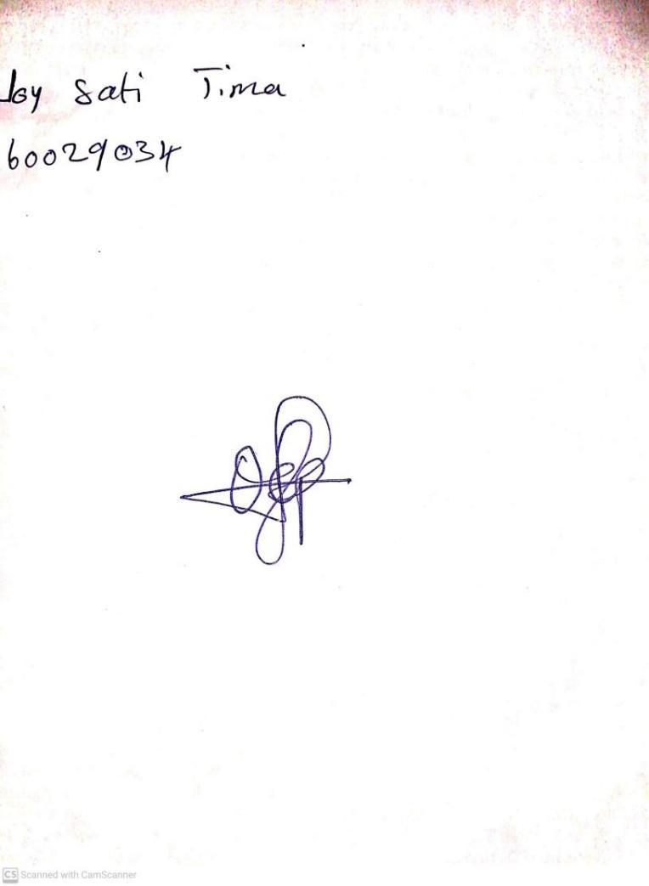

14th June, 2024

Perpetual Ojoma Ocheja

Stream Head Nursery