LESSON PLAN AND NOTE FOR WEEK 5 ENDING 13/10/2023

TERM: 1st

WEEK: 5th

DATE: 09/10/2023

CLASS: Nursery 2

SUBJECT: Nature studies

TOPIC: Body care for wounds.

SUB—TOPIC: Meaning of wounds and first aid treatment for wounds.

PERIOD: 4th

TIME: 10:40—11:20am

DURATION: 40 minutes

NUMBER IN CLASS: 14

AVERAGE AGE: 5 years

SEX: Mixed

LEARNING OBJECTIVES: By the end of the lesson, the pupils should be able to:

1. Define wound

2. State the first aid treatment for wounds

RATIONALE: For pupils to know the treatment for wounds.

PREVIOUS KNOWLEDGE: Pupils have learnt about cut in previous lesson.

INSTRUCTIONAL MATERIALS: cotton wool, water , bandage, jelly cream, and plaster.

REFERENCE MATERIALS: Basic science and technology for Nursery schools book 3 by OPEMIPO DADA.

LESSON DEVELOPMENT

|  |  |  |  |
| --- | --- | --- | --- |
| Steps | Teacher's activities | Pupils' activities | Learning point |
| Introduction | Teacher introduces the lesson by reviewing the previous lesson. | Pupils pay attention to the teacher. | To prepare pupils minds for the lesson ahead. |
| Presentation step 1 | Teacher defines wound to pupils and then asks them to repeat after her. | Pupils listen to the teacher and repeat after her. | To improve pupils listening and speaking ability. |
| Step 2 | Teacher States the first aid treatment for wound to pupils and also asks them to repeat after her. | Pupils pay attention to the teacher and repeat her. | To enhance pupils participation in the class. |
| Board summary | Teacher writes the whole note of lesson on the board for pupils to copy into their books. That is;  Wounds:  Wound is an injury to the body. It can be caused by a cut, a fall or a blow to the head.  First aid treatment for wounds are:   1. Wash your hands to avoid infection. 2. Stop the bleeding. 3. Clean the wound with the use of cotton wool. 4. Apply an antibiotic. 5. Cover the wound to avoid infections. 6. Get some rest after treatment to help the wound heal fast. | Pupils copy the note into their exercise books. | For onward study. |
| Evaluation | Teacher evaluates the lesson by asking pupils the following questions;   1. Define wound. 2. State the first aid treatment for wounds. | Pupils answer the questions asked by the teacher. | To assess pupils level of understanding. |
| Conclusion | Teacher concludes the lesson by marking pupils books. | Pupils submit their books for marking. | For endorsement. |
| Assignment | 1. What are living things? 2. Mention at least 4 examples of living things. 3. List the characteristics of living things. | Pupils do their assignment at home. | To encourage learning at home. |

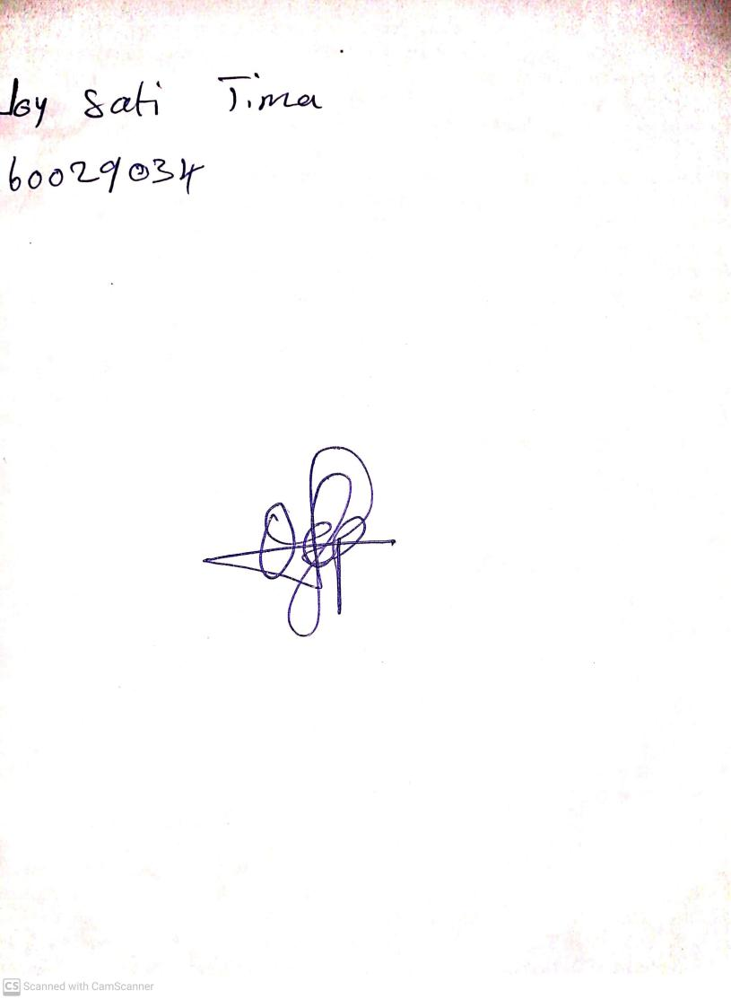

27th August, 2023

Perpetual Ojoma Ocheja

Stream Head Nursery