**EMERALD ROYAL INTERNATIONAL SCHOOL**

**MPAPE, ABUJA**

**Number Work 3rd Term Scheme Of Work NURSERY 1**

|  |  |  |
| --- | --- | --- |
| **Week 1** | **Counting numbers 1-100** | **Counting numbers 1-100**  **Identifying numbers 1-100**  **Writing numbers 1-100.** |
| **Week 2** | **Numbers before and after** | **Identification of numbers that comes before and after a particular number.** |
| **Week 3** | **Numbers before and after** | **Sorting numbers before and after numbers.** |
| **Week 4** | **Reciting months of the year** | **Reciting months of the year**  **January**  **February**  **March**  **April**  **May**  **June**  **July**  **August**  **September**  **October**  **November**  **December** |
| **Week 5** | **Odd Numbers** | **Identification of Odd Numbers.** |
| **Week 6** | **Even Numbers** | **Identification of Even Numbers.** |
| **Week 7** | **Introduction to Addition** | **Identification of mathematical simple signs i.e Plus (+)**  **Minus (-)**  **Equal to (=).**  **Addition of objects e.g two cups + one cup = three cups.s** |
| **Week 8** | **Simple addition** | **Addition of numbers e.g**  **2+2=4.**  **3+3=6.** |
| **Week 9** | **Simple Subtraction** | **Subtraction of objects e.g**  **Three triangles – One triangle = Two triangles.**  **Subtraction of numbers e.g**  **2-1=1**  **8-4=4.** |
| **Week 10** | **Simple subtraction and addition** | **Simple subtraction and addition of objects**  **Simple subtraction and addition of numbers.s** |
| **Week 11** | **Revision** |  |
| **Week 12** | **Examination.** |  |

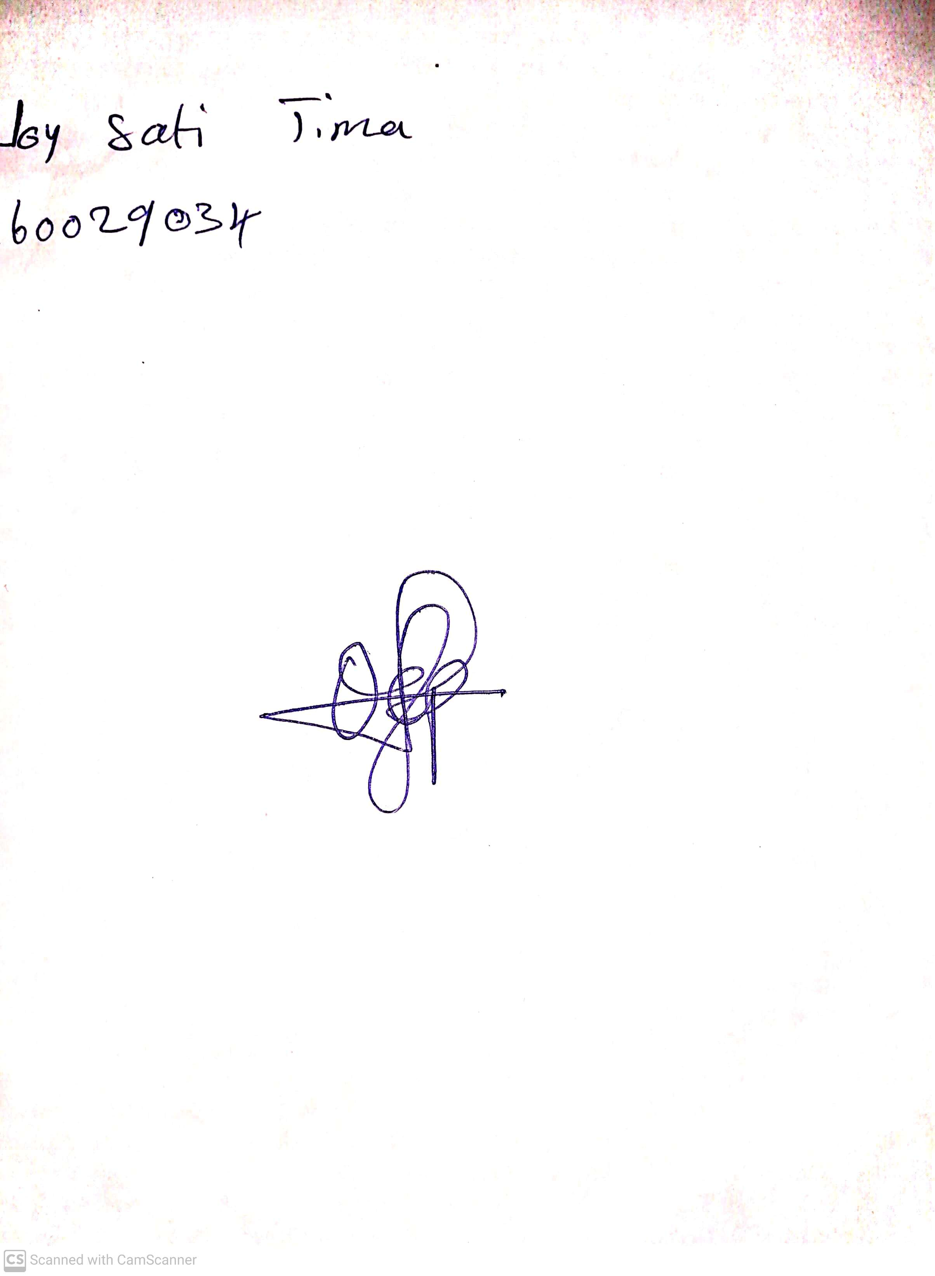

10th May, 2023

Perpetual Ojoma

Stream Head Nursery