**EMERALD ROYAL INTERNATIONAL SCHOOL MPAPE, ABUJA.**

**LESSONS PLAN AND NOTE FOR WEEK 6 ENDING 31st MAY, 2024**

**TERM: 3rd**

**WEEK: 6th**

**DATE: 27/05/2024**

**CLASS: Nursery 2**

**SUBJECT: Nature studies**

**TOPIC: Water storage**

**SUB—TOPIC: Reason for storing water.**

**PERIOD: 4th**

**TIME: 10:40—11:20am**

**DURATION: 40 minutes**

**NUMBER IN CLASS: 13**

**AVERAGE AGE: 5 years**

**SEX: Mixed**

**LEARNING OBJECTIVES: By the end of the lesson, the pupils should be able to:**

**1. Explain the reasons why we should store water.**

**2. Mention the container for storing water.**

**RATIONALE: For Pupils to know why it is good to store water.**

**PREVIOUS KNOWLEDGE: Pupils have learnt the how to purify water in previous lesson.**

**INSTRUCTIONAL MATERIALS: keg, bucket and bottle.**

**REFERENCE MATERIALS: Basic science and technology for Nursery schools book 3 by OPEMIPO DADA.**

**LESSON DEVELOPMENT**

|  |  |  |  |
| --- | --- | --- | --- |
| **Steps** | **Teacher's activities** | **Pupils' activities** | **Learning point** |
| **Introduction** | **Teacher introduces the lesson by reviewing the previous lesson.** | **Pupils pay attention to the teacher.** | **To prepare pupils minds for the lesson ahead.** |
| **Presentation step 1** | **Teacher explains to pupils the reason why it's good to store water and then asks them to repeat after her.** | **Pupils listen to the teacher and repeat after her.** | **For better understanding.** |
| **Step 2** | **Teacher mentions the containers for storing water and also asks Pupils to repeat after her.** | **Pupils pay attention to the teacher and repeat after the teacher.** | **For better understanding.** |
| **Board summary** | **Teacher writes the whole note of lesson on the board for pupils to copy. That is;**  **Why we store water**  **1. We store water to keep it clean and safe for use.**  **2. We store water to make it available to us all the time.**  **3. We store water to make it easy for us to get it when we need it.**  **4. We store water because it should not be wasted.**  **Water storage containers**  **Water storage containers are;**  **1. Tank**    **2. Bucket**    **3. Bottle**    **4. Keg** | **Pupils copy the note into their exercise books.** | **For onward study.** |
| **Evaluation** | **Teacher evaluates the lesson by asking the following questions;**  **1. What are the reasons why we store water?**  **2. Mention the containers for storing water.** | **Pupils answer the questions ask by the teacher.** | **To assess pupils level of understanding.** |
| **Conclusion** | **Teacher concludes the lesson by marking pupils books.** | **Pupils submit their books for marking.** | **For endorsement.** |
| **Assignment** | **Activity 20 page 66. Basic science textbook.** | **Pupils do their assignment at home.** | **To encourage learning at home.** |

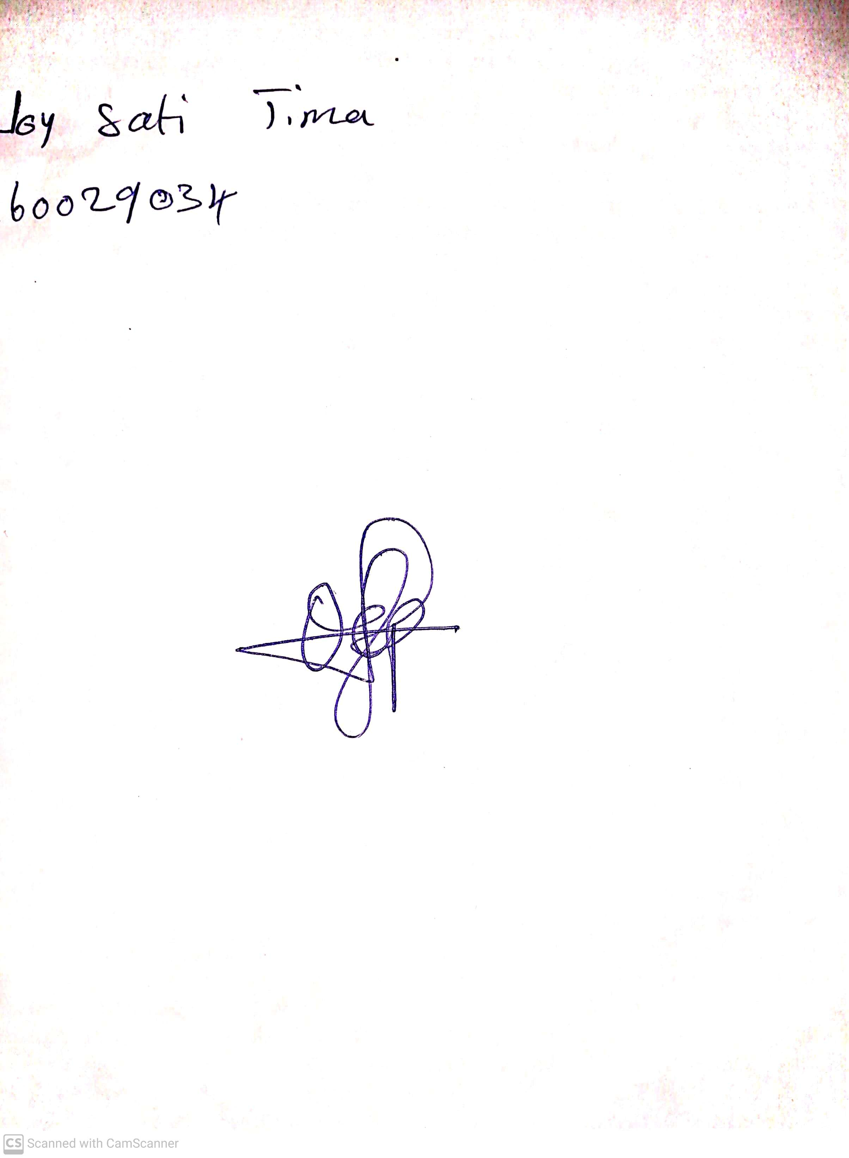

**17th May, 2024**

**Perpetual Ojoma Ocheja**

**Stream Head Nursery**