**EMERALD ROYAL INTERNATIONAL SCHOOL**

**MPAPE, ABUJA.**

**LESSON NOTE FOR WEEK 4 ENDING 6TH OCTOBER,2023.**

TERM: 1ST

SUBJECT: Number Work

TOPIC: Counting numbers 1 - 10

SUB-TOPIC: Tracing numbers 1 and 2

DATE: 2nd October, 2023.

DURATION: 40 minutes.

TIME: 08:50--09:30.

PERIOD: 1st

CLASS: Pre-nursery

NUMBER OF PUPILS: 15

AVERAGE AGE: 2 years

SEX: Mixed.

SPECIFIC OBJECTIVES: By the end of the lesson, the pupils should be able to:-

1. Count Numbers 1 - 10
2. Tracing numbers 1 and 2

RATIONALE: For pupils to be able to count numbers.

PREVIOUS KNOWLEDGE: Pupils have been counting numbers .

INSTRUCTIONAL MATERIALS: Number chart, flash cards, building blocks etc

REFERENCE MATERIALS: Mastering mathematics for nursery schools book 1 by Henry Idogun.

**LESSON DEVELOPMENT**

|  |  |  |  |
| --- | --- | --- | --- |
| STAGES/STEPS | TEACHER’S ACTIVITIES | PUPILS’ ACTIVITIES | LEARNING POINTS |
| INTRODUCTION | Teacher introduces the lesson by singing a number rhyme for the pupils. | Pupils sing the rhyme along with the teacher. | To arouse pupils interest in the lesson. |
| PRESENTATION  STEP 1 | Teacher counts numbers 1 - 10 for the pupils to repeat after her. | Pupils count numbers 1 - 10 after the teacher. I.e  1 2 3 4 5 6 7 8 9 10 | To teach pupils counting of numbers |
| STEP 2 | Teacher prepares the pupils books for them to trace numbers 1 and 2 . | Pupils trace numbers 1 and 2  Dotted numbersDotted numbers Dotted numbers Dotted numbers | For proper understanding of the lesson. |
| SUMMARY | Teacher counts and point at numbers 1 - 10 I.e  1 2 3 4 5 6 7 8 9 10. Then writes numbers 1 and 2 boldly on the board for the pupils to see. | Pupils point at the numbers and count after the teacher. | For more understanding of the lesson. |
| EVALUATION | Teacher asks Pupils to count numbers 1 - 10 | Pupils count numbers 1 - 10. | To assess pupils understanding of the lesson. |
| CONCLUSION | Teacher sings a number rhyme for the pupils. | Pupils sing the rhyme along with the teacher. | To improve pupils speaking ability. |
| ASSIGNMENT (HOME WORK) | Trace number 1  Dotted numbers Dotted numbers Dotted numbers | Pupils do their assignment at home. | To encourage pupils to learn at home. |

**LESSON NOTE FOR WEEK 4 ENDING 6th October, 2023.**

TERM: 1ST

SUBJECT: Number Work

TOPIC: Counting numbers 1 - 10.

SUB-TOPIC: Tracing numbers 3 and 4

DATE: 3rd October, 2023.

DURATION: 40 minutes.

TIME: 08:50--09:30.

PERIOD: 2nd

CLASS: Pre-nursery

NUMBER OF PUPILS: 15

AVERAGE AGE: 2 years

SEX: Mixed.

SPECIFIC OBJECTIVES: By the end of the lesson, the pupils should be able to:-

1. Count Numbers 1 - 10
2. Trace numbers 3 and 4

RATIONALE: For pupils to be able to count numbers.

PREVIOUS KNOWLEDGE: Pupils have been counting numbers

INSTRUCTIONAL MATERIALS: Number chart, flash cards, building blocks etc

REFERENCE MATERIALS: Mastering mathematics for nursery schools book 1 by Henry Idogun.

**LESSON DEVELOPMENT**

|  |  |  |  |
| --- | --- | --- | --- |
| STAGES/STEPS | TEACHER’S ACTIVITIES | PUPILS’ ACTIVITIES | LEARNING POINTS |
| INTRODUCTION | Teacher introduces the lesson by singing a number rhyme for the pupils. | Pupils sing the rhyme along with the teacher. | To arouse pupils interest in the lesson. |
| PRESENTATION  STEP 1 | Teacher counts numbers 1 - 10 for the pupils to repeat after her. | Pupils count numbers 1 - 10 after the teacher. I.e 1 2 3 4 5 6 7 8 9 10. | To teach pupils counting of numbers |
| STEP 2 | Teacher shows the pupils numbers 3 and 4 on flash cards then prepares the pupils books for them to trace numbers 3 and 4. | Pupils trace the numbers I.e  Dotted numbers Dotted numbers  Dotted numbers Dotted numbers | For proper understanding of the lesson. |
| SUMMARY | Teacher writes numbers 3 and 4 boldly on the board for the pupils to see. | Pupils point at the numbers and say them after the teacher. | For more understanding of the lesson. |
| EVALUATION | Teacher asks Pupils to identify numbers 3 and 4. | Pupils point at the numbers. | To assess pupils understanding of the lesson. |
| CONCLUSION | Teacher sings a number rhyme for the pupils. | Pupils sing the rhyme along with the teacher. | To improve pupils speaking ability. |
| ASSIGNMENT (HOME WORK) | Trace number 3  Dotted numbersDotted numbers Dotted numbers Dotted numbers | Pupils do their assignment at home. | To encourage pupils to learn at home. |

**LESSON NOTE FOR WEEK 3 ENDING 6TH OCTOBER, 2023.**

TERM: 1ST

SUBJECT: Number Work

TOPIC: Counting numbers 1 - 10.

SUB-TOPIC: Tracing number 5

DATE: 4th October, 2023.

DURATION: 40 minutes.

TIME: 08:50--09:30.

PERIOD: 3rd

CLASS: Pre-nursery

NUMBER OF PUPILS: 15

AVERAGE AGE: 2 years

SEX: Mixed.

SPECIFIC OBJECTIVES: By the end of the lesson, the pupils should be able to:-

1. Count Numbers 1 - 10
2. Trace number 5

RATIONALE: For pupils to be able to count numbers.

PREVIOUS KNOWLEDGE: Pupils have been counting numbers.

INSTRUCTIONAL MATERIALS: Number chart, flash cards, building blocks etc

REFERENCE MATERIALS: Mastering mathematics for nursery schools book 1 by Henry Idogun.

**LESSON DEVELOPMENT**

|  |  |  |  |
| --- | --- | --- | --- |
| STAGES/STEPS | TEACHER’S ACTIVITIES | PUPILS’ ACTIVITIES | LEARNING POINTS |
| INTRODUCTION | Teacher introduces the lesson by singing a number rhyme for the pupils. | Pupils sing the rhyme along with the teacher. | To arouse pupils interest in the lesson. |
| PRESENTATION  STEP 1 | Teacher counts numbers 1 - 10 for the pupils to repeat after her. | Pupils count numbers 1 - 10 after the teacher. I.e  1 2 3 4 5 6 78 9 10. | To teach pupils counting of numbers |
| STEP 2 | Teacher identifies number 1 - 10 for the pupils then prepares the pupils books for them to trace number 5 | Pupils trace number 5  Dotted numbersDotted numbers Dotted numbers Dotted numbers Dotted numbers Dotted numbers | For proper understanding of the lesson. |
| SUMMARY | Teacher writes number 5 on the board boldly for the pupils to see. | Pupils point at the number. | For more understanding of the lesson. |
| EVALUATION | Teacher asks Pupils to identify number 5 | Pupils point at the number number 5. | To assess pupils understanding of the lesson. |
| CONCLUSION | Teacher sings a number rhyme for the pupils. | Pupils sing the rhyme along with the teacher. | To improve pupils speaking ability. |
| ASSIGNMENT (HOME WORK) | Trace number 5  Dotted numbersDotted numbers Dotted numbers Dotted numbers Dotted numbers Dotted numbers | Pupils do their assignment at home. | To encourage pupils to learn at home. |

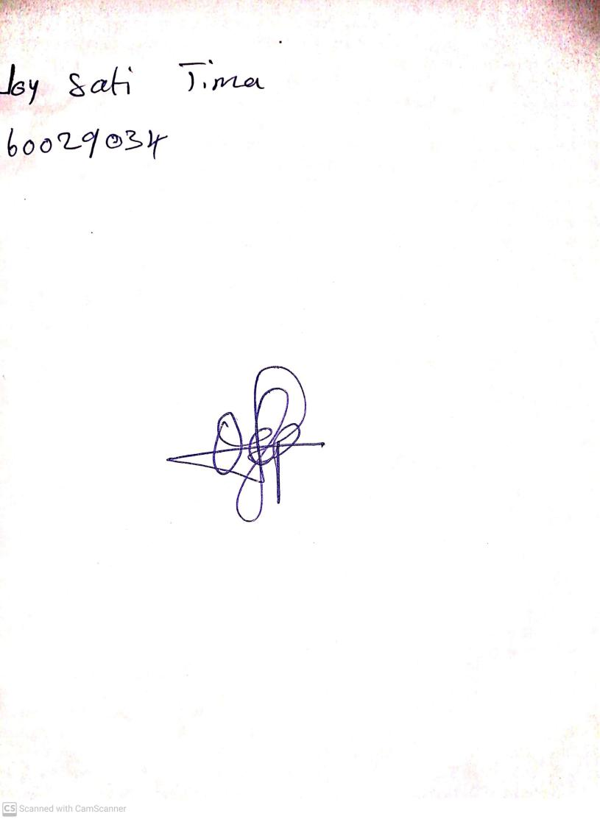

29th September, 2023

Perpetual Ojoma Ocheja

Stream Head Nursery