**LESSON PLAN AND NOTE FOR WEEK 2 ENDING 12/5/2023**

**Term 3rd term**

**Week 2nd week**

**Date 12/5/2023**

**Class Nursery one**

**Subject Nature studies**

**Topic Food**

**Sub-topic Meaning of food,naming & explaining sources of Food**

**Period 2nd period**

**Time 9:05 am**

**Duration 35 minutes**

**No in class 18**

**Average Age 3 years**

**Sex Mixed.**

**Specific Objectives: By the end of the lesson, the pupils should know how to:**

1. **Define Food**
2. **Mention food from animals.**
3. **Identify food from animals.**

**Rationale: To help the pupils have vital knowledge of Food.**

**Previous Knowledge: The pupils have knowledge of Rainbow.**

**Instructional Resources: Online Research,Chart.**

**Reference Materials: Online Research, Elementary Science by Showers Kiddies.**

**LESSON PRESENTATION**

|  |  |  |  |
| --- | --- | --- | --- |
| **Steps** | **Teacher’s Activities** | **Pupils’ Activities** | **Learning Points** |
| **Introduction** | **The teacher introduces the topic (Food) by showing the pupils pictures of some kinds of food.** | **The pupils could identify the kinds of food.** | **To arouse the interest of the pupils.** |
| **Step 1** | **The teacher starts the lesson by mentioning examples of food from plants e.g**  **Lettuce**  **Cabbage etc** | **The pupils listen attentively to the teacher and repeats after the teacher the meaning of food..** | **For proper understanding.** |
| **Step 2** | **The teacher mention the examples of food from animal e.g**  **Chicken, pork,beef etc.** | **The pupils listens to the teacher and repeats the sources of food.** | **For better understanding.** |
| **Step 3** | **The teacher leads the pupils to identify food from animals and plants.** | **The pupils identifies food from animals and plants.** | **For further understanding.** |
| **Summary** | **The teacher summarizes the lesson by defining food.** | **The pupils knows the definition of food.** | **For onward study.** |
| **Evaluation** | **Question:**  **Mention food from plants?**  **Mention food from animals?**  **Identify food from animals and plants?** | **The pupils answer the question correctly.** | **To ascertain the pupils’ understanding.** |
| **Conclusion** | **The teacher summarizes, reacts, and corrects the pupils.** | **The pupils gives answers to the teacher’s question.** | **To consolidate the lesson.** |
| **Assignment** | **Question:**  **Which food comes from animals?** | **The pupils copy and do their homework at home.** | **To encourage learning while at home.** |

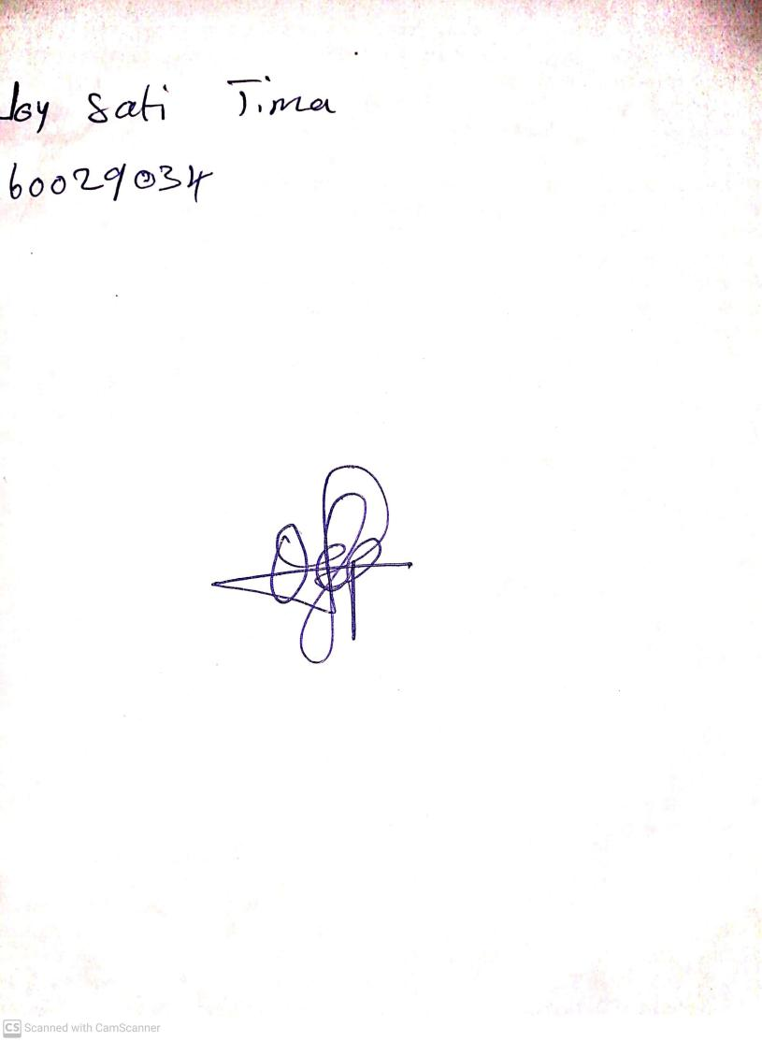

10th May, 2023

Perpetual Ojoma

Stream Head Nursery