**LESSON PLAN/NOTE FOR WEEK 8 ENDING 23/06/2023**

**Term**: 3rd

**Week**: 8

**Date**: 19/06/2023

**Class**: SS 1

**Subject**: Civic Education

**Topic**: Respect for Constituted Authority .

**Sub-Topic:** Meaning and types of constituted authority

**Period**: 3rd

**Time**: 9:30-10:10

**Duration**: 40 Minutes

**Number in class:** 8 students

**Average Age:** 14 Years

**Sex**: mixed

**Specific objectives:** By the end of the lesson, the students should be able to:

(1) Define Constituted Authority.

(11) State the types of constituted authority

**Rationale**: For the students to be able to state how people Carry out their duty according to power vested on them by the authority.

**Previous knowledge:** The students have seen the president, Governors and school principal carrying out their duty.

**Instructional material:** A chart showing cross section of national, traditional and religion leaders.

**Reference material:** Gbenga Babalola (2017) Essential civic Education for senior secondary schools.

**LESSON DEVELOPMENT**

|  |  |  |  |
| --- | --- | --- | --- |
| **Stages/Steps** | **Teacher's Activities** | **Students' Activities** | **Learning points** |
| **Introduction** | Review the previous lesson | Participate actively in the class discussion | To arouse the students interest to learn. |
| **Step 1** | Defines constituted authority as: constituted authority refers to the different forms of leadership established for the smooth running of a society. | Listen carefully to the teacher | For better understanding of the lesson. |
| **Step 11** | Asks the students to state the types of constituted authority | State the types of constituted authority as: (1) traditional (2) religious constituted authority etc. | To enable the students to reason logically. |
| **Board summary** | Summarizes the lesson as:  **Meaning of Constituted Authority**  Constituted Authority refers to the different forms of leadership established for the smooth running of a society. In every society, there are groups, associations, schools, government and business organizations that are composed of different groups of people. Each of these organizations has leaders and these leaders are referred to as constituted. For example, the constituted authority in a secondary school are the principal, the vice principal and other management staff working with the principal. A constituted authority is set up according to the rules and regulations of the society. Therefore, it is expected to be obeyed and respected by the people.  **Types** **of** **constituted** **authority**  (1) Traditional Constituted Authority  (2) Religious Constituted Authority  (3) Government Constituted Authority  (4) organizational Constituted Authority. | Copy and submit the note book for marking. | For future reference. |
| **Evaluation** | Evaluates the students as:  (1) Define Constituted Authority  (2) state 4 types of Constituted Authority | Respond to the questions | Ascertaining the attainment of the stated objectives. |
| **Conclusion** | Rounds up the lesson by marking and correcting students work. | Check and do their correction | Consolidation of the lesson. |
| **Assignment** | Gives home work as:  (1) Explain Bureaucratic type of constituted authority | Respond by doing the home work at home. | To ensure continuity of learning. |

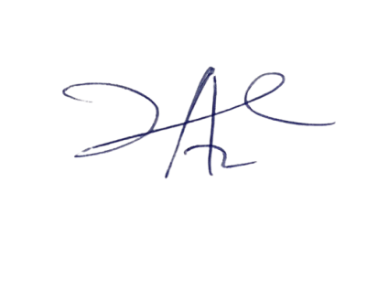

2/6/2023

Principal Head Instuctor