L**EMERALD ROYAL INTERNATIONAL SCHOOL, MPAPE ABUJA**

**LESSON PLAN AND NOTE FOR WEEK 2 ENDING 20th JANUARY, 2023**

**TERM:** SECOND TERM

**WEEK:** WEEK 2

**DATE** : 16th - 20th January 2023

**SUBJECT:** Biology

**CLASS : SS 2**

**TOPIC :**  pest and diseases of crop

**SUB - TOPIC: 1**. definition of pest

1. Classification of pest
2. Crop attack, nature of damage and prevention

**PERIOD : 7th**

**TIME :** 12: 30 - 1:00

**DURATION** : 40 minutes

**AVERAGE AGE** : 15 years

**SEX:** mixed

**LEARNING OBJECTIVES:** by the end of the lesson,the students, should be able to;

1. Define of pest
2. Classify pest
3. State the crop attack, nature of damage and prevention and control.

**RATIONALE:** the students should understand the classification of pest, nature of damage, prevention and control of pest

**PREVIOUS KNOWLEDGE:** The students have been taught natural resources.

**INSTRUCTIONAL MATERIALS:** chart showing different pests and diseases caused by pests.

**Reference Material:** Essential Biology foe Senior Secondary School by M.C. Michael.

**LESSON DEVELOPMENT**

|  |  |  |  |
| --- | --- | --- | --- |
| **STAGES** | **TEACHER’S ACTIVITIES** | **PUPILS ACTIVITIES** | **LEARNING POINT** |
| **INTRODUCTION** | The teacher introduces the lesson by asking the students to identify the different types of pests in the chart. | The students identify the different pests. | To arouse the students interest. |
| **PRESENTATION**  **STEP 1** | The teacher defines pests. | The students pay attention. | To keep them focus. |
| **STEP 2** | The teacher asks the students to classify pest. | The students classify pest. | To encourage critical thinking. |
| **STEP 3** | The teacher states the crop attack, nature of damage, prevention and control of pests. | The students were active. | To keep them focus. |
| **BOARD SUMMARY** | **PEST AND DISEASES OF CROP PLANT.**  Pest can be defined as any organism capable of causing damage to crops.  Examples are insects, monkeys, birds, man, rodents and nematodoes.  **Classification of insect pests.**  Pest can be classified based on their feeding method namely;   1. Biting and chewing insects - these are insects pest that possess strong mandible and maxillae( mouth parts) which enable them to bit and chew plant parts. Examples are termite, grasshoppers, leaf worm, arm worm, locust and beetles. 2. Boring insects - these including their larvae are capable of boring into plant parts and destroy the tissue of the plant, fruit or seeds. Examples are bean beettle, stem borers, maize weevil and rice weevils. 3. Piercing and sucking insects - these insects possess strong mouth parts called proboscis which enable them to pierce through plants and suck liquid materials from plants tissues. Examples are aphids, cotton stainer, mealy bugs, scale insects, capsides or mirids and white flies.   **EFFECT OR ECONOMIC IMPORTANTANCE OF INSECT PESTS**   1. Insect pest destroy crops in the field through their biting , chewing, boring and sucking activities. 2. They increase the cost of production during the course of controlling them. 3. They cause reduction in the viability of stored products. 4. Some pests are carriers or vectors of diseases. 5. They reduces crop yield.   **PEST, CROP ATTACKED, NATURE OF DAMAGES, PREVENTION AND CONTROL**   1. **PEST -** Stem borer   **Crop attacked-** cereals example rice, maize, guinea corn.  **Nature of damage and economic importance -**   1. Larvae bore holes into stems 2. They eat up the tissue 3. Reduce growth and yield. 4. Weaken the plants. 5. Army worm   Crop attacked - cereals  **Nature of damage and economic importance.**   1. Larvae invade and eat up leaves and stem. 2. Reduces photosynthesis 3. Retarded growth 4. It reduces yield.   **PREVENTION AND CONTROL**   1. Hand pick the pest. 2. Spray with insecticides. 3. Yam beetles   Crop attacked - tubers example yam.  **Nature of damages and economic importance**   1. Bore holes into yam tuber. 2. Reduction of yield. 3. Reduction in quality and market value.   **Prevention and control measures.**   1. **C**lean yam set with Adrin dust before planting. 2. Crop rotation 3. **APHID**   **Crop attacked -** legumes example cow-pea, beans, soya beans e.t.c  **Nature of damage and economic importance**   1. Stunted growth 2. It is a vector of diseases example Rosette, mosaic disease of cow-pea.   **Prevention and control measure**   1. Spray insecticides to kill vector. 2. Uproot and burn infected plants. 3. **Pod borer**   **Crop attacked -** legumes examples cow-pea, soya beans.  N**ature of damage and economic importance**   1. Larvae bore into the pod**.** 2. They eat up the seed. 3. They reduce yield. 4. It introduces diseases.   **Prevention and control measure**   1. Crop rotation 2. Early harvesting 3. Spray with insecticides. | The students ask questions for further clarification. | To create room for slow learners. |
| **Evaluation** | The teacher evaluates the students with the following questions:  1.Define pest.  2.List and explain the pest of crops and give at least 2 examples each.  3.State atleat 5 effect or economic importance of insect pests.  4.State the pest, crop attacked, nature of damage and economic importance, prevention and control measures of   1. . army worm 2. Stem borer 3. Yam beetle 4. Aphid 5. Pod borer | The students attempt the questions. | To ascertain their level of understanding. |
| **Conclusion** | The teacher concludes by coping the note on the board. She checks and marks the note. | The students copy the note on the board. | For future use. |
| **Assignment** | 1. State 5 importance of crops 2. State the crop attacked, economic importance, prevention and control measure of the following pest. 3. Cotton stainer 4. Birds 5. Rodents 6. monkey | The students did and submit their assignment for marking and correction. | To encourage the students to study at home. |

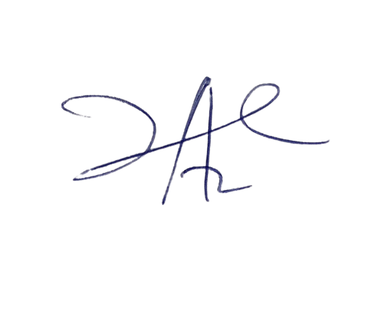

4/3/2023

Principal Head Instructor

NOTE: Do the necessary corrections as usual to avoid repetition.