**LESSON PLAN AND NOTE 1 FOR WEEK 6 ENDING 16/2/2024**

**Term 2nd term**

**Week 6th week**

**Date 12th February,2024**

**Class Nursery One**

**Subject Number Work**

**Topic Reciting days of the week**

**Sub-topic Rhyming Sunday, Monday, Tuesday**

**Period 2nd period**

**Time 9:05 am**

**Duration 35 minutes**

**No in class 15**

**Average Age 3 years**

**Sex Mixed**

**Specific Objectives: By the end of the lesson ,the pupils should be able to:**

1. **Know how many days there are in a week.**
2. **Rhyming Sunday, Monday, Tuesday.**

**Rationale: To make sure the pupils know and rhyme Sunday, Monday, Tuesday.**

**Previous Knowledge: The pupils have colour and match numbers 90-100.**

**Instructional Resources: Chart, board, marker, etc.**

**Reference Material: Online Research.**

**LESSON PRESENTATION**

|  |  |  |  |
| --- | --- | --- | --- |
| **Steps** | **Teacher’s Activities** | **Pupils’ Activities** | **Learning Points** |
| **Introduction** | **The teacher introduces the topic (Reciting days of the week) by rhyming.** | **The pupils together with the teacher rhyme the days of the week.** | **To arouse the pupils’ interest.** |
| **Step 1** | **The teacher teaches the pupils that there are seven (7) days in a week.** | **The pupils knows how many days there are in a week.** | **For proper understanding.** |
| **Step 2** | **The teacher start by rhyming Sunday, Monday, and Tuesday for the pupils.** | **The pupils participate with the teacher in rhyming Sunday, Monday, & Tuesday.** | **For better understanding.** |
| **Summary** | **The teacher summarizes the lesson by rhyming the first three days of the week (Sunday, Monday, Tuesday.)** | **The pupils have master and rhyme the first three days of the week.** | **For onward study.** |
| **Evaluation** | **Rhyme the first three days of the week you know** | **The pupils answer the question correctly.** | **To ascertain the pupils’ understanding.** |
| **Conclusion** | **The teacher summarizes, reacts and corrects the pupils.** | **The pupils gives answers to the teacher's question.** | **To consolidate the lesson.** |
| **Assignment** | **The teacher ask the pupils to:**   1. **Rhyme the first three days of the week you know?** | **The pupils copy and do their homework at home.** | **To encourage learning while at home.** |

**LESSON PLAN AND NOTE 2 FOR WEEK 6 ENDING 16/2/2024**

**Term** **2nd term**

**Week**  **6th week**

**Date** **14th February,2024**

**Class** **Nursery One**

**Subject** **Number Work**

**Topic**  **Reciting days of the week**

**Sub-topic**   **Days of the week schedules for kids.**

**Period** **2nd period**

**Time** **9:05 am**

**Duration** **35 minutes**

**No in class** **15**

**Average Age** **3 years**

**Sex** **Mixed**

**Specific Objectives: By the end of the lesson ,the pupils should be able to:**

1. **Rhyming Wednesday, Thursday, Friday, Saturday.**

**Rationale: To make sure the pupils rhyme Wednesday, Thursday, Friday, Saturday.**

**Previous Knowledge: The pupils have rhyme Sunday, Monday, Tuesday.**

**Instructional Resources: Chart, board, marker, etc.**

**Reference Material: Online Research.**

**LESSON PRESENTATION**

|  |  |  |  |
| --- | --- | --- | --- |
| **Steps** | **Teacher’s Activities** | **Pupils’ Activities** | **Learning Points** |
| **Introduction** | **The teacher introduces the topic (Reciting days of the week) by rhyming.** | **The pupils together with the teacher rhyme the days of the week.** | **To arouse the pupils’ interest.** |
| **Step 1** | **The teacher rhyme days of the week (Wednesday, Thursday, Friday, Saturday.)** | **The pupils together with the teacher rhyme days of the week (Wednesday, Thursday, Friday, Saturday).** | **For proper understanding.** |
| **Summary** | **The teacher summarizes the lesson by rhyming the days of the week (Wednesday, Thursday ,Friday, Saturday.)** | **The pupils have master the remaining days of the week.** | **For onward study.** |
| **Evaluation** | **Question:**  **Rhyme the days of the week you know** | **The pupils answer the question correctly.** | **To ascertain the pupils’ understanding.** |
| **Conclusion** | **The teacher summarizes, reacts and corrects the pupils.** | **The pupils gives answers to the teacher's question.** | **To consolidate the lesson.** |
| **Assignment** | **The teacher ask the pupils to:**   1. **Rhyme the 7 days of the week you know?** | **The pupils copy and do their homework at home?** | **To enhance learning while at home.** |

**LESSON PLAN AND NOTE 3 FOR WEEK 6 ENDING 15/2/2024**

**Term** **2nd term**

**Week** **6th  week**

**Date** **15th February,2024**

**Class** **Nursery One**

**Subject** **Number Work**

**Topic**  **Reciting days of the week.**

**Sub-topic** **Days of the week schedules for kids.**

**Period** **2nd period**

**Time** **9:50 am**

**Duration** **35 minutes**

**No in class** **15**

**Average Age** **3 years**

**Sex** **Mixed**

**Specific Objectives: By the end of the lesson ,the pupils should be able to:**

1. **What happens Sunday, Monday, Tuesday, Wednesday.**
2. **What happens Thursday, Friday, Saturday.**

**Rationale: To make sure the pupils know the days of the week schedules.**

**Previous Knowledge: The pupils have rhyme Wednesday, Thursday, Friday & Saturday.**

**Instructional Resources: Board, Chart.**

**Reference Material: Online research, Chart, Board.**

**LESSON PRESENTATION**

|  |  |  |  |
| --- | --- | --- | --- |
| **Steps** | **Teacher’s Activities** | **Pupils’ Activities** | **Learning Points** |
| **Introduction** | **The teacher introduces the topic (Reciting days of the week) by rhyming.** | **The pupils together with the teacher rhyme the days of the week.** | **To arouse the pupils’ interest.** |
| **Step 1** | **The teacher list the schedules for the days of the week below**  **SUNDAY: Christians go to church to pray.**  **MONDAY: Pupils go to school.**  **TUESDAY: Pupils go to school.**  **Wednesday: Pupils go to the school.** | **The pupils knows the schedules of Sunday-Wednesday.** | For proper understanding. |
| **Step 2** | **The teacher list the schedules for the days of the week below:**  **THURSDAY: Pupils go to school.**  **FRIDAY: Pupils go to school and the Muslims goes to pray.**  **SATURDAY: Everybody rests at home.** | **The pupils knows the schedules of Thursday- Saturday.** | For better understanding. |
| **Summary** | **The teacher summarizes the lesson by rhyming the days of the week (Sunday- Saturday.)** | **The pupils have master and rhyme the days of the week.** | For onward study. |
| **Evaluation** | **Question:**   1. **Rhyme the days of the week ?** 2. **Mention the schedules of the days of the week?** | **The pupils answer the question correctly.** | **To ascertain the pupils’ understanding.** |
| **Conclusion** | **The teacher summarizes, reacts and corrects the pupils.** | **The pupils gives answers to the teacher's question.** | **To consolidate the lesson.** |
| **Assignment** | **The teacher ask the pupils to:**   1. **Rhyme the days of the week?** 2. **Mention the schedules of the days of the week?** | **The pupils copy and do their homework at home.** | **To encourage learning while at home.** |

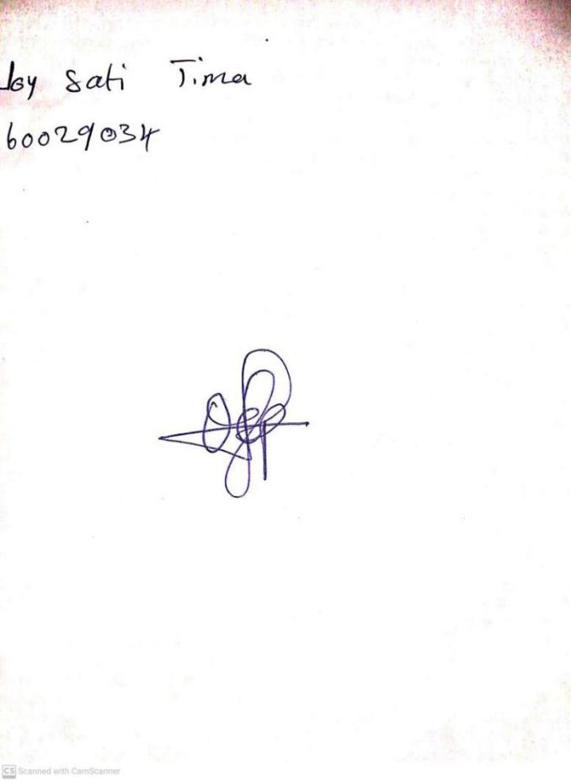

9TH February, 2024

Perpetual Ojoma Ocheja

Stream Head Nursery

**N.B THE EVALUATION SHOULD TALLY WITH THE LEARNING OBJECTIVES**

|  |  |
| --- | --- |
| **Evaluation** | **Question:**  **Count numbers: 90-100** |

**Specific Objectives: By the end of the lesson ,the pupils should be able to:**

1. **Know how many days there are in a week.**
2. **Rhyming Sunday, Monday, Tuesday.**

KINDLY DO SAME FOR THE OTHER NOTES