**LESSON PLAN FOR WEEK 6 ENDING 10th Feb. 2023**

|  |  |
| --- | --- |
| TERM | 2ND |
| WEEK | 7th |
| DATE | 10th feb. 2023 |
| CLASS | SS 1 |
| SUBJECT | History |
| TOPIC | The theory of Yoruba origin |
| SUB-TOPIC | The rise and fall of the Oyo empire |
| PERIOD | 3RD |
| PERIOD | 9;25am-9;55am |
| DURATION | 40 Minutes |
| NO IN CLASS | 2 |
| AVERAGE AGE | 14years |
| SEX | Mixed |
| SPECIFIC OBJECTIVES | By the end of the lesson, scholars should be able to:  i.Explain the rise and expansion of Oyo kingdom.  ii.State the government and administration of Oyo empire |
| RATIONALE | To acquaint scholars with the origin and growth of the Oyo kingdom. |
| PREVIOUS KNOWLEDGE | The scholars can explain some factors that led to the rise and decline of the Jukun kingdom. |
| INSTRUCTIONAL RESOURCES | Charts from textbook explaining the topic. |
| REFERENCE MATERIAL | A History of Nigeria for Schools and Colleges.  Eluwa E.T (2018) |

LESSON DEVELOPEMNT

|  |  |  |  |
| --- | --- | --- | --- |
| STEPS | TEACHER’S ACTIVITIES | SCHOLARS’ ACTIVITIES | LEARNING POINTS |
| Introduction | The teacher introduces the lesson by asking the scholars mention two factors that led to the fall of the Jukun kingdom. | The scholars mention one factors as:  i.Reign of weak rulers.  ii.Internal dissension. | To arouse scholars interest towards the topic. |
| Step 1 | The teacher explains the rise and expansion of the Oyo kingdom. | The scholars listen carefully. | To enhance proper understanding of the topic. |
| Step 2 | The teacher explains the government and administration of the Oyo kingdom. | The scholars ask relevant questions on the topic. | To encourage logical reasoning on the topic. |
| Board Summary | The teacher summarizes the lesson thus:  The Oyo was the most distinguished political achievement of the Yoruba speaking people. The Yoruba has two main tradition of origin   1. The tradition which claims that the world was created in the heart of region occupied by them at Ile Ife. 2. They also have another one which traces their origin to a wave of migration from an unspecified place in the far east. In both tradition however the position of the hero is often assigned to a mythical figure known as *ODUDUWA* whose seven children are believed to have been the founders of different Yoruba culture group.   **THE GOVERNMENT AND ADMINISTRATION OF OYO EMPIRE**   1. **The Alafin**: At the head of the imperial government was the priest monarch known as Alafin{who was more dreaded than the gods}. 2. **The Aremo**: The Aremo whose coronation was almost as elaborate as the Alafin was usually the eldest son of the reigning sovereign he exercise almost the same power with the Alafin 3. **The Oyomesi**: Apart from The Aremo there was another institution whose right and privileges the institution was Oyomesi. The Oyomesi was the watchdog of the Nation against the assumption of dictatorial power by either the Alafin or the Aremo. The leader of this group is called Bashorun | The scholars copy notes into their notebooks. | For reference purposes. |
| Evaluation | The teacher evaluates the scholars thus:   1. Explain the rise and expansion of the Oyo kingdom. 2. Explain the government and Administration of Oyo Empire | The scholars attempt the questions. | To ascertain scholars understanding of the lesson. |
| Conclusion | The teacher checks scholars notes and make corrections. | The scholars take corrections made by the teacher. | For consolidation of the topic. |
| Assignment | The teacher gives the scholars assignment:  Write briefly on the factors that limited the power of the Alafin. | The scholars copy their assignment to do it at home. | To encourage continuity of learning. |

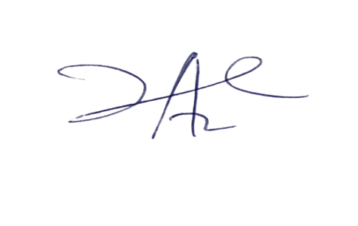

**20/3/2023**

**Principal Head Instructor**