**Lesson Plan/Notes for week 2 Ending 20/1/2023**

**Term: 2nd**

**Week:** 2 **.**

Date: 17/1/2023

**Class:** SS 2

**Subject:** civic Education

**Topic:** Intercommunal relationship

**Sub-Topic:** meaning of intercommunal relationship and basic skills.

**Period**: 6th

**Time:** 11:50-12:30

**Duration:** 40 minutes

**Number in class:** 5 students

**Sex:** mixed

**Average Age:** 14 Years

**Specific objectives:** By the end of the lesson, the students should be able to:

(1) Define intercommunal relationship

(11) State the basic skills of intercommunal relationship

**Rationale:** To be able to work together to achieve a common goal in the community.

**Previous knowledge:** The students have been working in group to achieve a goal.

**Instructional Material:** A chart showing people working together in the community.

**Reference material:** Gbenga Babalola (2017) Essential civic Education for senior Secondary schools.

**LESSON DEVELOPMENT**

|  |  |  |  |
| --- | --- | --- | --- |
| **Stages/steps** | **Teacher's Activities** | **Students' activities** | **Learning points** |
| **Introduction** | Review the previous lesson | Participate actively in the class discussion | To arouse the students interest to learn. |
| **Step 1** | Define Intercommunal relationship as: the relationship which exists between two or more communities. | Listen carefully to the teacher and give response when necessary. | For better understanding of the lesson. |
| **Step 11** | Guides the students to state the basic skills of intercommunal relationship. | State the basic skills of intercommunal relationship as: (1) The law Court (2) dialogue (3) mediation, etc. | To encourage critical thinking. |
| **Board Summary** | Summarises the lesson as:  **Meaning of intercommunal relationship**.  Intercommunal relationship is a relationship which exists between two or more communities. The aim or main objectives of any government is to bring the government close to citizens and provide a forum where local people can defend and develop their local interest thereby they can contribute to the peaceful and harmonious development of the society. A good government must respect ethnic identities and interest of all citizens. A good intercommunal relationship will work to promote peace and harmony among the communities and bring people of the various communities together.  **Basic skills Needed for resolving intercommunal conflict.**  (1) The law Court  (2) community leaders.  (3) Dialogue (4) Mediation  (5) peace keeping Force. | Copy and submit the Note book for marking. | For future reference. |
| **Evaluation** | Evaluates the lesson as:  (1) what is intercommunal relationship?  (2) state 4 basic skills in intercommunal relationship | Respond to the questions | Ascertaining the attainment of the stated objectives. |
| **Conclusion** | Rounds up the lesson by marking and correcting students work. | Check and do their correction | Consolidation of the lesson. |
| **Assignment** | Gives home work as:  (1) Explain 4 basic skills needed to resolving intercommunal relationship. | Respond by doing the home work at home. | To ensure continuity of learning. |

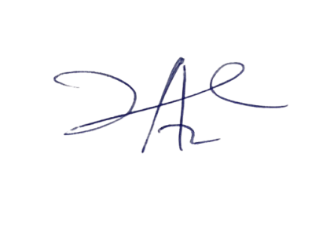

14/3/2023

Principal Head Instructor