**EMERALD ROYAL INTERNATIONAL SCHOOL MPAPE, ABUJA**

**LESSON PLAN AND NOTE FOR WEEK 3 ENDING 26/01/2024**

**TERM: 2nd**

**WEEK: 3**

**DATE: 22/01/2024**

**CLASS: Nursery 2**

**SUBJECT: Letter work**

**TOPIC: Initial consonant blend 2**

**SUB—TOPIC : Examples of initial consonant dr and wr**

**PERIOD : 3rd**

**TIME: 09:30—10:10am**

**DURATION: 40 minutes**

**NUMBER IN CLASS: 13**

**AVERAGE AGE: 5 years**

**SEX: Mixed**

**LEARNING OBJECTIVES: By the end of the lesson, the Pupils should be able to:**

**1. Mention with initial consonant “ dr”**

**2. State words with initial consonant“ wr”**

**RATIONALE: For Pupils to know how to read.**

**PREVIOUS KNOWLEDGE: Pupils have learnt initial consonant blend 1 in previous lesson.**

**INSTRUCTIONAL MATERIALS: Chart of initial consonant blends.**

**REFERENCE MATERIALS: My choice of English Language Stage 3 by J.F. OMOTAYO**

**LESSON DEVELOPMENT**

|  |  |  |  |
| --- | --- | --- | --- |
| **Steps** | **Teacher's activities** | **Pupils' activities** | **Learning point** |
| **Introduction** | **Teacher introduces the lesson by singing nursery rhymes.** | **Pupils sing the rhymes along with the teacher.** | **To arouse pupils interest.** |
| **Presentation step 1** | **Teacher mentions the examples of words with initial consonant blend “dr”and then ask Pupils to repeat after her.** | **Pupils listen to the teacher and repeat after the teacher.** | **For proper understanding.** |
| **Step 2** | **Teacher lists the examples of words with initial consonant blend “wr”and also ask Pupils to repeat after her.** | **Pupils pay attention to the teacher and also repeat after her.** | **For better understanding.** |
| **Board summary** | **Teacher summarizes the lesson by going through the lesson over again and then copy the note of lesson on the board for pupils to copy into their books.**  **WORDS WITH INITIAL CONSONANT BLEND /DR/.**  **“dr”as:**  **1. Drum**  **2. Dry**  **3. Drug**  **4. Drop**  **5. Drove**  **6. Drool**  **7. Driver**  **8. Drink**  **9. Drip**  **10. Drive**  **11. Dress**  **12. Drank etc.**  **WORDS WITH INITIAL CONSONANT BLEND /WR/.**  **“wr”as in;**  **1. Wrap**  **2. Write**  **3. Wring**  **4. Wrist**  **5. Wrinkle**  **6. Wrestle**  **7. Wrong**  **8. Written**  **9. Writing**  **10. Wristwatch**  **11. Wreck**  **12. Wrack etc.** | **Pupils listen to the teacher and copy the note into their exercise books.** | **For onward study.** |
| **Evaluation** | **Teacher evaluates the lesson by asking pupils to spell and pronounce the words on the board one after the other.** | **Pupils spell and pronounce the words on the board one after the other.** | **To assess Pupils reading ability.** |
| **Conclusion** | **Teacher concludes the lesson by marking pupils books.** | **Pupils submit their books for marking.** | **For endorsement** |
| **Assignment** | **Identify and write 10 words with initial consonant blend “fr”** | **Pupils do their assignment at home.** | **To encourage learning at home.** |

**LESSON PLAN AND NOTE FOR WEEK 3 ENDING 26/01/2024**

**TERM: 2nd**

**WEEK: 3**

**DATE: 25/01/2024**

**CLASS: Nursery 2**

**SUBJECT: Letter work**

**TOPIC: Initial consonant blend 2**

**SUB—TOPIC: words with initial consonant blend “fr”**

**PERIOD: 2nd**

**TIME: 08:50—09:30am**

**DURATION: 40 minutes**

**NUMBER IN CLASS: 13**

**AVERAGE AGE: 5 years**

**SEX: Mixed**

**LEARNING OBJECTIVES: By the end of the lesson, the Pupils should be able to:**

**1. Mention words with initial consonant blend“ fr”**

**2. Spell and pronounce the words with initial consonant blend “fr”**

**RATIONALE: For Pupils to know how to read.**

**PREVIOUS KNOWLEDGE: Pupils have learnt the examples of consonant blend dr and wr in previous lesson.**

**INSTRUCTIONAL MATERIALS: A chart of initial consonant blends.**

**REFERENCE MATERIALS: My choice of English Language Stage 3 by J.F. OMOTAYO**

**LESSON DEVELOPMENT**

|  |  |  |  |
| --- | --- | --- | --- |
| **Steps** | **Teacher's activities** | **Pupils' activities** | **Learning point** |
| **Introduction** | **Teacher introduces the lesson by asking pupils to mention words with initial consonant blend “dr” and “wr”.** | **Pupils answer the questions ask by the teacher.** | **To prepare pupils minds for the lesson ahead.** |
| **Presentation steps 1** | **Teacher mentions words with initial consonant blend “fr”to Pupils and then asks them to repeat after her.** | **Pupils pay attention to the teacher and repeat after her.** | **For proper understanding.** |
| **Step 2** | **Teacher writes the words on the board, and then spell and pronounce. And then asks Pupils to repeat after her.as;**  **Frog, fry,free, fresh, fraction, from, France, Frank etc.** | **Pupils spell and pronounce the words after the teacher** | **For better understanding.** |
| **Board summary** | **Teacher summarizes the lesson by writing the whole note of lesson on the board for pupils to copy. As;**  **Initial consonant “fr”are:**  **fr as in frog**  **fr as in front**  **fr as in from**  **fr as in fry**  **fr as in fruit**  **fr as in fresh**  **fr as in fraction**  **fr as in Frank**  **fr as in friend**  **fr as in Fred etc.** | **Pupils copy the note into their exercise books.** | **For onward study.** |
| **Evaluation** | **Teacher ask Pupils to all stand and mention the words with initial consonant blend “fr” on the board.** | **Pupils all stand and mention the words on the board.** | **To enhance Pupils participation in class.** |
| **Conclusion** | **Teacher concludes the lesson by marking pupils books.** | **Pupils submit their books for marking.** | **For endorsement.** |
| **Assignment** | **1. Write 5 words on initial consonant blend “sm”**  **2. Mention 5 words on initial consonant “sn”.** | **Pupils do their assignment at home.** | **To encourage learning at home.** |

**LESSON PLAN AND NOTE FOR WEEK 3 ENDING 26/01/2024**

**TERM: 2nd**

**WEEK: 3**

**DATE : 26/01/2024**

**CLASS: Nursery 2**

**SUBJECT: Letter work**

**TOPIC: Initial consonant blend 2**

**SUB—TOPIC: Initial consonant blend “sm” and “sn”**

**PERIOD: 3rd**

**TIME: 09:30—10:10am**

**DURATION: 40 minutes**

**NUMBER IN CLASS: 13**

**AVERAGE AGE: 5 years**

**SEX: Mixed**

**LEARNING OBJECTIVES : By the end of the lesson, the Pupils should be able to:**

**1. Mention words with initial consonant blend “sm”**

**2. States words with initial consonant blend “sn”**

**RATIONALE: For Pupils to know how to read.**

**PREVIOUS KNOWLEDGE: Pupils have learnt initial consonant blend “fr”**

**INSTRUCTIONAL MATERIALS: A chart of words with initial consonant blends.**

**REFERENCE MATERIALS: My choice of English Language Stage 3 by J.F.**

**OMOTAYO**

**LESSON DEVELOPMENT**

|  |  |  |  |
| --- | --- | --- | --- |
| **Steps** | **Teacher's activities** | **Pupils' activities** | **Learning point** |
| **Introduction** | **Teacher introduces the lesson by singing nursery rhymes.** | **Pupils sing the rhymes along with the teacher.** | **To arouse pupils interest.** |
| **Presentation step 1** | **Teacher mentions words with initial consonant blend “sm”and then ask Pupils to repeat after him or her.** | **Pupils pay attention to the teacher and repeat after her.** | **For proper understanding.** |
| **Step 2** | **Teacher States words with initial consonant blend “sn”and also ask Pupils to repeat after her.** | **Pupils listen to the teacher and also repeat after her.** | **For better understanding.** |
| **Board summary** | **Teacher writes the whole note of lesson on the board for pupils to copy into their books. That is;**  **Initial consonant blend “sm”are:**  **sm as in small**  **sm as in smart**  **sm as in smell**  **sm as in smock**  **sm as in smoke**  **sm as in smong**  **sm as in smith**  **sm as in smooth etc**  **Initial consonant blend “sn”are;**  **sn as in snack**  **sn as in snail**  **sn as in snake**  **sn as in snap**  **sn as in snapper**  **sn as in snag**  **sn as in snapshot**  **sn as in snuff**  **sn as in snatch etc.** | **Pupils copy the note into their exercise books.** | **For onward study.** |
| **Evaluation** | **Teacher asks pupils to all stand and pronounce the words on the board** | **Pupils all stand and pronounce the words on the board.** | **To enhance Pupils participation in class.** |
| **Conclusion** | **Teacher concludes the lesson by marking pupils books.** | **Pupils submit their books for marking.** | **For endorsement.** |
| **Assignment** | **1. Mention 10 words with initial consonant blend “gl ”**  **2. List 10 words with initial consonant blend “gr”** | **Pupils do their assignment at home .** | **To encourage learning at home.** |

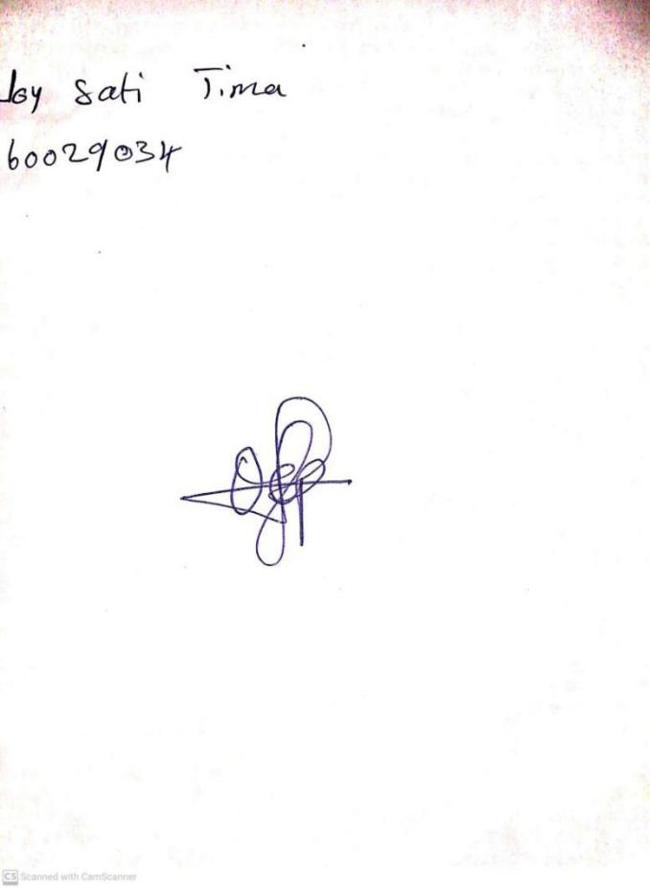

**19TH JANUARY, 2024**

**Perpetual Ojoma Ocheja**

**Stream Head Nursery**