**LESSON PLAN AND NOTE FOR WEEK 9 ENDING 21/6/2024**

**Term 3rd term**

**Week 9th week**

**Date 19th June,2024**

**Class Nursery one**

**Subject Nature studies**

**Topic Simple machines in the home.**

**Sub-topic Naming simple machines in the home.**

**Period 2nd period**

**Time 9:05 am**

**Duration 35 minutes**

**No in class 14**

**Average Age 3 years**

**Sex Mixed.**

**Specific Objectives: By the end of the lesson, the pupils should know how to:**

1. **Name the simple machines in the home**
2. **Identify the simple machines in the home**
3. **List the uses of simple machine in the home**

**Rationale: To help the pupils know the simple machines in the home.**

**Previous Knowledge: The pupils have knowledge of sources and uses of water.**

**Instructional Resources: Online Research.**

**Reference Materials: Online Research, Elementary Science by Showers Kiddies.**

**LESSON PRESENTATION**

|  |  |  |  |
| --- | --- | --- | --- |
| **Steps** | **Teacher’s Activities** | **Pupils’ Activities** | **Learning Points** |
| **Introduction** | **The teacher introduces the topic (Simple Machines ) by showing the pupils pictures of different simple machines.** | **The pupils participates in seeing the simple machines on the chart.** | **To arouse the interest of the pupils.** |
| **Step 1** | **The teacher starts the lesson by naming the simple machines in the home e.g**  **Opener**  **Rake**  **Broom**  **Spoon**  **Blender etc.** | **The pupils listen attentively to the teacher and repeats after the teacher the simple machines in the home.** | **For proper understanding.** |
| **Step 2** | **The teacher leads the pupils to identify the simple machines in the home on the chart.** | **The pupils identify the simple machines found in the home in the chart.** | **For better understanding.** |
| **Step 3** | **The teacher name the uses of simple machines in the home for the pupils**  **Broom is used for sweeping our environment.**  **Spoon is used for eating our food.**  **Blender is used for grinding our solid food to liquid form etc.** | **The pupils mention uses of simple machines in the home with the teacher.** | **For further understanding.** |
| **Summary** | **The teacher summarizes the lesson by listing more simple machines that can be found in the home.** | **The pupils lists with the teacher the simple machines in the home.** | **For onward study.** |
| **Evaluation** | **Question:**  **Name three simple machines you know?**  **Is duster a simple machine found in the home?**  **What is use of Blender?** | **The pupils answer the question correctly.** | **To ascertain the pupils’ understanding.** |
| **Conclusion** | **The teacher summarizes, reacts, and corrects the pupils.** | **The pupils gives answers to the teacher’s question.** | **To consolidate the lesson.** |
| **Assignment** | **Question:**  **Name three simple machines you know?**  **Is duster a simple machine found in the home?**  **What is use of Broom?** | **The pupils copy and do their homework at home.** | **To encourage learning while at home.** |

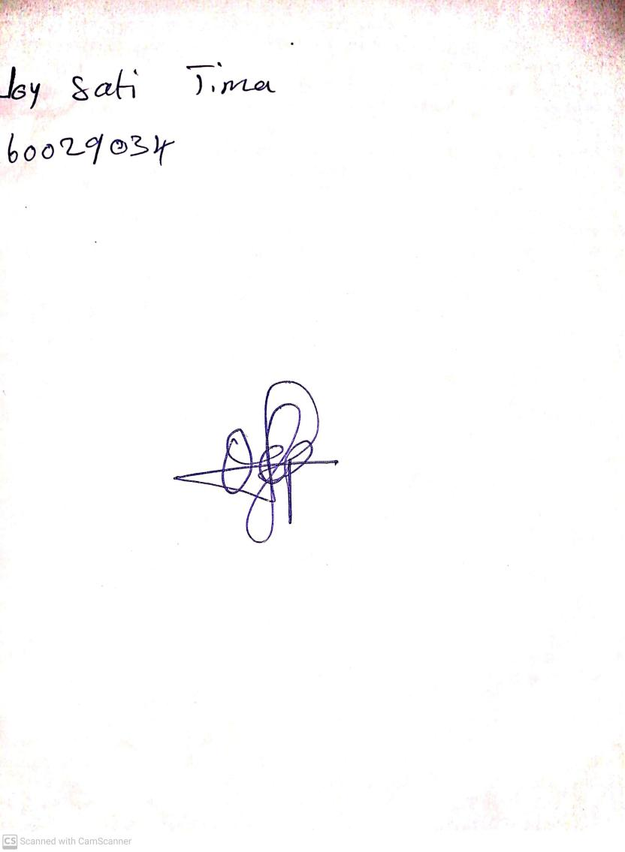

14th June, 2024

Perpetual Ojoma Ocheja

Stream Head Nursery