EMERALD ROYAL INTERNATIONAL SCHOOL

MPAPE, ABUJA.

LESSON PLAN AND NOTE FOR WEEK 8 ENDING 14TH JUNE, 2024.

TERM: Third term.

WEEK: 8th

SUBJECT: Nature studies.

TOPIC: Animals and their sounds.

SUB-TOPIC: Definition of animals and the animals sounds

DATE: 13/6/2024

DURATION: 40 minutes

TIME: 08:50-09:30

PERIOD: 3rd

CLASS: Pre-nursery

NUMBER OF PUPILS: 19

AVERAGE AGE: 2 years

SEX: Mixed

SPECIFIC OBJECTIVES: By the end of the lesson, the pupils should be able to:-

I Define an animal

2. List the animals and their sounds in a tabular form.

RATIONALE: For Pupils to know the sounds the animals in their environment makes

PREVIOUS KNOWLEDGE: Pupils have been seeing some of the animals in their environment.

INSTRUCTIONAL MATERIALS: chart of different kinds of animals.

REFERENCE: Showers kiddies books Elementary science book nursery 1 by showers kiddies books.

LESSON DEVELOPMENT

|  |  |  |  |
| --- | --- | --- | --- |
| Stages/steps | Teacher's activities | Pupils' activities | Learning points |
| Introduction | Teacher introduces the lesson by asking the pupils if they have seen a goat or a dog making sounds. After getting their responses , the teacher introduces the lesson as "Animals and their sounds". | Pupils listen to the teacher and answer the teacher's question and pay attention as she introduces the lesson | To arouse the interest of the pupils. |
| Presentation  Step 1 | Teacher defines animals to the pupils as:  Animals are living things that need food and water to live."  "Teacher asks the pupils to repeat after the teacher. | Pupils listen to the teacher and repeat after the teacher. | For better understanding of the lesson. |
| Step 2 | Teacher lists the animals and their sounds.   |  |  | | --- | --- | | Animals | Sounds | | Dog | Bark | | Goat | Bleat | | Snake | Hiss | | Cat | Meow | | Cow | Moo | | Lion | Roar | | Cock | Crow | | Elephant | Trumpet |   Teacher also demonstrate how some of the above mentioned animals makes their sounds. | Pupils listen to the teacher and also demonstrate how those animals makes their sounds. | For active classroom participation . |
| Summary | Teacher summarizes the lesson by going over the lesson again to define animals and the sounds some of the animals makes for more understanding. | Pupils listen attentively to the teacher as she is going over the lesson. | To ensure better understanding. |
| Evaluation | Teacher asks the Pupils :-   1. What are animals? 2. The dog_____ 3. The cat______ | Pupils answer the teacher's questions correctly. | To ascertain the level of pupils understanding of the lesson. |
| Conclusion | Teacher concludes the lesson by singing a nursery rhyme for the pupils.  Mac Donald had a farm eeeyya eeeyya ooo  And on his farm he had a dog eeeyya eeeyya ooo  With the bark bark here  Bark bark there  Here bark ,there bark , everywhere bark bark....... | Pupils sing along with the teacher and demonstrate it. | For onwards learning. |
| Assignment | Teacher encourages the pupils to watch the dogs or goats around their environment to know the sounds they make at home. | Pupils do the assignment at home. | To encourage Learning at home. |

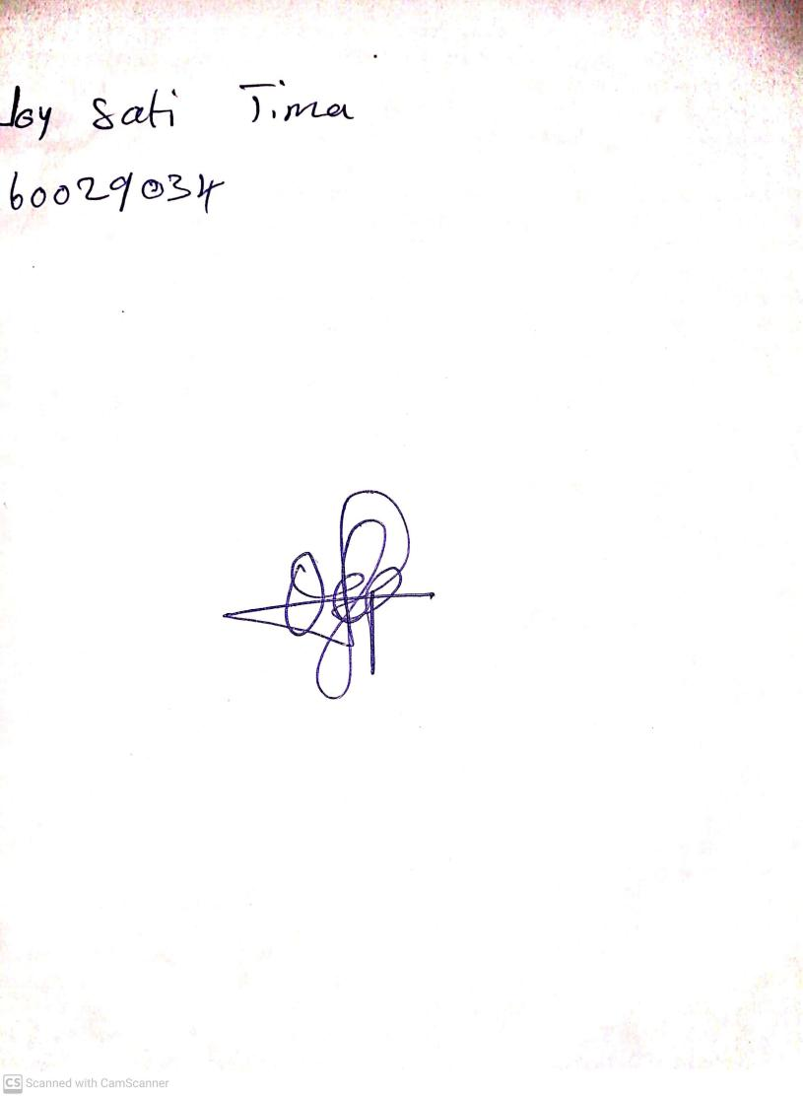

**7th June, 2024**

**Perpetual Ojoma Ocheja**

**Stream Head Nursery**