LESSON PLAN FOR WEEK 6 ENDING 17TH FEBRUARY, 2023

|  |  |
| --- | --- |
| TERM | 2ND |
| WEEK | 6 |
| DATE | 13TH February -17th February,2023 |
| CLASS | SS 1 |
| SUBJECT | Government |
| TOPIC | Separation of Powers |
| SUB-TOPIC | Merits and Demerits |
| PERIOD | 1st |
| TIME | 8:10-8:50 |
| DURATION | 40 Minutes |
| NO IN CLASS | 2 |
| AVERAGE AGE | 15years |
| SEX | Mixed |
| SPECIFIC OBJECTIVES | By the end of the lesson, scholars should be able to:  i.Define Separation of powers.  ii.List the merits and demerits of separation of powers. |
| RATIONALE | To acquaint the scholars with the meaning, merits and demerits of separation of powers. |
| PREVIOUS KNOWLEDGE | The scholars can mention the factors that safeguard the liberty of individuals. |
| INSTRUCTIONAL RESOURCES | Charts from textbook explaining the topic. |
| REFERENCE MATERIAL | Essential Government for Senior Secondary Schools.  Debbie C. Chris(2017) |

LESSON DEVELOPMENT

|  |  |  |  |
| --- | --- | --- | --- |
| STEPS | TEACHER’S ACTIVITIES | SCHOLARS’ ACTIVITIES | LEARNING POINTS |
| Introduction | The teacher introduces the lesson by asking the scholars to mention two factors that safeguard the liberty of individuals. | The scholars mention them as:   1. The Law. 2. Democracy. | To arouse scholar’s interest towards the topic. |
| Step 1 | The teacher explains the meaning of separation of powers. | The scholars listen carefully. | To ensure proper understanding of the topic. |
| Step 2 | The teacher lists the meris and demerits of separation of powers. | The scholars ask questions on the topic. | To make room for logical reasoning on the topic. |
| Board summary | The teacher summarizes the lesson thus:  **Separation of Powers**  It is defined as the separation or division of political powers and functions among the three arms of government-the executive, legislature and judiciary. Each body should be constituted and be involved only in the administration of that department. For example, the executive should be solely involved in policy making and implementation. Liberal writers believe that power is dangerous and argue that it is normally bad for men to enjoy an excessive amount of it. Lord Acton declared in one of his writings that “Power corrupts, but absolute power corrupts absolutely” .  **Merits of Separation of Power**  1.Freedom and Liberty: The freedom and liberty of individuals are safeguarded, since the constitution has these rights and courts are independent to protect them.  2.Excesses of Performance: This is removed on the part of the groups exercising the functions.  3.Checks and balances: This produces a proper coordination of functions since each organ acts as a check on the other.  4.It is democratic: Separation of powers is an essential attribute of modern political system. It is democratic.  **Demerits of Separation of Powers**  1.Factor of rigidity: A rigid application of the principle of separation of powers can hinder the smooth running of government.  2.Checks and balances: This can bring about the inability of government to take prompt and quick decisions on matters that needed urgent attention.  3.Abuse of power: The possibility of separation of powers, checking the abuse of power and violation of rights of citizens, cannot be achieved.  4.It can delay and affect performance: Checks and balances can delay and affect each arms performance in the decision-making process. | The scholars copy notes into their notebooks. | For reference purposes. |
| Evaluation | The teacher evaluates the scholars thus:  i.Define separation of powers  ii.List two merits and demerits of separation of powers. | The scholars attempt the questions. | To ascertain the level of understanding of the lesson. |
| Conclusion | The teacher check scholars notes and make corrections. | The scholars take corrections made by the teacher. | For consolidation of the lesson. |
| Assignment | The teacher gives the scholars assignment:  State five importance of the separation of powers in a democratic system. | The scholars copy their assignment to do it at home. | To encourage continuity of learning. |

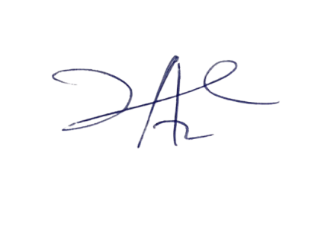

28/3/2023

Principal Head Instructor