**LESSON PLAN AND NOTE 1 FOR WEEK 10 ENDING 15/3/2024**

**Term 2nd term**

**Week 10th week**

**Date 11th March,2024**

**Class Nursery one**

**Subject Number work**

**Topic Learning & writing figures 1-10 in words.**

**Sub-topic Learning figure 6-8 in words**

**Period 2nd period**

**Time 9:05 am**

**Duration 35 minutes**

**No in class 15**

**Average Age 3 years**

**Sex Mixed**

**Specific Objectives: By the end of the lesson the pupils should be able to;**

1. **Spell figure 6-8 in words**
2. **Identify figures 6-8 in words**

**Rationale: To make sure the pupils spell & identify figures 6-8 in words**

**Previous knowledge: The pupils can spell in figure 4-5 in words.**

**Instructional Resources: Numbers in words chart.**

**Reference Materials: Online Research,chart,board.**

**LESSON PRESENTATION**

|  |  |  |  |
| --- | --- | --- | --- |
| **Steps** | **Teacher’s Activities** | **Pupils’ Activities** | **Learning Points** |
| **Introduction** | **The teacher introduces the topic [Learning & writing figures 1-10 in words] to the pupils.** | **The pupils listen attentively to the teacher.** | **To arouse the interest of the pupils.** |
| **Step 1** | **The teacher writes on the board the figures 6-8 in words and guides the pupils to spell**  **S-I-X S-E-V-E-N**  **E-I-G-H-T** | **The pupils spell the figures 6-8 in words as the teacher guides them.** | **For proper understanding.** |
| **Step 2** | **The teacher leads the pupils to identify the figures 6-8 in words**  **SIX SEVEN**  **EIGHT** | **The pupils identify the figures 6-8 in words.** | **For better understanding.** |
| **Summary** | **The teacher summarizes the lesson by spelling figures 6-8 in words.** | **The pupils can spell figures 6-8 in words.** | **For onward study.** |
| **Evaluation** | **Question: spell figure ‘7’ in words.** | **The pupils answer the question correctly.** | **To ascertain the pupils understanding.** |
| **Conclusion** | **The teacher summarizes, reacts, and corrects the pupils.** | **The pupils gives answers to the teacher.** | **To consolidate the lesson.** |
| **Assignment** | **Write the following figures in words**  **1 _____________**  **2 _____________**  **3 _____________** | **The pupils copy and do their homework at home.** | **To encourage learning while at home.** |

**LESSON PLAN AND NOTE 2 FOR WEEK 10 ENDING 15/3/2024**

**Term 2nd term**

**Week 10th week**

**Date 13th March,2024**

**Class Nursery one**

**Subject Number work**

**Topic Learning & writing figures 1-10 in words.**

**Sub-topic Learning figure 9-10 in words**

**Period 2nd period**

**Time 9:35 am**

**Duration 35 minutes**

**No in class 15**

**Average Age 3 years**

**Sex Mixed**

**Specific Objectives: By the end of the lesson the pupils should be able to;**

1. **Spell figure 9-10 in words**
2. **Identify figures 9-10 in words**

**Rationale: To make sure the pupils spell & identify figures 9-10 in words**

**Previous knowledge: The pupils can spell and identify figures 6-8 in words.**

**Instructional Resources: Numbers in words chart.**

**Reference Materials: Online Research,chart,board.**

**LESSON PRESENTATION**

|  |  |  |  |
| --- | --- | --- | --- |
| **Steps** | **Teacher’s Activities** | **Pupils’ Activities** | **Learning Points** |
| **Introduction** | **The teacher introduces the topic [Learning & writing figures 1-10 in words] to the pupils.** | **The pupils listen attentively to the teacher.** | **To arouse the interest of the pupils.** |
| **Step 1** | **The teacher writes on the board the figures 9-10 in words and guides the pupils to spell**  **N-I-N-E T-E-N** | **The pupils spell the figures 9-10 in words as the teacher guides them.** | **For proper understanding.** |
| **Step 2** | **The teacher leads the pupils to identify the figures 9-10 in words**  **NINE TEN** | **The pupils identify the figures 9-10 in words.** | **For better understanding.** |
| **Summary** | **The teacher summarizes the lesson by spelling figures 9-10 in words.** | **The pupils can spell figures 9-10 in words.** | **For onward study.** |
| **Evaluation** | **Question: spell figure ‘9’ in words.** | **The pupils answer the question correctly.** | **To ascertain the pupils understanding.** |
| **Conclusion** | **The teacher summarizes, reacts, and corrects the pupils.** | **The pupils gives answers to the teacher.** | **To consolidate the lesson.** |
| **Assignment** | **Write the following figures in words**  **9 ___________**  **10 ___________** | **The pupils copy and do their homework at home.** | **To encourage learning while at home.** |

**LESSON PLAN AND NOTE 3 FOR WEEK 10 ENDING 15/3/2024**

**Term 2nd term**

**Week 10th week**

**Date 15th March,2024**

**Class Nursery one**

**Subject Number work**

**Topic Learning & writing figures 1-10 in words.**

**Sub-topic Writing and Matching figures 6-10 in words**

**Period 2nd period**

**Time 9:50 am**

**Duration 35 minutes**

**No in class 15**

**Average Age 3 years**

**Sex Mixed**

**Specific Objectives: By the end of the lesson the pupils should be able to;**

1. **Write figure 6-10 in words**
2. **Match figures 6-10 in words**

**Rationale: To make sure the pupils write and match figures 6-10 in words**

**Previous knowledge: The pupils can spell and identify figures 9-10 in words.**

**Instructional Resources: Numbers in words chart.**

**Reference Materials: Online Research,chart,board.**

**LESSON PRESENTATION**

|  |  |  |  |
| --- | --- | --- | --- |
| **Steps** | **Teacher’s Activities** | **Pupils’ Activities** | **Learning Points** |
| **Introduction** | **The teacher introduces the topic [Learning & writing figures 1-10 in words] to the pupils.** | **The pupils listen attentively to the teacher.** | **To arouse the interest of the pupils.** |
| **Step 1** | **The teacher writes inside their notebooks the figures 6-10 for the pupils to write in words**  **6 ___________**  **7 ___________**  **8 ___________**  **9 ___________**  **10 ___________** | **The pupils write the figures 6-10 in words inside their notebooks.** | **For proper understanding.** |
| **Step 2** | **The teacher leads the pupils to match the figures 6-10 to their words**  **NINE EIGHT**  **SIX TEN**  **EIGHT SEVEN**  **TEN NINE**  **SEVEN SIX** | **The pupils match the figures 6-10 to their words.**  NINE **EIGHT**  SIX **TEN**  EIGHT **SEVEN**  **TEN NINE**  **SEVEN SIX** | **For better understanding.** |
| **Summary** | **The teacher summarizes the lesson by spelling figures 6-10 in words.** | **The pupils can spell figures 6-10 in words.** | **For onward study.** |
| **Evaluation** | **Question: spell figure ‘10’,’7’, ‘8’ in words.** | **The pupils answer the question correctly.** | **To ascertain the pupils understanding.** |
| **Conclusion** | **The teacher summarizes, reacts, and corrects the pupils.** | **The pupils gives answers to the teacher.** | **To consolidate the lesson.** |
| **Assignment** | **Match the following figures 6-10 to their words**  **NINE EIGHT**  **SIX TEN**  **EIGHT SEVEN**  **TEN NINE**  **SEVEN SIX**  **Write the following figure 6-10 in words**  **6 ___________**  **7 ___________**  **8 ___________**  **9 ___________**  **10 ___________** | **The pupils copy and do their homework at home.** | **To encourage learning while at home.** |

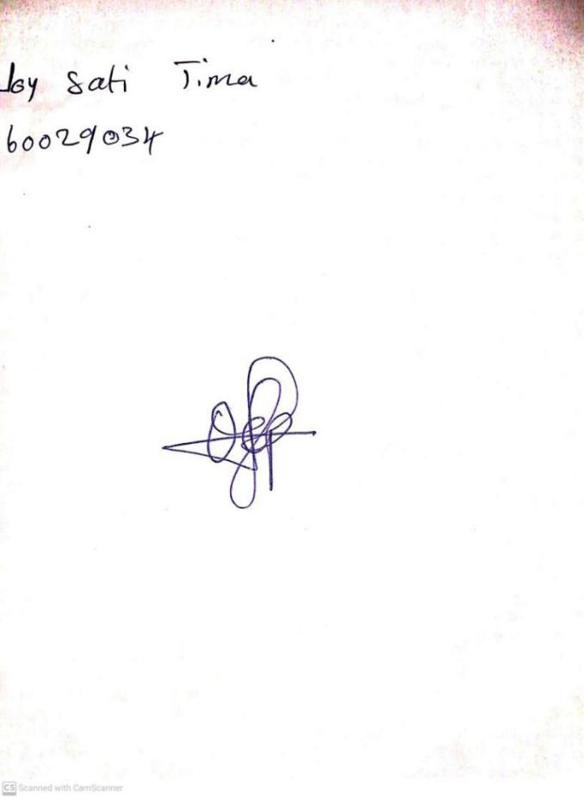

8TH March, 2024

Perpetual Ojoma Ocheja

Stream Head Nursery

**N.B THE EVALUATION SHOULD TALLY WITH THE LEARNING OBJECTIVES**

|  |  |
| --- | --- |
| **Evaluation** | **Question:**  **Question: spell figure ‘10’,’7’, ‘8’ in words.** |

**Specific Objectives: By the end of the lesson ,the pupils should be able to:**

1. **Write figure 6-10 in words**
2. **Match figures 6-10 in words**

KINDLY DO SAME FOR THE OTHER NOTES