**SCHEME OF WORK**

**NUMBER WORK PRE - NURSERY**

Week 1: Counting numbers 1 -25 and copying numbers 3&4 - 1 counting and identification of numbers 1 - 25, copying numbers 3 & 4.

Week 2: Counting numbers 1 - 30. - 1 counting identification of numbers 1 - 130 and matching patterns 1 - 4.

Week 3: Counting numbers 1 - 30. - 1 counting and identification of numbers 1 - 30 and tracing numbers 5 & 6.

Week 4 Counting numbers 1 - 35. - 1 counting and identification of numbers 1 - 35 and copying numbers 5 & 6.

Week5 Counting numbers 1 - 35. - 1 counting numbers 1 - 35, identification of numbers 1 - 35 and tracing numbers 7 & 8.

Week 6 Counting numbers 1 - 40. - counting numbers 1 - 40 , identification of numbers 1 - 40, copying numbers 5 & 6.

Week 7 Counting numbers 1- 40 .- counting and identification of numbers 1 - 40 and tracing numbers 9 & 10.

Week8 Counting numbers 1- 45 - counting numbers 1- 45 , identification of numbers 1 - 45.

Week9 Shapes, Counting numbers 1 - 45 - identification of common shapes -counting and identification of numbers 1 - 45.

Week10 Counting numbers 1 - 50 . - counting objects 1 - 50 -identification of numbers 1 - 50.

Week11 Counting numbers 1 -50, writing numbers 1 -50 -counting numbers and identification of numbers 1 - 50 -writing numbers 1 - 50.

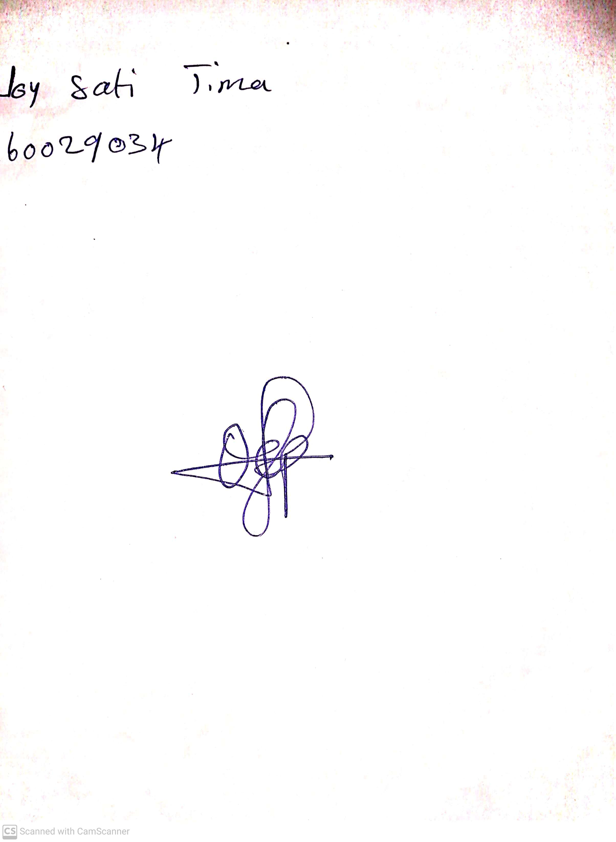

28th May, 2023

Perpetual Ojoma

Stream Head Nursery