**EMERALD ROYAL INTERNATIONAL SCHOOL MPAPE, ABUJA.**

**LESSON PLAN AND NOTE FOR WEEK 3 ENDING 10/05/2024**

**TERM: 3rd**

**WEEK: 3rd**

**DATE: 06/05/2024**

**CLASS: Nursery 2**

**SUBJECT: Social norms**

**TOPIC: Violence (physical).**

**SUB—TOPIC: Meaning, harmful effect and examples.**

**PERIOD: 2nd period after long break**

**TIME: 11:20—12: 00pm**

**DURATION: 40 minutes**

**NUMBER IN CLASS: 13**

**AVERAGE AGE: 5 years**

**SEX: Mixed**

**LEARNING OBJECTIVES: By the end of the lesson, the Pupils should be able to:**

**1. Explain the meaning of physical violence.**

**2. State the examples of physical violence.**

**3. Mention the effect of physical violence.**

**RATIONALE: For pupils to have the awareness of violence**

**PREVIOUS KNOWLEDGE: Pupils have learnt Parental care in previous lesson**

**INSTRUCTIONAL MATERIALS: Pictures of people who have fall victim of physical violence.**

**REFERENCE MATERIALS: Google. com**

**LESSON DEVELOPMENT**

|  |  |  |  |
| --- | --- | --- | --- |
| **Steps** | **Teacher's activities** | **Pupils' activities** | **Learning point** |
| **Introduction** | **Teacher review the previous lesson.** | **Pupils pay attention to the teacher.** | **To prepare pupils minds for the lesson ahead.** |
| **Presentation step 1** | **Teacher explains the meaning of physical violence to pupils and then asks them to repeat after her.** | **Pupils pay attention to the teacher and repeat after her.** | **For proper understanding.** |
| **Step 2** | **Teacher states the examples.of.physical violence to pupils and also asks them to repeat after her.** | **Pupils listen to the teacher and repeat after her.** | **For better understanding.** |
| **Step 3** | **Teacher mentions the effect of physical violence to pupils .** | **Pupils listen attentively to the teacher.** | **To enhance Pupils listening skills.** |
| **Board summary** | **Teacher summarizes the lesson by writing the whole note of lesson on the board for pupils to copy into their books. That is;**  **Violence (physical)**  **Physical violence is simply the use of physical force so as to injured, abuse,damage, or destroy. Physical violence occurs when a person close to the child deliberately commit an act that results in a physical injury to the child.**  **Examples of physical violence are:**  **1. Beating**  **2. Burning**  **3. Kicking**  **4. Punching**  **5. Biting**  **6. Maiming or killing**  **7. The use of objects or weapons.**  **Effect of physical violence.**  **1. Heart problems**  **2. High blood pressure**  **3. Digestive problems etc.** | **Pupils copy the note into their exercise books.** | **For onward study.** |
| **Evaluation** | **Teacher evaluates the lesson by asking pupils the following questions:**  **1. What is Physical violence?**  **2. State the examples of physical violence.**  **3. Mention the effects of physical violence..** | **Pupils answer the questions asked by the teacher.** | **To assess pupils level of understanding.** |
| **Conclusion** | **Teacher concludes the lesson by marking pupils books.** | **Pupils submit their books for marking..** | **For endorsement.** |
| **Assignment** | **Answer the following questions:**  **1. What is mental violence?**  **2. State the examples of mental violence.**  **3. Mention the effects of mental violence.** | **Pupils do their assignment at home.** | **To encourage learning at home.** |

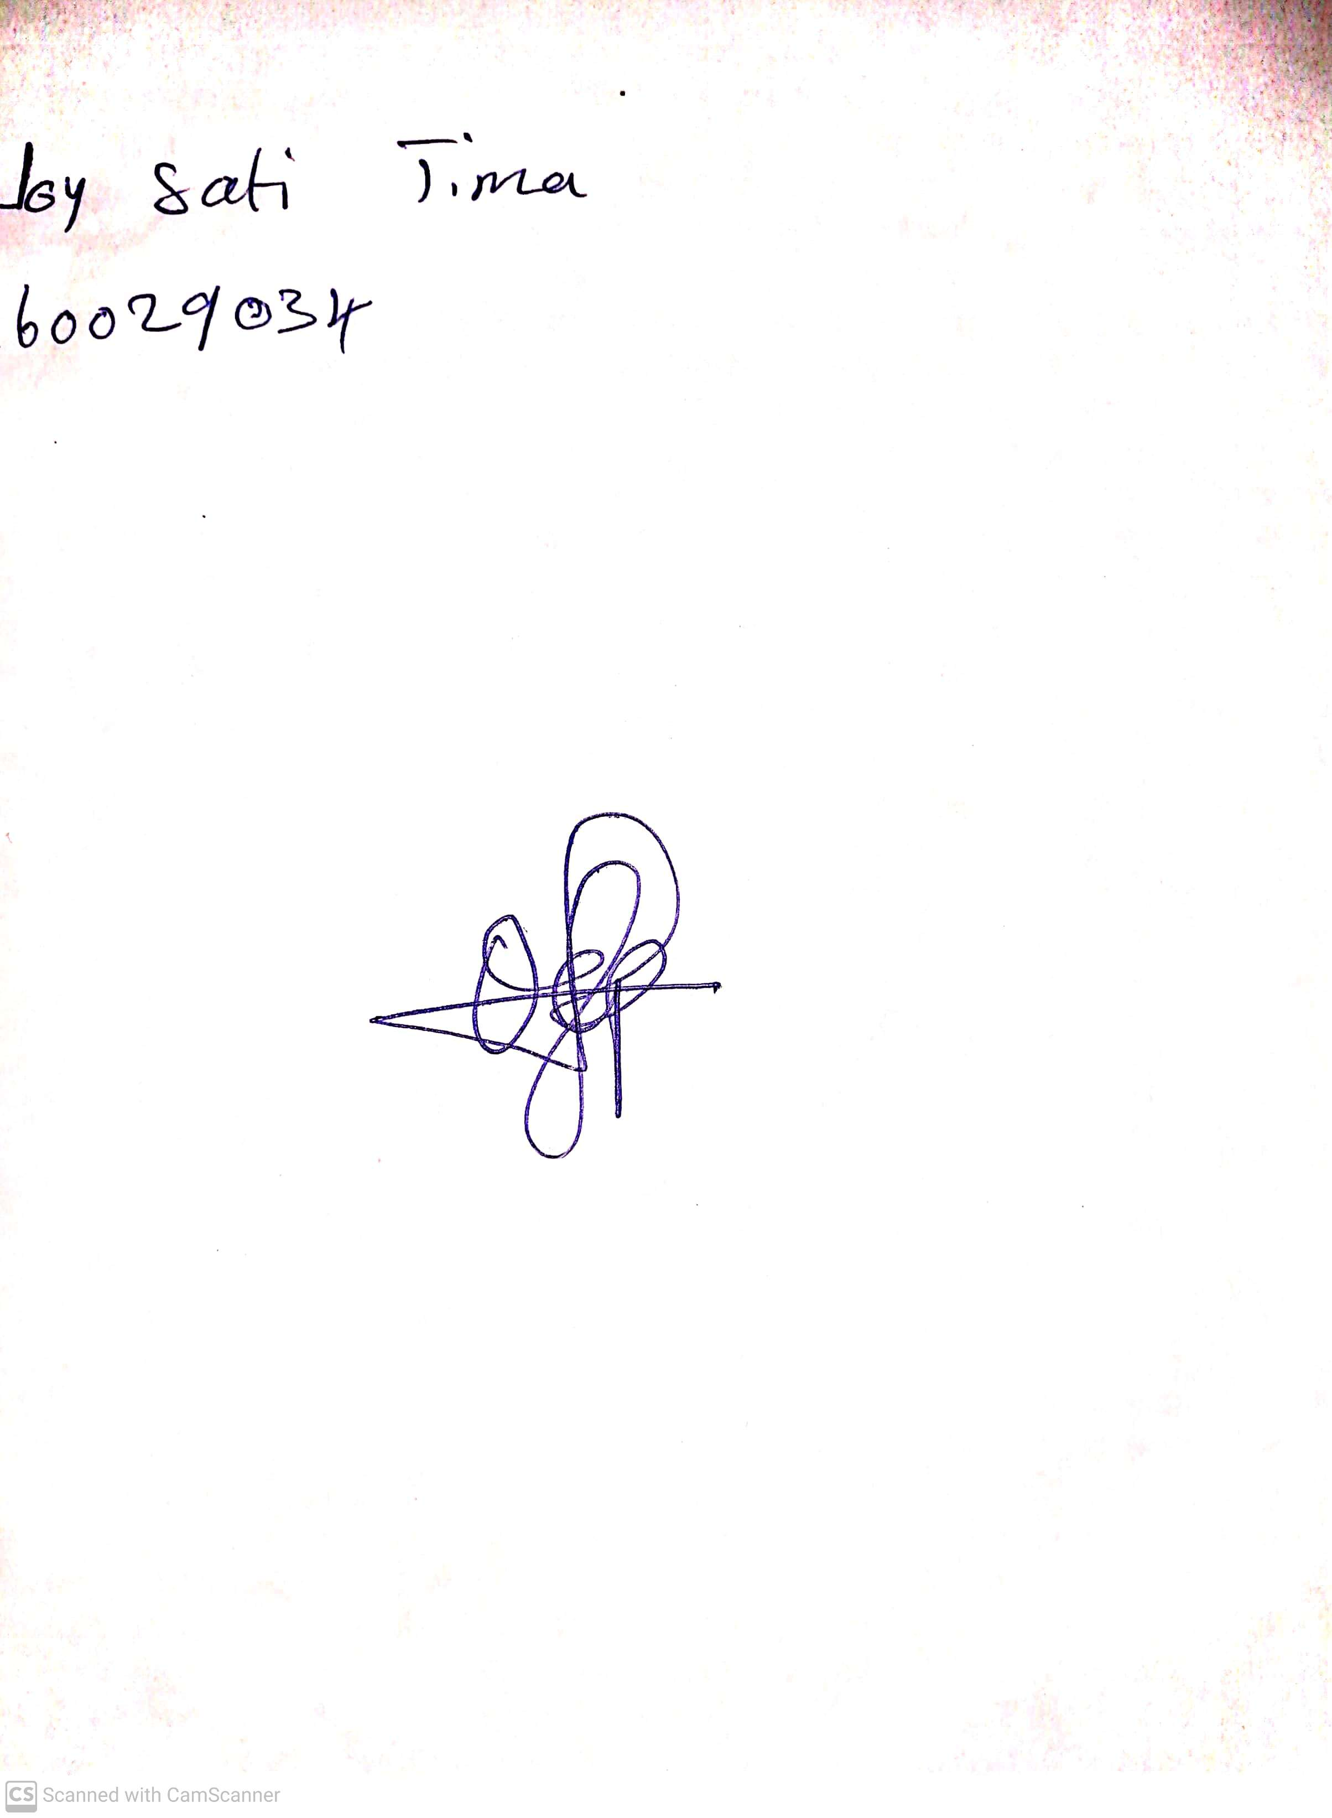

**3rd May, 2024**

**Perpetual Ojoma Ocheja**

**Stream Head Nursery**