**EMERALD ROYAL INTERNATIONAL SCHOOL**

**MPAPE, ABUJA.**

**LESSON PLAN AND NOTE FOR WEEK 4 ENDING 6TH OCTOBER,2023**

TERM : First term.

WEEK : 4

SUBJECT: Social Norms

TOPIC: Members of the family.

SUB-TOPIC: Identifying daddy and mummy.

DATE: 27/8/2023

DURATION: 40 minutes

TIME: 10:40-11:20

PERIOD: 5th

CLASS: pre-nursery

NUMBER OF PUPILS: 10

AVERAGE AGE: 2

SEX: Mixed

SPECIFIC OBJECTIVES: By the end of the lesson, the pupils should be able to:-

1. Identify daddy in the picture and what daddy does in the family.

2. Identify mummy in the picture and what mummy does in the family.

RATIONALE: For pupils to know the members of the family.

PREVIOUS KNOWLEDGE: Pupils came from a family that comprises father, and mother .

INSTRUCTIONAL MATERIALS: chart and picture book.

REFERENCE: Smart start Civic education for nursery Schools book 1 by T.Y. Alabi and A. M. Solu.

LESSON DEVELOPMENT

|  |  |  |  |
| --- | --- | --- | --- |
| Stages/steps | Teacher's activities | Pupils' activities | Learning points |
| Introduction | Teacher introduces the lesson by singing nursery rhymes for the pupils as:-  Daddy daddy daddy  Mummy mummy mummy  Mummy is good and  Daddy is great  If not for them I will not be in school  When I grow up  I will take care of them. | Pupils attempt to sing the rhymes along with the teacher. | To get pupils attention for the lesson. |
| Presentation  Step 1 | Teacher shows the pupils a family picture and points at daddy in the picture for the pupils. Teacher also asks the pupils one after another to point at daddy on the chart. Teacher also explains to the pupils the duties of daddy in the family . | Pupils pay attention to the teacher as she shows them daddy on the chart. Pupils take turns to point at daddy on the chart. Pupils repeat after the teacher to say mention the duties of daddy in the family as:-   1. Daddy provide for the family. 2. Daddy pay our school fees. | To improve better understanding. |
| Step 2 | Teacher shows the pupils mummy in the picture book and asks them one after another to point at mummy. Teacher also tells the pupils the duties of mummy in the family. | Pupils point at mummy in the picture book and say "mummy" repeatedly. Pupils also pay attention to the teacher and repeat after the her to mention the duties of mummy in the family as:-   1. Mummy cooks food for the family. 2. Mummy buys clothes for the family. 3. Mummy baths us. | For better understanding of the lesson. |
| Summary | Teacher summarizes the lesson by emphasizing on the topic again for more clarification and better understanding of the lesson. | Pupils pay attention to the teacher's explanation. | To ensure better understanding of the lesson. |
| Evaluation | Teacher asks the pupils to:-   1. Identify daddy in the picture. 2. Mention the duties of mummy in the family. | Pupils answer the teacher's question correctly. | To assess pupils level of understanding of the lesson. |
| Conclusion | Teacher ends the lesson by singing a nursery rhyme that was sang at the introduction of the lesson. | Pupils sing the rhyme along with the teacher. | To consolidate the lesson. |

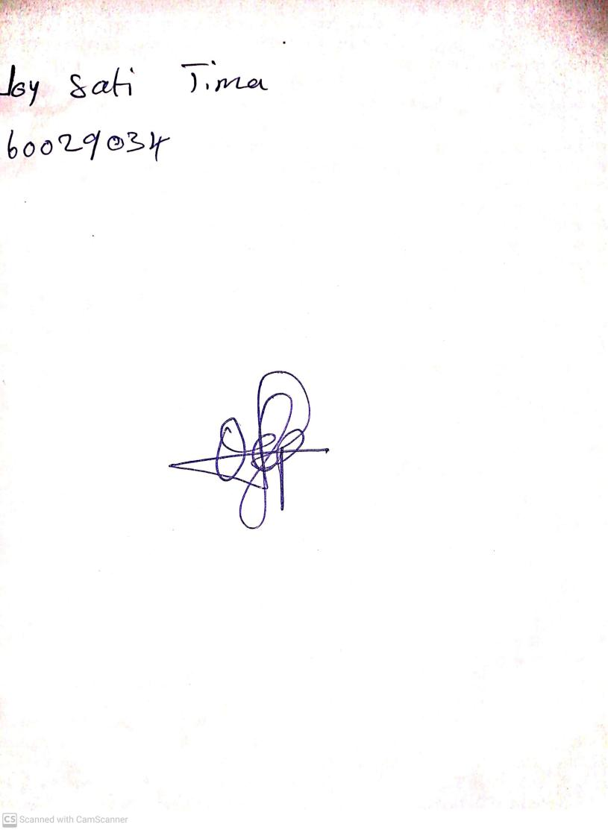

25th August, 2023

Perpetual Ojoma Ocheja

Stream Head Nursery