**EMERALD ROYAL INTERNATIONAL SCHOOL MPAPE, ABUJA**

**NURSERY 2 (TWO) SCHEME OF WORK**

**1ST TERM**

**BASIC SCIENCE AND TECHNOLOGY**

|  |  |  |
| --- | --- | --- |
| **WEEKS** | **TOPICS** | **CONTENT/ACTIVITIES** |
| **1** | **First aid: First aid box** | **- Meaning of first aid**  **-Mention some first aid box/kit contents. E.g bandage, wool, scissors, plaster. etc** |
| **2** | **First aid: Uses** | **-Discuss uses of the content of the first aid, demonstrate the use of the items.** |
| **3** | **My body: Parts** | **- Head, nose, etc.**  **-Explain why we care for our body.** |
| **4** | **Body care for cuts.** | **- Stop the blood, wash etc** |
| **5** | **Body care for wounds** | **- Meaning of wounds, first aid treatment on wounds in the body e.g rest head on soft pillow etc.** |
| **6** | **Living things** | **Identify and discuss the characteristics of living things.** |
| **7** | **Non-living things** | **-Identify and discuss the characteristics of non - living things.** |
| **8** | **Body care on sickness** | **Explain meaning of sickness, example, fever, steps to take for recovery: visit the doctor, eat and drink, take medication, sleep.** |
| **9** | **Food** | **-meaning, types, use of food in our body.** |
| **10** | **Garden tools** | **- meaning of garden tools.**  **-examples- rake, cutlass, hoe, shovel, wheelbarrow etc.** |
| **11-12** | **Revision** |  |
| **13-14** | **Examination** |  |

**EMERALD ROYAL INTERNATIONAL SCHOOL MPAPE, ABUJA**

**NURSERY 2 (TWO) SCHEME OF WORK**

**2ND TERM**

**BASIC SCIENCE AND TECHNOLOGY**

|  |  |  |
| --- | --- | --- |
| **WEEKS** | **TOPICS** | **CONTENT/ACTIVITIES** |
| **1** | **Food: table manners** | **- meaning of table manners, examples.** |
| **2** | **Living and non-living things** | **Things that living things can do.**  **Things that non-living things cannot do.** |
| **3** | **Animals (types of animals).** | **Classify animals as; (i) mammals, (ii) fishes (iii) birds (iv) insects (v) reptiles.** |
| **4** | **Domestic animal: Dog** | 1. **Features of a dog (ii) dog house, baby and food.** |
| **5** | **Insects** | **- insects are living things.**  **-they crawl or fly. E.g ant, cockroach, housefly, mosquito, butterfly, bee etc.** |
| **6** | **Care of nose** | **- identify nose on the body.**  **-uses of nose and first aid treatment for nose bleeds** |
| **7** | **Bones** | **-meaning of bones, use of bones in our body.** |
| **8** | **Purification of water** | **Example boiling and filtration, adding alum.** |
| **9** | **Things that float on water.** | **Explain, examples** |
| **10** | **Things that sink in water** | **Explain , examples** |
| **11** | **Water transport** | **Explain water as one of the means of transportation, some vehicles e.g canoe, boat, ship etc.** |
| **12-13** | **Revision** |  |
| **14** | **Examination** |  |

**EMERALD ROYAL INTERNATIONAL SCHOOL MPAPE, ABUJA**

**NURSERY 2 (TWO) SCHEME OF WORK**

**3RD TERM**

**BASIC SCIENCE AND TECHNOLOGY**

|  |  |  |
| --- | --- | --- |
| **WEEKS** | **TOPICS** | **CONTENT/ACTIVITIES** |
| **1** | **Sources of water** | **-Well, spring, bore- hole,tap etc.** |
| **2** | **Water: uses** | **Uses of water to plants and animals-to stay alive, drinking etc.** |
| **3** | **Water: Characteristics** | **- Colourless, odourless and tasteless.** |
| **4** | **Water: Methods of water purification** | **Reasons for making water clean before drinking-boiling, water filter etc.** |
| **5** | **Water : Water storage** | **- reasons for storing water**  **-containers e.g bottle, tank etc.** |
| **6** | **Water -borne disease** | **Cholera, typhoid, fever etc.** |
| **7** | **Growing plants.** | **- sample of growing plant.**  **- what plants need for growth, e.g air, sunlight,water and good soil.** |
| **8** | **Colours** | **Mention and identify some colours e.g red, blue, yellow etc.** |
| **9** | **Things that have natural colours.** | **- blood, sky, milk, charcoal, fresh leaf or grass, the tongue, carrot, cotton wool etc.** |
| **10** | **Elements of weather.** | **- Rain and dry season.** |
| **11** | **The existence of air** | **-flying paper kite etc.** |
| **12** | **Importance of air** | **- breathing, inflated balloons, inflated ball.** |
| **13** | **Revision** |  |
| **14** | **Examination** |  |

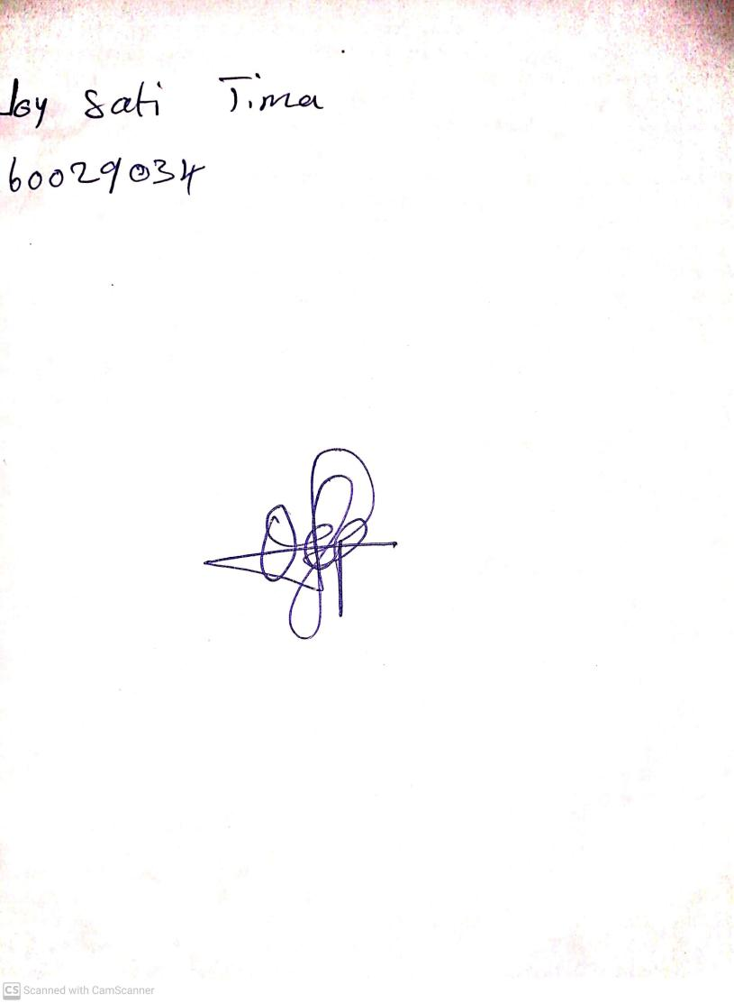

11TH OCTOBER, 2023

Perpetual Ojoma Ocheja

Stream Head Nursery