**EMERALD ROYAL INTERNATIONAL SCHOOL,**

**MPAPE ABUJA**

**NURSERY 2 SCHEME OF WORK ON NUMBER WORK THIRD TERM**

|  |  |
| --- | --- |
| **WEEKS** | **TOPICS** |
| 1 | Revision of 2nd term's work |
| 2 | Numbers 41–45 |
| 3 | Greater than(>) less than (<) |
| 4 | Place value of numbers |
| 5 | Length |
| 6 | Numbers 46–50 |
| 7 | Numbers in words 1–10 |
| 8 | Numbers in words 11–20 |
| 9 | Simple addition (number 1–9) |
| 10 | Simple subtraction (numbers 1–9) |
| 11 | Money:#1 to #20 |
| 12 | Revision |
| 13 | Examination |

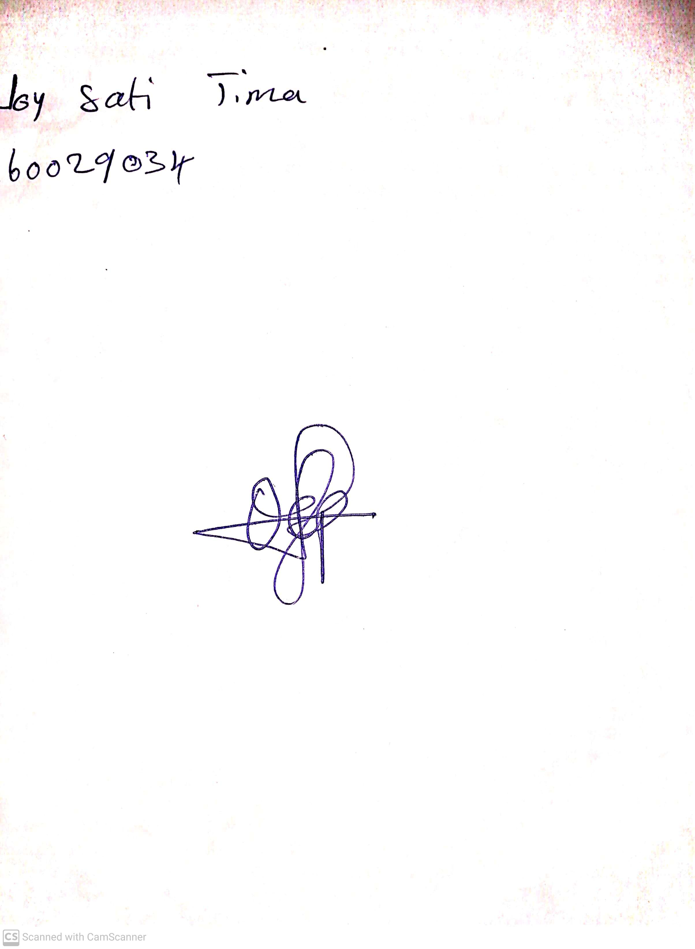

4th May, 2023

Perpetual Ojoma

Stream Head Nursery