PRE-NURSERY SCHEME OF WORK ON SOCIAL NORMS FIRST TERM.

WEEK I:- Myself.(my name)

WEEK 2:- Myself (my age).

WEEK 3:- The family.

WEEK 4:- Members of the family.

WEEK 5:- Members of the family.

WEEK 6:- Greetings.(good morning)

WEEK 7:- Greetings (good afternoon).

WEEK 8:- Greetings (welcome).

WEEK 9:- Greetings (good bye)

WEEK 10:- It is not good to fight.

WEEK 11:- Being kind.

WEEK 12:- Revision

WEEK 13:- Examination.

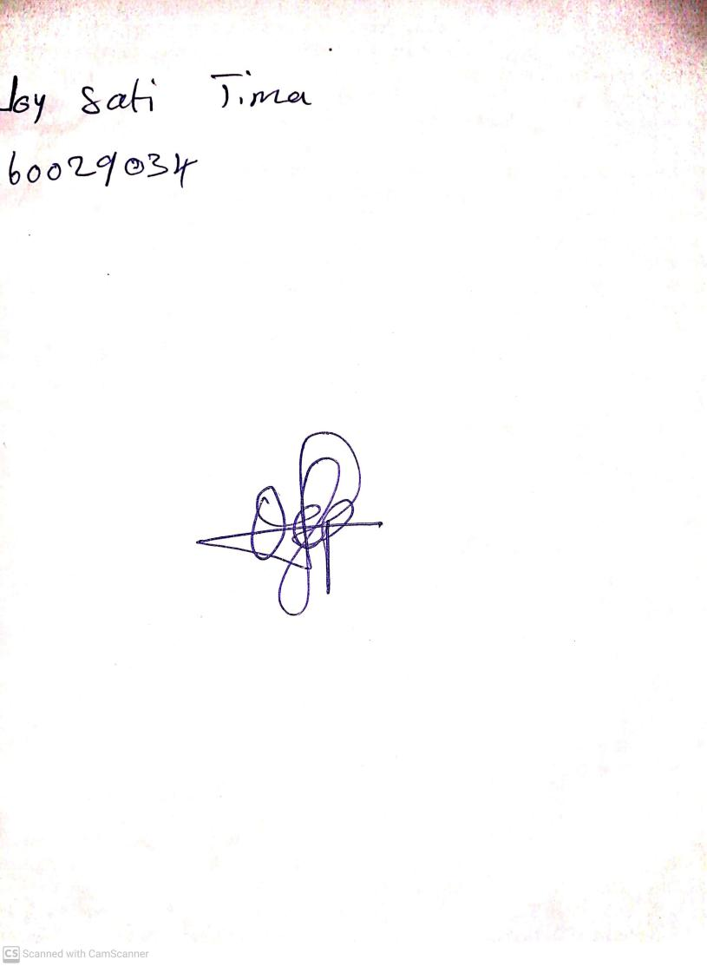

25th August, 2023

Perpetual Ojoma Ocheja

Stream Head Nursery