**LESSON PLAN AND NOTE FOR WEEK 8 ENDING 01/03/2024**

**Term 2nd term**

**Week 8th week**

**Date 28th February,2024**

**Class Nursery one**

**Subject Nature studies**

**Topic Weather**

**Sub-topic Meaning & kinds of weather**

**Period 2nd period**

**Time 9:05 am**

**Duration 35 minutes**

**No in class 15**

**Average Age 3 years**

**Sex Mixed.**

**Specific Objectives: By the end of the lesson, the pupils should know how to:**

1. **Define Weather**
2. **Mention the types of weather.**

**Rationale: To help the pupils have vital knowledge of weather.**

**Previous Knowledge: The pupils have knowledge of Fruits & Vegetables**

**Instructional Resources: Online Research,Chart.**

**Reference Materials: Online Research, Elementary Science by Showers Kiddies.**

**LESSON PRESENTATION**

|  |  |  |  |
| --- | --- | --- | --- |
| **Steps** | **Teacher’s Activities** | **Pupils’ Activities** | **Learning Points** |
| **Introduction** | **The teacher introduces the topic (weather) by showing the pupils pictures of the kinds of weather.** | **The pupils could identify the kinds of weather.** | **To arouse the interest of the pupils.** |
| **Step 1** | **The teacher starts the lesson by teaching the pupils the meaning of weather as “the state of the atmosphere at any given period of time”.** | **The pupils listen attentively to the teacher and repeats after the teacher the meaning of weather.** | **For proper understanding.** |
| **Step 2** | **The teacher mention the kinds of weather such as:**  **Rainy weather.**  **Sunny weather.**  **Cloudy weather.**  **Windy weather.** | **The pupils listens to the teacher and repeats the kinds of weather.** | **For better understanding.** |
| **Summary** | **The teacher summarizes the lesson by defining weather.** | **The pupils knows the definition of weather.** | **For onward study.** |
| **Evaluation** | **Question:**   1. **Define Weather?** 2. **Mention 3 the kinds of weather?** | **The pupils answer the question correctly.** | **To ascertain the pupils’ understanding.** |
| **Conclusion** | **The teacher summarizes, reacts, and corrects the pupils.** | **The pupils gives answers to the teacher’s question.** | **To consolidate the lesson.** |
| **Assignment** | **Question:**   1. **Define Weather?** 2. **Mention 3 the kinds of weather?** 3. **Draw a sunny weather?** | **The pupils copy and do their homework at home.** | **To encourage learning while at home.** |

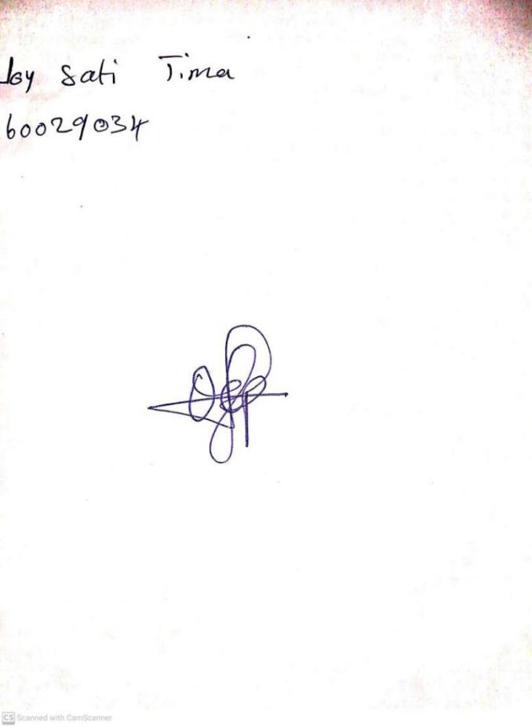

26TH February, 2024

Perpetual Ojoma Ocheja

Stream Head Nursery