**LESSON PLAN AND NOTE 1 FOR WEEK 6 ENDING 16/02/2024**

**Term 2nd term**

**Week 6th week**

**Date 12th February,2024**

**Class Nursery one**

**Subject Letter work**

**Topic Coping words with letter Ff.**

**Sub-topic Naming three letter words with letter Ff.**

**Period 2nd period**

**Time 9:05 am**

**Duration 35 minutes**

**No in class 13**

**Average Age 3 years**

**Sex Mixed.**

**Specific Objectives: By the end of the lesson, the pupils should be able to:**

1. **Name three letters words that start with Ff.**
2. **Trace three letters words that start with Ff.**

**Rationale: To make the pupils mention & trace three letter words with Ff.**

**Previous Knowledge: The pupils can match & write three letter words starting with letter Ff.**

**Instructional Resources: Chart, board, marker.**

**Reference Material: Online research, chart.**

**LESSON PRESENTATION**

|  |  |  |  |
| --- | --- | --- | --- |
| **Steps** | **Teacher’s Activities** | **Pupils’ Activities** | **Learning Points** |
| **Introduction** | **The teacher introduces the topic (coping words with letter Ff.) to the pupils.** | **The pupils listen to the teacher attentively.** | **To arouse the interest of the pupils.** |
| **Step 1** | **The teacher starts by naming three letter words with Ff for the pupils to repeat after**  **‘’fat’’, ‘’fan’’, “far”** | **The pupils repeat after the teacher three letter words with Ff**  **‘’fat’’, ‘’fan’’, “far”** | **For proper understanding.** |
| **Step 2** | **The teacher guides the pupils in writing three letter words with sound Ff inside their notebook.**  **f a n**  **_____________** | **The pupils trace the three letter words with Ff. as the teacher guides them inside their notebook.** | **For better understanding.** |
| **Summary** | **The teacher summarizes the lesson by sounding three letter words with Ff**  **‘’fat’’, ‘’fan’’, “far”** | **The pupils mention three letter words with Ff**  **‘’fat’’, ‘’fan’’, “far”** | **For onward study** |
| **Evaluation** | **Question:**  **Mention three letter words with Ff.**  **Write the three letter word with sound Ff below.**  **f a n**  **_____________**  **f a t**  **______________** | **The pupils answer the question correctly.** | **To ascertain the pupils’ understanding of the lesson.** |
| **Conclusion** | **The teacher summarizes, reacts and corrects the pupils.** | **The pupils gives answers to the teacher's question.** | **To consolidate the lesson.** |
| **Assignment** | **Question:**  **Mention three letter words with Ff.**  **Write the three letter word with sound Ff below.**  **f a n**  **_____________**  **f a t**  **______________** | **The pupils copy and do their homework at home.** | **To encourage learning while at home.** |

**LESSON PLAN AND NOTE 2 FOR WEEK 6 ENDING 16/02/2024**

**Term 2nd term**

**Week 6th week**

**Date 14th February,2024**

**Class Nursery one**

**Subject Letter work**

**Topic Coping words with letter Ff.**

**Sub-topic Colouring objects & animals with letter Ff.**

**Period 2nd period**

**Time 9:32 am**

**Duration 35 minutes**

**No in class 13**

**Average Age 3 years**

**Sex Mixed.**

**Specific Objectives: By the end of the lesson, the pupils should be able to:**

1. **Identify three letters words & objects that start with Ff.**
2. **Colour three letters words & objects that start with Ff.**

**Rationale: To make the pupils identify & colour three letter words & object**

**Previous Knowledge: The pupils have name & trace three letter words starting with letter Ff.**

**Instructional Resources: Crayons, pencils, exercise books, board, marker.**

**Reference Material: Online research.**

**LESSON PRESENTATION**

|  |  |  |  |
| --- | --- | --- | --- |
| **Steps** | **Teacher’s Activities** | **Pupils’ Activities** | **Learning Points** |
| **Introduction** | **The teacher introduces the topic (coping words with letter Ff.) to the pupils.** | **The pupils listen to the teacher attentively.** | **To arouse the interest of the pupils.** |
| **Step 1** | **The teacher draws objects that start with three letter word Ff for the pupils to identify** | **The pupils participate to identify objects that starts with Ff.** | **For proper understanding.** |
| **Step 2** | **The teacher draws & guides the pupils to colour objects starting with letter Ff.** | **The pupils colour the objects that start with letter Ff.** | **For better understanding.** |
|  |  |  |  |
| **Summary** | **The teacher summarizes the lesson by identifying other objects with letter Ff.** | **The pupils have knowledge of identifying & colouring objects with letter Ff.** | **For onward study.** |
| **Evaluation** | **Question:**  **Identify the object below with letter Ff inside the notebook.**  **Colour the object below with letter Ff inside the notebook.** | **The pupils answer the question correctly.** | **To ascertain the pupils’ understanding of the lesson.** |
| **Conclusion** | **The teacher summarizes, reacts and corrects the pupils** | **The pupils gives answers to the teacher's question.** | **To consolidate the lesson.** |
| **Assignment** | **Question:**  **Identify the object below with letter Ff inside the notebook.**  **Colour the object below with letter Ff inside the notebook.** | **The pupils copy and do their homework at home.** | **To encourage learning while at home** |

**LESSON PLAN AND NOTE 3 FOR WEEK 6 ENDING 16/02/2024**

**Term 2nd term**

**Week 6TH week**

**Date 17TH February,2024**

**Class Nursery one**

**Subject Letter work**

**Topic Coping words with letter Ff.**

**Sub-topic Matching objects & animals with letter Ff on**

**Cardboard (practical)**

**Period 2nd period**

**Time 9:55 am**

**Duration 35 minutes**

**No in class 13**

**Average Age 3 years**

**Sex Mixed.**

**Specific Objectives: By the end of the lesson, the pupils should be able to:**

1. **Pick from a box a picture words with letter Ff & paste it on the cardboard.**

**2. Write three letters words with Ff.**

**Rationale: To make the pupils match & write three letter words with Ff.**

**Previous Knowledge: The pupils have identify & colour three letter words with letter Ff.**

**Instructional Resources: Cardboard, pencils, exercise books.**

**Reference Material: Online research ,cardboard.**

**LESSON PRESENTATION**

|  |  |  |  |
| --- | --- | --- | --- |
| **Steps** | **Teacher’s Activities** | **Pupils’ Activities** | **Learning Points** |
| **Introduction** | **The teacher introduces the topic (coping words with letter Ff) to the pupils.** | **The pupils listen to the teacher attentively.** | **To arouse the interest of the pupils.** |
| **Step 1** | **The teacher present a box with picture words and assists the pupils using gum to paste on the cardboard the pictures starting with Ff.** | **The pupils participate actively in picking and pasting on the cardboard the word picture with letter Ff.** | **For proper understanding.** |
| **Step 2** | **The teacher guides the pupils to write three letter words with Ff inside their notebooks.**  **f a t**  __________  **f a n**  **_____________** | **The pupils write three letter words with Ff as the teacher guides them inside their notebooks.** | **For better understanding.** |
| **Summary** | **The teacher summarizes the lesson by sounding random three letter words with Ff.** | **The pupils have knowledge of three letter words with Ff.** | **For onward study.** |
| **Evaluation** | **Question:**  **Write the three letter words with Ff.**   |  | | --- | | **f a n** | |  | | **f a n** | |  | | **The pupils answer the question correctly.** | **To ascertain the pupils’ understanding of the lesson.** |
| **Conclusion** | **The teacher summarizes, reacts and corrects the pupils.** | **The pupils gives answers to the teacher's question.** | **To consolidate the lesson.** |
| **Assignment** | **Question:**  **Write the three letter words with Ff.**  **f a t**  __________  **f a n**  **_____________** | **The pupils copy and do their homework at home.** | **To ensure learning while at home.** |

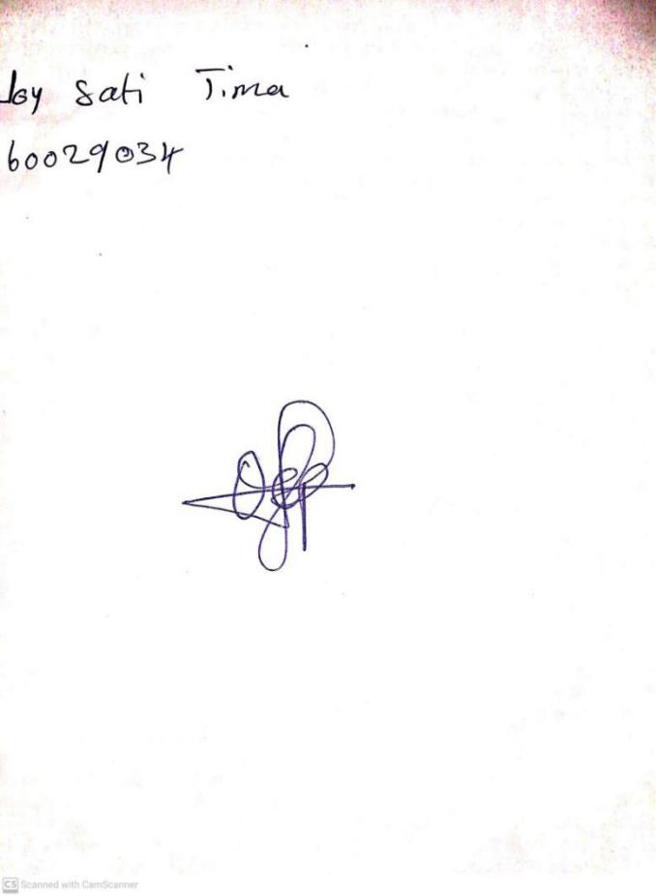

**9th February, 2024**

**Perpetual Ojoma Ocheja**

**Stream Head Nursery**