EMERALD ROYAL INTERNATIONAL SCHOOL

MPAPE, ABUJA.

LESSON PLAN AND NOTE 1 FOR WEEK 5 ENDING 2ND JUNE, 2023.

SUBJECT: Letter work

TOPIC: Matching letters Pp - Tt with picture word .

SUB-TOPIC: identification of letters Pp-Tt.

DATE: 30/5/2023.

DURATION: 40 minutes.

TIME: 08:50--09:30.

PERIOD: 2nd

CLASS: Pre-nursery

NUMBER OF PUPILS: 11

AVERAGE AGE: 2 YEARS

SEX: Mixed.

SPECIFIC OBJECTIVES: By the end of the lesson, the pupils should be able to:-

1. Identify letters Pp-Tt.
2. Match the upper case with the lower case.

RATIONALE: For pupils to know letters and their sounds.

PREVIOUS KNOWLEDGE: Pupils have been learning the lower case.

INSTRUCTIONAL MATERIALS: Flash cards, board, and phonics song.

REFERENCE:Mastering English for nursery schools book 1 by J.M.Omogbai.

LESSON DEVELOPMENT

|  |  |  |  |
| --- | --- | --- | --- |
| STAGES/STEPS | TEACHER’S ACTIVITIES | PUPILS’ ACTIVITIES | LEARNING POINTS |
| INTRODUCTION | Teacher introduces the lesson by singing a jolly phonics song for the pupils. | Puils sing along with the teacher. | To arouse the interest of the pupils for the lesson. |
| PRESENTATION  STEP 1 | Teacher scattered the flash cards of upper and lower case on the table and asks the pupils the upper case and the lower case of each letters. | Pupils identify the upper and lower case ofeach letters on the table. | For betterr understanding of the lesson . |
| STEP2 | Teacher prepares the pupils books for them to match the upper case with lower case .  P t  Q s  R q  S r  T p | Pupils match the upper case with the lower case.  P t .  Q s  R q  S r  T p | To improve pupils psychomotive skills. |
| SUMMARY | Teacher summarizes the lesson by going over the lesson again for more understanding | Pupils listen very attentively to the teacher | For more understanding of the lesson. |
| EVALUATION | Teacher calls out the pupils one after another to identify the upper and the lower case of letter Pp-Tt. | Pupils answer the teacher’s questions. | To assess the level of pupils understanding of the lesson. |
| CONCLUSION | Teacher marks the pupils books and make corrections where necessary. | Pupils submit their books for marking and corrections . | For onwards study. |
| ASSIGNMENT | Teacher asks the pupils to read and match upper case and lower case of letter Pp-Tt. | Pupils do their Home work at home. | To ensure learning takes place at home. |

LESSON PLAN AND NOTE 2 FOR WEEK 5 ENDING 2ND JUNE, 2023.

SUBJECT: Letter work

TOPIC: Matching letter Pp-Tt with picture word .

SUB-TOPIC: identification of letters Kk-Oo and matching letters with the picture word

DATE: 30/5/2023.

DURATION: 40 minutes.

TIME: 08:50--09:30.

PERIOD: 2nd

CLASS: Pre-nursery

NUMBER OF PUPILS: 11

AVERAGE AGE: 2 YEARS

SEX: Mixed.

SPECIFIC OBJECTIVES: By the end of the lesson, the pupils should be able to:-

1. Identify letter Pp-Tt.
2. Match the upper case with the picture word.

RATIONALE: For pupils to know letters and their sounds.

PREVIOUS KNOWLEDGE: Pupils have been learning the lower case.

INSTRUCTIONAL MATERIALS: Flash cards, board, and phonics song.

REFERENCE:Mastering English for nursery schools book 1 by J.M.Omogbai.

LESSON DEVELOPMENT

|  |  |  |  |
| --- | --- | --- | --- |
| STAGES/STEPS | TEACHER’S ACTIVITIES | PUPILS’ ACTIVITIES | LEARNING POINTS |
| INTRODUCTION | Teacher introduces the lesson by singing a jolly phonics song for the pupils. | Pupils sing along with the teacher. | To arouse the interest of the pupils for the lesson. |
| PRESENTATION  STEP 1 | Teacher scattered the flash cards of upper and lower case on the table and asks the pupils the upper case and the lower case of each letters. | Pupils identify the upper and lower case of each on the table. | For better understanding of the lesson . |
| STEP2 | Teacher prepares the pupils books for them to match the upper case with the picture words.  Pp as in images (2)    Qq as in download (20)    Rr as in download (15)    Ss as in images    Tt as in download | Pupils match the upper case with the picture words.  Pp as in images (2)  Qq as in download (20)  Rr as in download (15)  Ss as in images  Tt as in download  . | To improve pupils writing skills. |
| SUMMARY | Teacher summarizes the lesson by going over the lesson again for more understanding | Pupils listen very attentively to the teacher | For more understanding of the lesson. |
| EVALUATION | Teacher calls out the pupils one after another to:- 1. identify the upper and the lower case of letter Pp-Tt   1. match the letters with the pictures.   Pp as in images (2)  Qq as in download (20)  Rr as in download (15)  Ss as in images    Tt as in download | Pupils answer the teacher’s questions. | To assess the level of pupils understanding of the lesson. |
| CONCLUSION | Teacher marks the pupils books and make corrections where necessary. | Pupils submit their books for marking and corrections . | For onwards study. |
| ASSIGNMENT | Teacher asks the pupils to read and match upper case with the picture words in the text books. | Pupils do their Home work at home. | To ensure learning takes place at home. |

LESSON PLAN AND NOTE 3 FOR WEEK 5 ENDING 2ND JUNE, 2023.

SUBJECT: Letter work

TOPIC: Matching letter Pp-Tt with picture word .

SUB-TOPIC: identification of letters Pp-Tt and writing letters.

DATE: 2/6/2023.

DURATION: 40 minutes.

TIME: 08:50--09:30.

PERIOD: 2nd

CLASS: Pre-nursery

NUMBER OF PUPILS: 11

AVERAGE AGE: 2 YEARS

SEX: Mixed.

SPECIFIC OBJECTIVES: By the end of the lesson, the pupils should be able to:-

1. Identify letter Pp-Tt
2. Copy letters Pp-Tt.

RATIONALE: For pupils to know letters and their sounds.

PREVIOUS KNOWLEDGE: Pupils have been learning the lower case.

INSTRUCTIONAL MATERIALS: Flash cards, board, and phonics song.

REFERENCE:Mastering English for nursery schools book 1 by J.M.Omogbai.

LESSON DEVELOPMENT

|  |  |  |  |
| --- | --- | --- | --- |
| STAGES/STEPS | TEACHER’S ACTIVITIES | PUPILS’ ACTIVITIES | LEARNING POINTS |
| INTRODUCTION | Teacher introduces the lesson by singing a nursery rhyme for the pupils. | Pupils sing along with the teacher. | To arouse the interest of the pupils for the lesson. |
| PRESENTATION  STEP 1 | Teacher writes the upper case and lower case of letter Pp-Tt on the board for pupils to identify.  Pp Qq Rr Ss Tt. | Pupils points at the letters on the chalk board and identify them by reading them one after another. | For proper recognition of letters. |
| STEP2 | Teacher prepares the pupils books for them to re-write letter Pp-Tt  .  Pp Qq Rr Ss Tt | Pupils re-write Pp-Qq in the books.  Pp Qq Rr Ss Tt  .  Pp Qq Rr Ss Tt  Pp Qq Rr Ss Tt | To improve pupils psychomotive skills. |
| SUMMARY | Teacher summarizes the lesson by asking the pupils to sing the phonics song for letters Pp-Tt with the teacher. | Pupils sing the phonics song for letters Pp-Tt with the teacher. | For more understanding of the lesson. |
| EVALUATION | Teacher calls out the pupils one after another to:- 1. identify the upper and lower case on the flash card.  2.Re-write letter Pp-T | Pupils answer the teacher’s questions. | To assess the level of pupils understanding of the lesson. |
| CONCLUSION | Teacher marks the pupils books and make corrections where necessary. | Pupils submit their books for marking and corrections . | For onwards study. |
| ASSIGNMENT | Teacher asks the pupils to read and match upper case with the picture words in the text books. | Pupils do their Home work at home. | To ensure learning takes place at home. |

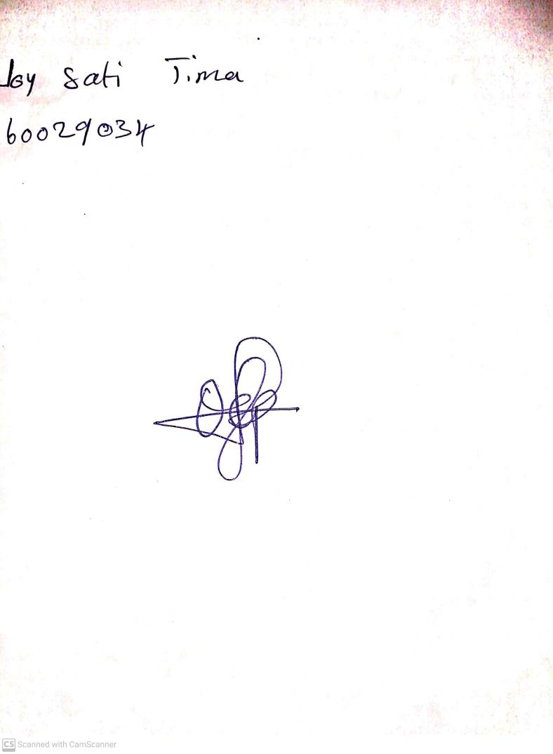

5th July, 2023

Perpetual Ojoma

Stream Head Nursery