**EMERALD ROYAL INTERNATIONAL SCHOOL**

**MPAPE, ABUJA.**

**LESSON PLAN AND NOTE FOR WEEK 10 ENDING 17/11/2023**

TERM: FIRST

WEEK: 10TH

DATE: 13/11/2023

CLASS: NURSERY 2

SUBJECT: SOCIAL NORMS

TOPIC: RELIGIONS IN MY COUNTRY .

SUB-TOPIC: MEANING AND TYPES OF RELIGIONS IN NIGERIA

PERIOD: 2ND PERIOD AFTER LONG BREAK

TIME: 11: 20- 12: 00PM

DURATION: 40 MINUTES.

NUMBER IN CLASS: 14

AVERAGE AGE: 5 YEARS.

SEX: MIXED.

SPECIFIC OBJECTIVES: BY THE END OF THE LESSON,THE PUPILS SHOULD BE

ABLE TO:

1. DEFINE RELIGION
2. STATE THE THREE MAIN TYPES OF RELIGION IN NIGERIA
3. MENTION THE OBJECTS OF WORSHIP

RATIONALE: FOR PUPILS TO KNOW OTHERS RELIGIONS.

PREVIOU KNOWLEDGE: PUPILS ARE IN DIFFERENT RELIGION

INSTRUCTIONAL MATERIALS: PICTURES OF A CHURCH AND A MOQUES IN TEXT

BOOKS.

REFERENCE MATERIALS: SOCIAL STUDIES FOR PRIMARY SCHOOLS BOOK 1 BY GBENGA M.BABALOLA

**LESSON DEVELOPMENT**

|  |  |  |  |
| --- | --- | --- | --- |
| STAGES/STEPS | TEACHER’S ACTIVITIES | PUPILS’ ACTIVITIES | LEARNING POINTS |
| INTRODUCTION | Teacher introduces the lesson by reviewing the previous lesson. | Pupils pay attention to the teacher. | To arouse pupils interest for the lesson ahead. |
| PRESENTATION  STEP 1 | Teacher defines religion to pupils and then asks them to repeat after her. | Pupils listen attentively to the teacher and repeat after her. | For proper understanding . |
| STEP 2 | Teacher states the three types ofreligion to pupils and also asks them to repeat after her. | Pupils pay attention to the teacher and repeat after her. | For better understanding of the lesson. |
| STEP 3 | Teacher teacher also mention the objects of worship to pupils and also asks them to repeat after her. | Pupils listen very attentively to the teacher and repeat after her. | To enhance pupils speaking ability. |
| BOARD SUMMARY | Teacher summarizes the lesson by writing the whole note of lesson on the board for pupils to copy into their books. That is:  Meaning of religion:  Religion is what people believe and worship.  It is the belief in the existence of Almighty God.  In nigeria, there are three main relions. These are:   1. Christianity religion 2. Islamic religion 3. Traditional religion   Objects of worship  The objects of worship are:   1. Holy bible 2. Holy quran 3. Charms 4. Rosary 5. Cowries 6. Cross etc   Places of worship are:   1. A church 2. A mosque 3. A shrine   The christians worship in thechurch.  The muslims worship in the mosque.  The traditional worshippers worship at the shrine. | Pupils copy the note into their exercise books. | For onward study. |
| EVALUATION | Teacher evaluates the lesson by asking the following questions;   1. What is religion?. 2. List the three main types of religions in Nigeria. 3. Mention the objects of worship. | Pupils answer the questions asked by the teacher. | To assess pupils level of understanding. |
| CONCLUSION | Teacher concludes the lesson by marking pupils books. | Pupils submit their books for marking. | For endorsement. |
| ASSIGNMENT | 1. What is religions? 2. Mention the 3 main types of religion in Nigeria. 3. List 6 objects of worship by the three main types of religion in Nigeria. 4. Where does the Christians worship? 5. Where does the Muslims worship? 6. The traditional worshippers worship in the ------- | Pupils do their assignment at home. | To encourage learning at home. |

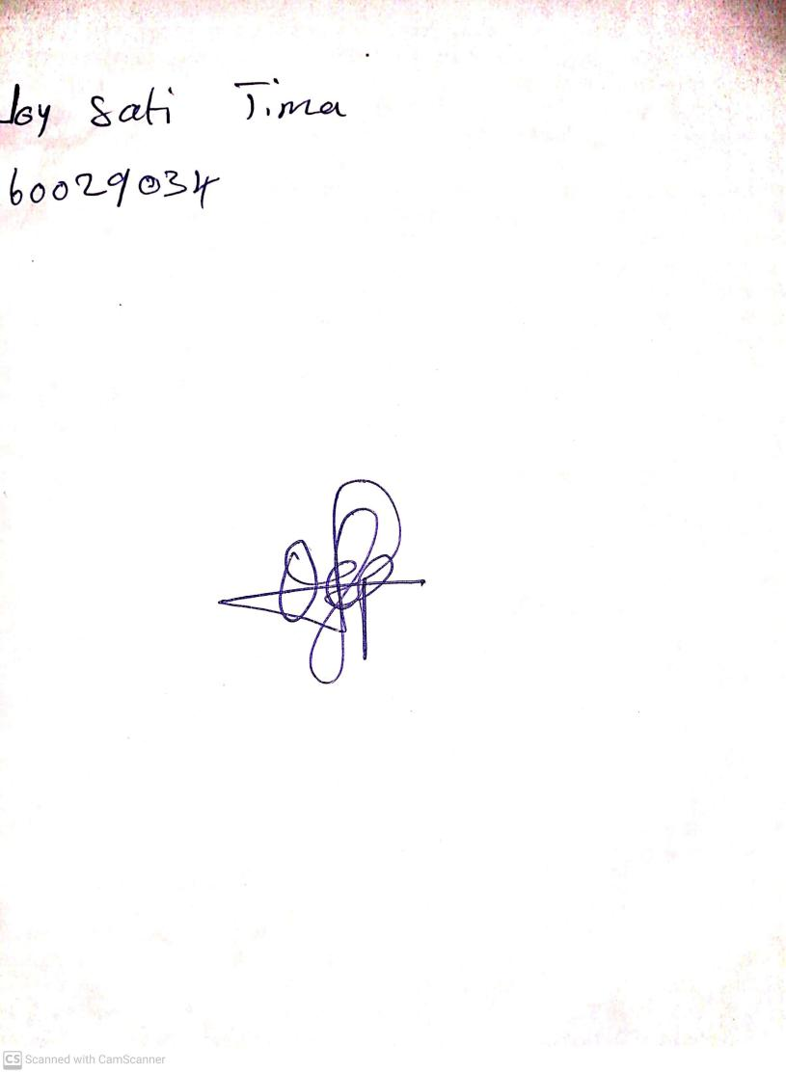

18th September, 2023

Perpetual Ojoma Ocheja

Stream Head Nursery