**EMERALD ROYAL INTERNATIONAL SCHOOL, MPAPE ABUJA**

**LESSON PLAN AND NOTE FOR WEEK 1 ENDING FRIDAY, 15TH SEPTEMBER, 2023**

**TERM:** FIRST TERM

**WEEK:** WEEK 1

**SUBJECT:** ENGLISH LANGUAGE (SPEECH)

**TOPIC:** WHERE ARE YOU FROM?

**SUB-TOPIC:** ASKING AND ANSWERING QUESTION

**DATE:** WEDNESDAY, 13TH SEPTEMBER, 2023

**TIME:** 02:00 – 02:30PM

**DURATION:** 30 MINUTES

**PERIOD:** 9TH

**CLASS:** NURSERY 3

**NUMBER IN CLASS:** ELEVEN

**AVERAGE AGE:** FIVE

**SEX:** MIXED

**LEARNING OBJECTIVES:** By the end of the lesson, the pupils should be able to

1. Ask and answer question.

**RATIONALE:** for pupils to learn about asking and answering questions.

**PREVIOUS KNOWLEGDE:** pupils have learnt to answer questions

**INSTRUCTIONAL MATERIALS:**

1. Text book – Nigeria Primary English book 1 – Fourth Edition

**REFERENCE MATERIALS:**

1. Nigeria Primary English book 1 by B. Someye, D Dallas etal 2000

|  |  |  |  |
| --- | --- | --- | --- |
| **STAGES /STEPS** | **TEACHER’S ACTIVITIES** | **PUPILS’ ACTIVITIES** | **LEARNING POINT** |
| **INTRODUCTION** | Ask the pupils to get a partner. | Chose a partner. | Arouse their interest |
| **PRESENTATION**  **STEP 1** | Leads pupils ask partner questions for the partner to respond.  **Where are you from?**  **Ima:** Where are you from?  **Zik:** I’m from Warri, in Delta State.  **Ima:** Where is Warri? Is it near Asaba?  **Zik:** Yes it is. It’s close to the East.  **Ima:** Is it neat?  **Zik:** Yes it is. It is very clean. | Respond to the teacher. | Asking and answering questions. |
| **SUMMARY** | Summarises the lesson by emphasising on the main concept and writes note on the board. | Listen and copy their notes | For onward study |
| **EVALUATION** | Ask pupils to:  1.attempt exercise 1 on page 2 of their textbook. | Respond to the teacher’s question. | To test the pupils’ understanding of the lesson |
| **CONCLUSION** | Summarizes, correct and mark the pupils note books. | Submits their notes for marking. | Clarifying the concept. |
| **HOME-WORK** | Nigeria Primary English book 1 page 2 exercise 2 | Return home with task | Extending lesson home. |

**LESSON PLAN AND NOTE FOR WEEK 1 ENDING FRIDAY, 15TH SEPTEMBER, 2023**

**TERM:** FIRST TERM

**WEEK:** WEEK 1

**SUBJECT:** ENGLISH LANGUAGE (GRAMMAR)

**TOPIC:** NOUN

**SUB-TOPIC:** MEANING OF NOUN

**DATE:** MONDAY, 11TH SEPTEMBER, 2023

**TIME:** 01:20 – 02:00PM

**DURATION:** 40 MINUTES

**PERIOD:** 8TH

**CLASS:** NURSERY 3

**NUMBER IN CLASS:** ELEVEN

**AVERAGE AGE:** FIVE

**SEX:** MIXED

**LEARNING OBJECTIVES:** at the end of the lesson, pupils should be able to:

1. Give the meaning of noun
2. Give the examples of noun.

**LESSON DEVELOPMENT**

|  |  |  |  |
| --- | --- | --- | --- |
| **STAGES /STEPS** | **TEACHER’S ACTIVITIES** | **PUPILS’ ACTIVITIES** | **LEARNING POINT** |
| **INTRODUCTION** | Ask pupils what they understand by the word noun. | Respond to the teacher’s question | Arouse their interest |
| **PRESENTATION**  **STEP 1** | Teaches the pupils the meaning of noun.  **Meaning of noun**  A noun is the name of a person animal place or things | Define greeting. | Meaning of greeting. |
| **STEP 2** | Leads pupils to state the examples of noun  **Examples of noun**  **Name of person**   1. Emmanuel 2. Success 3. Miracle 4. Jamal 5. Daniella   **Names of animals**   1. Goat 2. Cow 3. Elephant 4. Dog 5. Cat   **Name of places**   1. Kano 2. Abuja 3. Sokoto 4. Lagos 5. School   **Name of things**   1. Book 2. Pencil 3. Table 4. Bucket 5. mat | Practice simple greeting. | Practical on simple greeting.. |
| **SUMMARY** | Summarises the lesson by emphasising on the main concept and writes note on the board. | Listen and copy their notes | For onward study |
| **EVALUATION** | Ask pupils to:   1. Define noun 2. Give examples of noun. | Respond to the teacher’s question. | To test the pupils’ understanding of the lesson |
| **CONCLUSION** | Summarizes, correct and mark the pupils note books. | Submits their notes for marking. | Clarifying the concept. |
| **HOME-WORK** | Nigeria Primary English workbook 1 pages 1 | Return home with task | Extending lesson home. |

**LESSON PLAN AND NOTE FOR WEEK 1 ENDING FRIDAY, 15TH SEPTEMBER, 2023**

**TERM:** FIRST TERM

**WEEK:** WEEK 1

**SUBJECT:** ENGLISH LANGUAGE (COMPREHENSION)

**TOPIC:** THINGS IN THE CLASSROOM

**SUB-TOPIC:** OBJECTS IN THE CLASSROOM

**DATE:** THURSDAY, 14TH SEPTEMBER, 2023

**TIME:** 09:25 – 09:55PM AND 12:30 – 01:00PM

**DURATION:** 40 MINUTES

**PERIOD:** 3RD AND 7TH

**CLASS:** NURSERY 3

**NUMBER IN CLASS:** ELEVEN

**AVERAGE AGE:** FIVE

**SEX:** MIXED

**LEARNING OBJECTIVES:** by the end of the lesson, pupils should be able to:

1. Identify and mention objects in the classroom.
2. Write down the objects in the classroom.

**RATIONALE:** for pupils to learn to identify objects in the classroom.

**PREVIOUS KNOWLEGDE:** pupils are familiar with objects in the classroom

**INSTRUCTIONAL MATERIALS:**

1. Charts
2. Classroom
3. Text book – Nigeria Primary English book 1 – Fourth Edition

**REFERENCE MATERIALS:**

1. Nigeria Primary English book 1 by B. Someye, D Dallas etal 2000

**LESSON DEVELOPMENT**

|  |  |  |  |
| --- | --- | --- | --- |
| **STAGES /STEPS** | **TEACHER’S ACTIVITIES** | **PUPILS’ ACTIVITIES** | **LEARNING POINT** |
| **INTRODUCTION** | Ask to look around the classroom and observe the things they can see. | Respond to the teacher’s question | Arouse their interest |
| **PRESENTATION**  **STEP 1** | Teaches and guide the pupils to identify the things in the classroom.  **Things in the classroom**   1. Tables 2. Chairs 3. Pencils 4. Charts 5. Books 6. School bags 7. Board 8. Marker 9. Eraser 10. Crayon etc | Identify the things in the classroom. | Things in the classroom |
| **STEP 2** | Guides pupils to write out the things in the classroom.  **Things in the classroom**   1. Tables 2. Chairs 3. Pencils 4. Charts 5. Books 6. School bags 7. Board 8. Marker 9. Eraser 10. Crayon etc | Write out things in the classroom. | For better understanding. |
| **SUMMARY** | Summarises the lesson by emphasising on the main concept and writes note on the board. | Listen and copy their notes | For onward study |
| **EVALUATION** | Ask pupils to:   1. List the things in the classroom. | Respond to the teacher’s question. | To test the pupils’ understanding of the lesson |
| **CONCLUSION** | Summarizes, correct and mark the pupils note books. | Submits their notes for marking. | Clarifying the concept. |
| **HOME-WORK** | Nigeria Primary English  book 1 pages 4 and 5 | Return home with task | Extending lesson home. |

**LESSON PLAN AND NOTE FOR WEEK 1 ENDING FRIDAY, 15TH SEPTEMBER, 2023**

**TERM:** FIRST TERM

**WEEK:** WEEK 1

**SUBJECT:** ENGLISH LANGUAGE (COMPOSITION)

**TOPIC:** COMPOSITION

**SUB-TOPIC:** ABOUT MYSELF

**DATE:** THURSDAY, 14TH SEPTEMBER, 2023

**TIME:** 11:10AM – 11:50AM

**DURATION:** 45 MINUTES

**PERIOD:** 5TH

**CLASS:** NURSERY 3

**NUMBER IN CLASS:** ELEVEN

**AVERAGE AGE:** FIVE

**SEX:** MIXED

**LEARNING OBJECTIVES:** By the end of the lesson, the pupils should be able to

1. Say something about themselves
2. Write about ‘myself’
3. Answer the questions about ‘myself’

**RATIONALE:** for pupils to learn about themselves.

**PREVIOUS KNOWLEGDE:** pupils have learnt to say and write their names, age and class.

**INSTRUCTIONAL MATERIALS:**

1. A book
2. Pencil
3. Text book – Nigeria Primary English book 1 – Fourth Edition

**REFERENCE MATERIALS:**

1. Nigeria Primary English book 1 by B. Someye, D Dallas etal 2000

|  |  |  |  |
| --- | --- | --- | --- |
| **STAGES /STEPS** | **TEACHER’S ACTIVITIES** | **PUPILS’ ACTIVITIES** | **LEARNING POINT** |
| **INTRODUCTION** | Review previous knowledge. | Open their text books | Arouse their interest |
| **PRESENTATION**  **STEP 1** | Leads pupils to say something about themselves. Name, where you live, age date of birth etc. | Respond to the teacher. | Personal presentation about oneself. |
| **STEP 2** | Leads pupils to write about myself  My name is --------------  I am a ------------------  I live in -------------------  I was born on ------------  I am --------- years old etc. | Write about myself. | Writing a composition about myself. |
| **STEP 3** | Ask pupils questions about themselves.  1. what class are you?  2. what is your shoe size?  3. what is your best colour?  4. what is your best food?  5. Who is your best friend? | Answer the questions. | Questions on composition. |
| **SUMMARY** | Summarises the lesson by emphasising on the main concept and writes note on the board. | Listen and copy their notes | For onward study |
| **EVALUATION** | Ask pupils to:  1. Ask pupils to say something about themselves.  2. write a composition titled ‘myself’.  3. answer the question. | Respond to the teacher’s question. | To test the pupils’ understanding of the lesson |
| **CONCLUSION** | Summarizes, correct and mark the pupils note books. | Submits their notes for marking. | Clarifying the concept. |
| **HOME-WORK** | Nigeria Primary English book 1 page 11 | Return home with task | Extending lesson home. |

**LESSON PLAN AND NOTE FOR WEEK 1 ENDING FRIDAY, 15TH SEPTEMBER, 2023**

**TERM:** FIRST TERM

**WEEK:** WEEK 1

**SUBJECT:** ENGLISH LANGUAGE (PHONICS)

**TOPIC:** SOUND BANK

**SUB-TOPIC:** SOUND BANK /I/ and /i:/

**DATE:** TUESDAY12TH SEPTEMBER, 2023

**TIME:** 10:30 – 11:10PM

**DURATION:** 40 MINUTES

**PERIOD:** 4TH

**CLASS:** NURSERY 3

**NUMBER IN CLASS:** ELEVEN

**AVERAGE AGE:** FIVE

**SEX:** MIXED

**LEARNING OBJECTIVES:** By the end of the lesson, the pupils should be able to:

1. Identify sound /I/ and /i:/
2. Pronounce the sounds /I/ and /i:/
3. State and write words with the sounds /I/ and /i:/

**RATIONALE:** for pupils to learns to transcribe words and letters in their exercises.

**PREVIOUS KNOWLEGDE:** pupils learnt about sounds

**INSTRUCTIONAL MATERIALS:**

1. Flash cards
2. pictorial chars

**REFERENCE MATERIALS:**

1. Nigeria Primary English book 1 by B. Someye, D Dallas etal 2000

|  |  |  |  |
| --- | --- | --- | --- |
| **STAGES/STEPS** | **TEACHER’S ACTIVITIES** | **PUPILS ACTIVITIES** | **LEARNING POINTS** |
| **INTRODUCTION** | Displays cards on a flat surface. | Identifies the flash cards. | Arousing interest. |
| **PRESENTATION**  **STEP 1** | Leads pupils to identify sounds /I/ and /i:/   |  | | --- | | **/I/** |  |  | | --- | | **/i:/** | | Identifies sounds /I/ and /i:/. | Identifying the sounds /I/ and /i:/. |
| **STEP 2** | Teaches pupils to pronounce sounds /I/ and /i:/ | Pronounce sounds /I/ and /i:/. | Pronouncing sounds /I/ and /i:/. |
| **STEP 3** | Teaches and highlight words with the sounds /I/ and /i:/.  Words with the sound /I/   1. Knit 2. Fill 3. kick 4. Busy 5. Think 6. Egypt   Words with the sound /i:/  1. peel  2. steam  3. the  4. kneel  5. dream  6. speed  7. lean | Identifies, learn and write words with the sounds /I/ and /i:/. | Words with sounds /I/ and /i:/. |
| **SUMMARY** | Summarises the lesson by emphasising on the main concept and writes note on the board. | Listen and copy their notes | For onward study |
| **EVALUATION** | Ask pupils to:  1. Identify sounds /I/ and /i:/  2. Pronounce sounds /I/ and /i:/  3. Pronounce and underline sounds /I/ and /i:/ in the following words.  /I/ /i:/  Crib seat  Bit tea | Respond to the teacher’s questions. | To test the pupils’ understanding on the lesson. |
| **CONCLUSION** | Summarizes, corrects and mark the pupils’ notebook. | Copy the note on the board and submit for marking. | Clarifying the concept. |
| **HOMEWORK** | Write 5 words each with the sound /I/ and /I:/ | Return home with task. | Extending lesson home. |

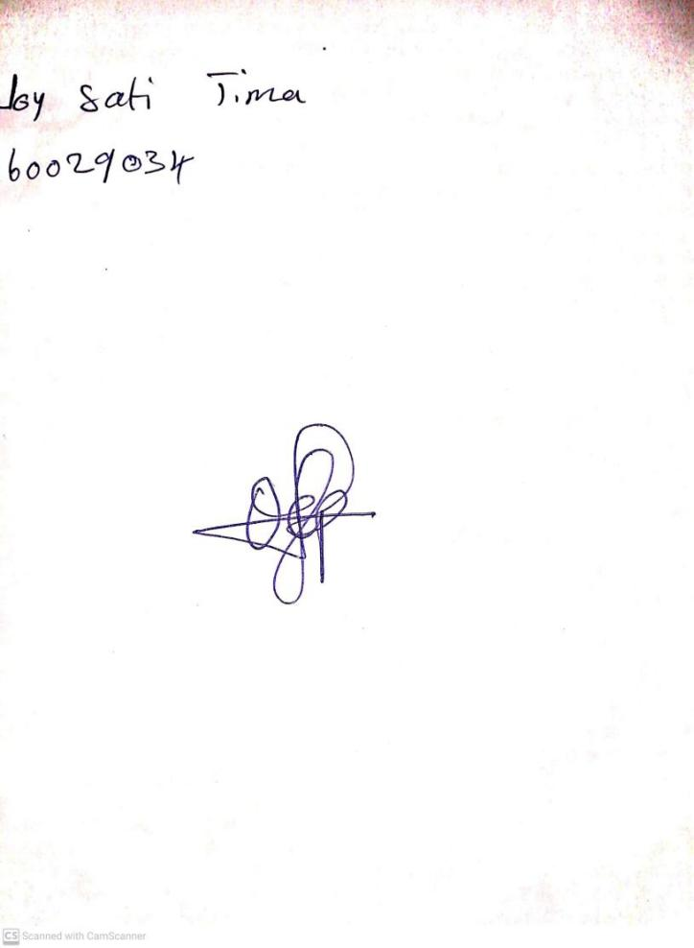

11TH September, 2023

Perpetual Ojoma Ocheja

Stream Head Nursery