**EMERALD ROYAL INTERNATIONAL SCHOOL MPAPE, ABUJA**

**LESSON PLAN AND NOTE FOR WEEK 5 PERIOD 1 ENDING 09/02/2024**

**TERM: 2nd**

**WEEK: 5th**

**DATE: 05/02/2024**

**CLASS: Nursery 2**

**SUBJECT: Number work**

**TOPIC: Descending order of numbers**

**SUB—TOPIC: Meaning and examples of descending order.**

**PERIOD: 3rd**

**TIME: 08:50—09:30am**

**DURATION: 40 minutes**

**NUMBER IN CLASS: 13**

**AVERAGE AGE: 5 years**

**SEX: Mixed**

**LEARNING OBJECTIVES: By the end of the lesson, the pupils should be able to:**

**1. Understand the meaning of descending order of numbers**

**2. Identify the examples of descending order of numbers.**

**RATIONALE: For pupils to know the meaning and examples of descending order of numbers.**

**PREVIOUS KNOWLEDGE: Pupils have learn Ordinal numbers in previous Lesson.**

**INSTRUCTIONAL MATERIALS: A chart of numbers in descending order**

**REFERENCE MATERIALS: My choice of mathematics stage 3.**

**LESSON DEVELOPMENT**

|  |  |  |  |
| --- | --- | --- | --- |
| **Steps** | **Teacher's activities** | **Pupils' activities** | **Learning point** |
| **Introduction** | **Teacher sings nursery rhyme.** | **Pupils sing the rhyme along with the teacher.** | **To prepare pupils minds for the lesson proper.** |
| **Presentation step 1** | **Teacher explains the meaning of descending order of numbers to pupils and then asks them to repeat after her.** | **Pupils listen and repeat after the teacher.** | **For proper understanding.** |
| **Step 2** | **Teacher mentions the examples of descending order of numbers to pupils and also asks them to repeat after her.** | **Pupils pay attention and repeat after the teacher.** | **For better understanding.** |
| **Board summary** | **Teacher writes the note of lesson on the board for pupils to copy. That is:**  **DESCENDING ORDER OF NUMBERS**  **When numbers are arranged from the biggest to the smallest, it is called Descending order.**  **Examples**  **1). 5 4 3 2 1**  **2). 11 10 9 8 7**  **3). 50 40 30 20 10 etc.** | **Pupils copy the note into their exercise books.** | **For better understanding.** |
| **Evaluation** | **Teacher writes numbers on the board randomly and ask Pupils to go to the board one after the other and arrange in descending order.** | **Pupils go to the board one after the other and arrange the numbers in descending order.** | **For onward study.** |
| **Conclusion** | **Teacher concludes the lesson by marking pupils books.** | **Pupils submit their books for marking.** | **For endorsement.** |
| **Home work** | **Arrange the following numbers in descending order**  **1). 6 4 3 5 2**  **2). 9 5 7 8 4**  **3). 13 15 10 12 14**  **4). 20 10 30 50 40**  **5). 6 4 5 8 3** | **Pupils do their assignment at home.** | **To encourage learning at home.** |

**LESSON NOTE/ PLAN FOR WEEK 5 PERIOD 2 ENDING 09/02/2024**

**TERM: 2nd**

**WEEK: 5th**

**DATE: 08/02/2024**

**CLASS: Nursery 2**

**SUBJECT: Number work**

**TOPIC: Descending order of numbers**

**SUB—TOPIC: Arranging numbers in descending order**

**PERIOD: 2nd**

**TIME: 08:50—09:30am**

**DURATION: 40 minutes**

**NUMBER IN CLASS: 13**

**AVERAGE AGE: 5 years**

**SEX: Mixed**

**LEARNING OBJECTIVES: By the end of the lesson, the pupils should be able to:**

**1. Identify numbers.**

**2. Arrange the numbers in descending order.**

**RATIONALE: For pupils to know how to arrange numbers from biggest to smallest.**

**PREVIOUS KNOWLEDGE: Pupils have learnt the meaning and examples of of descending order of numbers in previous lesson.**

**INSTRUCTIONAL MATERIALS: A chart of numbers in descending order.**

**REFERENCE MATERIALS: My choice of mathematics stage 3**

**LESSON DEVELOPMENT**

|  |  |  |  |
| --- | --- | --- | --- |
| **Steps** | **Teacher's activities** | **Pupils' activities** | **Learning point** |
| **Introduction** | **Teacher introduces the lesson by asking pupils the meaning of descending order of numbers.** | **Pupils answer the question ask by the teacher.** | **To prepare pupils minds for the lesson.** |
| **Presentation step 1** | **Teacher writes numbers on the board for pupils to identify.** | **Pupils identify the numbers on the board.** | **For proper understanding.** |
| **Step 2** | **Teacher guides pupils to arrange the numbers on the board in descending order.** | **Pupils arrange the numbers on the in descending order one after the other.** | **For better understanding.** |
| **Board summary** | **Teacher writes the whole note of lesson on the board for pupils to copy into their books. That is;**  **ARRANGING NUMBERS IN DESCENDING ORDER**  **Examples**  **1). 16 14 13 15 12**  **= 16 15 14 13 12**  **2). 26 24 23 22 25**  **= 26 25 24 23 22**  **3). 46 49 50 47 48**  **= 50 49 48 47 46**  **4). 82 83 81 85 84**  **= 85 84 83 82 81**  **5). 100 97 98 99 96**  **= 100 99 98 97 96** | **Pupils copy the note into their exercise books.** | **For onward study.** |
| **Evaluation** | **Teacher evaluates the lesson by writing numbers on the board and then ask Pupils to arrange them in descending order one after the other. That is,**  **1). 10 5 6 3 2**  **=**  **2). 15 16 18 14 13**  **=**  **3). 30 10 20 50 40**  **=**  **etc.** | **Pupils arrange the numbers on the board one after the other.** | **To assess pupils level of understanding.** |
| **Conclusion** | **Teacher concludes the lesson by marking pupils books.** | **Pupils submit their books for marking.** | **For endorsement** |
| **Assignment** | **Arrange in descending order**  **1). 1 5 3 2 4**  **2). 15 16 18b 14 13**  **3). 26 24 23 22 25**  **4). 96 94 93 95 92**  **5). 79 76 75 78 77**  **6). 23 25 24 22 25**  **7). 52 54 53 55 51** | **Pupils do their assignment at home.** | **To encourage learning at home.** |

**LESSON NOTE/ PLAN FOR WEEK 5 PERIOD 3 ENDING 09/ 02/ 2024**

**TERM: 2nd**

**WEEK: 5th**

**DATE: 10/02/2023**

**CLASS: Nursery 2**

**SUBJECT: Number work**

**TOPIC: Descending order of numbers**

**SUB—TOPIC: Arranging numbers in descending order**

**PERIOD: 3rd**

**TIME: 08:10—08:50am**

**DURATION: 40 minutes**

**NUMBER IN CLASS: 13**

**AVERAGE AGE: 5 years**

**SEX: Mixed**

**LEARNING OBJECTIVES: By the end of the lesson, the pupils should be able to:**

**1. Identify numbers**

**2. Arrange numbers in descending order**

**RATIONALE: For pupils to be conversant with numbers in descending order.**

**PREVIOUS KNOWLEDGE: Pupils have been arranging numbers in descending order.**

**INSTRUCTIONAL MATERIALS: A chart of numbers in descending order.**

**REFERENCE MATERIALS: My choice of mathematics stage 3.**

**LESSON DEVELOPMENT**

|  |  |  |  |
| --- | --- | --- | --- |
| **Steps** | **Teacher's activities** | **Pupils' activities** | **Learning point** |
| **Introduction** | **Teacher reviews the previous Lesson.** | **Pupils listen to the teacher.** | **To arouse pupils interest for the lesson.** |
| **Presentation step 1** | **Teacher writes numbers on the board for pupils to identify.** | **Pupils identify the numbers on the board** | **For proper understanding.** |
| **Step 2** | **Teacher guides pupils to arrange the numbers on the board in descending order** | **Pupils arrange the numbers in descending order one after the other.** | **For better understanding.** |
| **Board summary** | **Teacher writes the whole note of lesson on the board for pupils to copy into their books.**  **Arranging numbers in descending order.**  **1).**   |  | | --- | | **14** | | **7** | | **28** | | **21** |   **=**   |  | | --- | | **28** | | **21** | | **14** | | **7** |   **2).**   |  | | --- | | **20** | | **13** | | **38** | | **27** |   **=**   |  | | --- | | **38** | | **27** | | **20** | | **13** |   **3). 21 15 37 28**  **= 37 28 21 15**  **4). 41 21 46 31**  **= 46 41 31 21**  **5). 19 13 33 25**  **= 33 25 19 13** | **Pupils copy the note into their exercise books.** | **For onward study.** |
| **Evaluation** | **Teacher asks pupils questions based on the lesson so far.** | **Pupils answer the questions ask by the teacher.** | **To assess pupils level of understanding.** |
| **Conclusion** | **Teacher concludes the lesson by marking pupils books.** | **Pupils submit their books for marking.** | **For endorsement.** |
| **Assignment** | **Arrange in descending order.**  **1). 123 129 127 128**  **2). 163 165 162 164**  **3). 138 137 139 136**  **4). 51 50 49. 47**  **5). 12 13 11 15**  **6). 23 25 26 24**  **7). 5 3 4 2**  **8). 3 5 7 9**  **9). 43 45 41 47**  **10). 12 14 13 15** | **Pupils do the assignment at home.** | **To encourage learning at home.** |

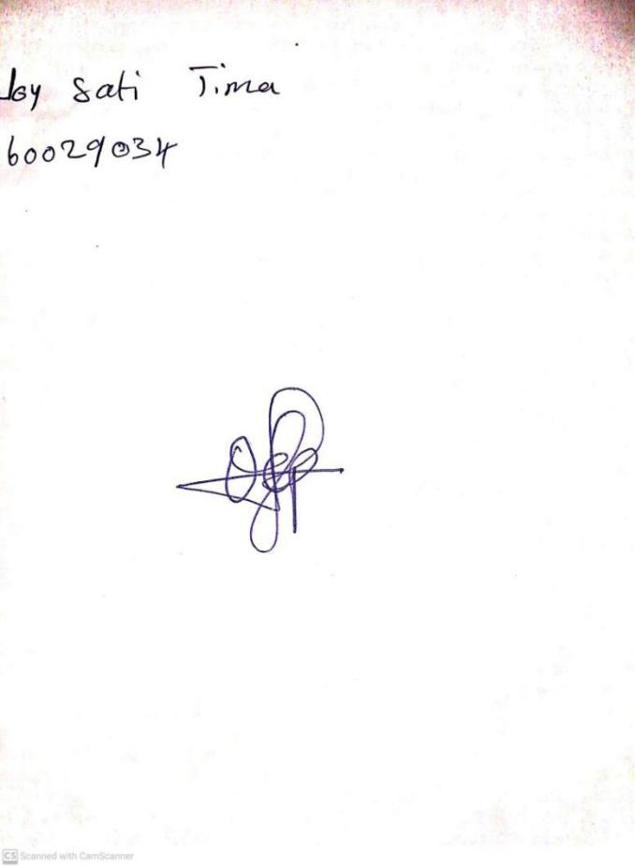

**2ND FEBRUARY, 2024**

**Perpetual Ojoma Ocheja**

**Stream Head Nursery**