EMERALD ROYAL INTERNATIONAL SCHOOL

MPAPE, ABUJA.

LESSON PLAN AND NOTE FOR WEEK 2 ENDING 12TH MAY,2023

TERM: Third term.

WEEK: 2nd

SUBJECT: Nature studies.

TOPIC: Water

SUB-TOPIC: Sources of water and uses of water

DATE: 11/5/2023

DURATION: 40 minutes

TIME: 08:50-09:30

PERIOD: 3rd

CLASS: Pre-nursery

NUMBER OF PUPILS: 11

AVERAGE AGE: 2 years

SEX: Mixed

SPECIFIC OBJECTIVES: By the end of the lesson, the pupils should be able to:-

I mention sources of water.

2. State the uses of water.

RATIONALE: For Pupils to know the sources of water

PREVIOUS KNOWLEDGE: Pupils have been drinking good water.

INSTRUCTIONAL MATERIALS: Table, chair, Pupils in the class .

REFERENCE: Showers kiddies books Elementary science book nursery 1 by Showers kiddies books.

LESSON DEVELOPMENT

|  |  |  |  |
| --- | --- | --- | --- |
| Stages/steps | Teacher's activities | Pupils' activities | Learning points |
| Introduction | Teacher introduces the lesson by singing a nursery rhyme as:-  Water Water water  Water is life.  Anytime am thirsty.  I drink clean water. | Pupils listen to the teacher and practice the rhyme and sing along with the teacher.. | To arouse the interest of the pupils. |
| Presentation  Step 1 | Teacher mentions the sources of water as:-  Rain water.  River water.  Tap water.  Well water.  Spring water | Pupils listen to the teacher and repeat after the teacher. | For better understanding of the lesson. |
| Step 2 | Teacher asks the pupils what they use water to do. | Pupils state the uses of water as:-  We use We use water for bathing.  It is used for cooking.  It is used for washing clothes.  It is used for washing our plates.  It is used for washing our hand.  We drink water. | For better understanding of the lesson. |
| Summary | Teacher summarizes the lesson by going over the lesson again for more understanding. | Pupils listen attentively to the teacher as she is going over the lesson. | To ensure better understanding. |
| Evaluation | Teacher asks the Pupils to :-   1. State the sources of water.   Il. Mention the uses of water. | Pupils answer the teacher's questions correctly. | To ascertain the level of pupils understanding of the lesson. |
| Conclusion | Teacher concludes the lesson by singing nursery rhymes for the pupils on water | Pupils sing along with the teacher. | To improve the pupils speaking ability. |
| Assignment | Teacher encourages the pupils to always look into the water before drinking to make sure that the water is clean. | Pupils do the assignment at home. | To encourage Learning at home. |

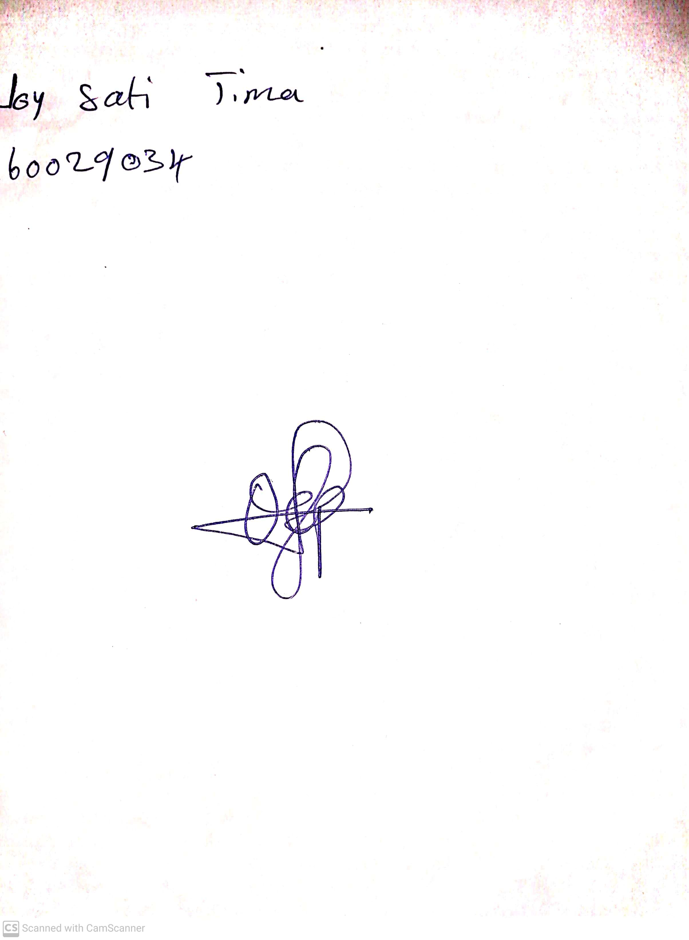

29th April, 2023

Perpetual Ojoma

Stream Head Nursery