**LESSON PLAN/NOTE FOR WEEK 5 ENDING 02/ 06/ 2023.**

**Term**: 3rd

**Week**: 5

**Date**: 29/05/2023

**Class**: SS 1

**Subject**: Civic Education

**Topic**: cultism

**Sub-Topic**: preventive measures against cultism.

**Period**: 3rd

**Time**: 9:30-10:10

**Duration**: 40 Minutes

**Number in class:** 8 students

**Average Age**: 14 years

**Sex**: mixed

**Specific objectives:** By the end of the lesson, the students should be able to:

(1) Define cultism.

(11) state the preventives measures on cultism

(111) Explain the preventives measures on cultism .

**Rationale**: For the students to be able to profer solution to the problem of cultism and why they should not join cults.

**Previous knowledge:** The students have seen people renouncing cultism and some are been recue from the hand of cultist.

**Instructional material**: A chart showing Police arresting cults groups and some been expelled from school.

**Reference material:** Gbenga Babalola (2017) Essential civic Education for senior secondary schools.

**LESSON DEVELOPMENT**

|  |  |  |  |
| --- | --- | --- | --- |
| **Stages/Steps** | **Teacher's Activities** | **Students' Activities** | **Learning points** |
| **Introduction** | Review the previous lesson. | Participate actively in the class discussion. | To arouse the students interest to learn. |
| **Step 1** | Defines cultism as: cultism is a social crime and their activities are often laden with blood. | Listen carefully to the teacher | For better understanding of the lesson. |
| **Step 11** | Asks the students to state the preventives measures against cultism. | State the preventives measures against cultism as: (1) legislation (2) moral education etc | To encourage critical thinking. |
| **Step 111** | Guides the students to explain the preventives measures against cultism. | Respond to the class activity. | To enable the students reason logically. |
| **Board summary** | Summarizes the lesson as:  **Preventives measures against cultism**  Cultism is a social crime and their activities are often laden with blood. There is urgent need to put an end to the evil. Some people have openly declared that cultism is as condemnable as armed robbery. Therefore, in order to curb it, there should be the following measures:  (1) A definite legislation that will pass a death sentence to anybody found quilty of cults activities on the campuses.  (2) Moral education should be made compulsory in the primary and secondary schools in the country.  (3) cultism and its consequences should be treated in the general studies courses in the country.  (4) parents should take time to understand their children, give enough time to listen to them at home and satisfy their emotional, psychological and physical needs.  (5) parents should watch the friends their wards are keeping in the institutions. There should also take time to watch any strange behavior put up by their wards and correct them immediately.  (6) Aggressive efforts to wage war against cultism in all tertiary institutions should be allowed by government and religious groups in the country. | Copy and submit the note book for marking | For future reference. |
| **Evaluation** | Evaluates the students as:  (1) Explain cultism  (2) state 5 ways to prevent cultism in Nigeria.  (3) Explain any 4 of the preventives measures against cultism. | Respond to the questions | Ascertaining the attainment of the stated objectives. |
| **Conclusion** | Rounds up the lesson by marking and correcting students work | Check and do their correction | Consolidation of the lesson. |
| **Assignment** | Gives home work as:  (1) suggest 5 ways on how to stop cultism in Nigeria. | Respond by doing the home work at home. | To ensure continuity of learning. |

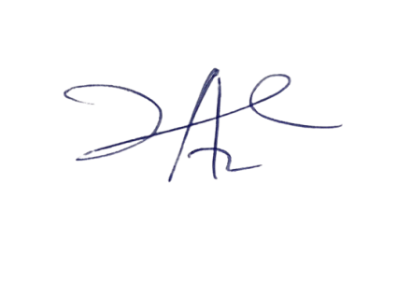

2/6/2023

Principal Head Instuctor