**LESSON PLAN AND NOTE 1 FOR WEEK 2 ENDING 12/5/2023**

**Term 3rd term**

**Week 2nd week**

**Date 12/5/2023**

**Class Nursery one**

**Subject Number work**

**Topic Numbers before and after.**

**Sub-topic Meaning and Learning of numbers before & after.**

**Period 2nd period**

**Time 9:05 am**

**Duration 35 minutes**

**No in class 19**

**Average Age 3 years**

**Sex Mixed**

**Specific Objectives: By the end of the lesson the pupils should be able to;**

1. **Define numbers before & after**
2. **Learn numbers before and after.**

**Rationale: To make sure the pupils define & learn numbers before & after**

**Previous knowledge: The pupils can colour & match numbers 90 - 100.**

**Instructional Resources: Numbers before and after chart.**

**Reference Materials: Online Research,chart,board.**

**LESSON PRESENTATION**

|  |  |  |  |
| --- | --- | --- | --- |
| **Steps** | **Teacher’s Activities** | **Pupils’ Activities** | **Learning Points** |
| **Introduction** | **The teacher introduces the topic [numbers before and after] to the pupils.** | **The pupils listen attentively to the teacher.** | **To arouse the interest of the pupils.** |
| **Step 1** | **The teacher defines numbers before and after "as numbers that comes before a particular number and numbers that comes after a particular number" to the pupils.**  **The pupils listens to the teacher's definition of numbers before and after.** | **For proper understanding.** | **For proper understanding.** |
| **Step 2** | **The teacher leads the pupils to learn numbers before and after with examples**  **Numbers before**  **1 2 3 4 5 6 7**  **1 is before 2**  **6 is before 7**  **3 is before 4**  **Numbers after**  **10 11 12 13 14 15**  **12 is after 11**  **11 is after 10**  **15 is after 14.** | **The pupils learns the numbers before and after with their teacher.** | **For better understanding.** |
| **Summary** | **The teacher summarizes the lesson by defining numbers before and after.** | **The pupils knows numbers before and after.** | **For onward study.** |
| **Evaluation** | **Question:**  **Define numbers before and after?**  **After 15 is what ___________?** | **The pupils answer the question correctly.** | **To ascertain the pupils understanding.** |
| **Conclusion** | **The teacher summarizes, reacts, and corrects the pupils.** | **The pupils gives answers to the teacher.** | **To consolidate the lesson.** |
| **Assignment** | **Write the following numbers before and after below**  **After 2 is _________**  **Before 8 is __________**  **Before 11 is _________** | **The pupils copy and do their homework at home.** | **To encourage learning while at home.** |

**LESSON PLAN AND NOTE 2 FOR WEEK 2 ENDING 12/5/2023**

**Term 3rd term**

**Week 2nd week**

**Date 12/5/2023**

**Class Nursery one**

**Subject Number work**

**Topic Numbers before and after.**

**Sub-topic Identification of numbers before and after.**

**Period 2nd period**

**Time 9:35 am**

**Duration 35 minutes**

**No in class 19**

**Average Age 3 years**

**Sex Mixed**

**Specific Objectives: By the end of the lesson the pupils should be able to;**

1. **Identify numbers before and after**
2. **Sorting numbers before and after.**

**Rationale: To make sure the pupils identify and sort numbers before & after.**

**Previous knowledge: The pupils defines and learns numbers before and after.**

**Instructional Resources: Numbers before and after chart.**

**Reference Materials: Online Research,chart,board.**

**LESSON PRESENTATION**

|  |  |  |  |
| --- | --- | --- | --- |
| **Steps** | **Teacher’s Activities** | **Pupils’ Activities** | **Learning Points** |
| **Introduction** | **The teacher introduces the topic [Numbers before and after] to the pupils.** | **The pupils listen attentively to the teacher.** | **To arouse the interest of the pupils.** |
| **Step 1** | **The teacher leads the pupils to identify numbers before and after.** | **The pupils identify with their teacher numbers before and after.** | **For proper understanding.** |
| **Step 2** | **The teacher leads the pupils in sorting numbers before and after**  **Numbers before**   |  |  |  | | --- | --- | --- | |  | **8** | **9** | |  | **53** | **54** | |  | **32** | **33** |   **Numbers after**   |  |  |  | | --- | --- | --- | | **3** | **4** |  | | **68** | **69** |  | | **14** | **15** |  | | **The pupils can sort numbers before and after.** | **For better understanding.** |
| **Summary** | **The teacher summarizes the lesson by sorting numbers before for the pupils**   |  |  |  | | --- | --- | --- | | **7** | **8** | **9** | | **52** | **53** | **54** | | **31** | **32** | **33** | | **The pupils can sort numbers before and after.** | **For onward study.** |
| **Evaluation** | **Question:**  **Identify the numbers 52,53,54,55**  **Sort the numbers before below**   |  |  |  | | --- | --- | --- | |  | **11** | **12** | |  | **43** | **44** | |  | **22** | **23** | | **The pupils answer the question correctly.** | **To ascertain the pupils understanding.** |
| **Conclusion** | **The teacher summarizes, reacts, and corrects the pupils.** | **The pupils gives answers to the teacher.** | **To consolidate the lesson.** |
| **Assignment** | **Sort the numbers after below**   |  |  |  | | --- | --- | --- | | **10** | **11** |  | | **34** | **35** |  | | **56** | **57** |  | | **The pupils copy and do their homework at home.** | **To encourage learning while at home.** |

**LESSON PLAN AND NOTE 3 FOR WEEK 2 ENDING 12/5/2023**

**Term 3rd term**

**Week 2nd week**

**Date 12/5/2023**

**Class Nursery one**

**Subject Number work**

**Topic Numbers before and after.**

**Sub-topic Writing numbers before and after**

**Period 2nd period**

**Time 9:50 am**

**Duration 35 minutes**

**No in class 19**

**Average Age 3 years**

**Sex Mixed**

**Specific Objectives: By the end of the lesson the pupils should be able to;**

1. **Write numbers before and after**

**Rationale: To make sure the pupils write numbers before and after.**

**Previous knowledge: The pupils can identify and sort numbers before and after.**

**Instructional Resources: Numbers before and after chart.**

**Reference Materials: Online Research,chart,board.**

**LESSON PRESENTATION**

|  |  |  |  |
| --- | --- | --- | --- |
| **Steps** | **Teacher’s Activities** | **Pupils’ Activities** | **Learning Points** |
| **Introduction** | **The teacher introduces the topic [Number before and after] to the pupils.** | **The pupils listen attentively to the teacher.** | **To arouse the interest of the pupils.** |
| **Step 1** | **The teacher gives inside their notebooks random numbers before and after for the pupils to write.**  **Numbers after**   |  |  |  | | --- | --- | --- | | **5** | **6** |  | | **72** | **73** |  | | **32** | **33** |  |   **Numbers before**   |  |  |  | | --- | --- | --- | |  | **55** | **56** | |  | **24** | **25** | |  | **61** | **62** | | **The pupils write the numbers before and after**   |  |  |  | | --- | --- | --- | | **5** | **6** | **7** | | **72** | **73** | **74** | | **32** | **33** | **34** |  |  |  |  | | --- | --- | --- | | **54** | **55** | **56** | | **23** | **24** | **25** | | **60** | **61** | **62** | | **For proper understanding.** |
| **Summary** | **The teacher summarizes the lesson defining numbers before and after as "numbers that comes before a particular number and numbers that comes after a particular number".** | **The pupils understands the lesson.** | **For onward study.** |
| **Evaluation** | **Question:**  **After 56 is ________**  **After 99 is ________**  **Before 65 is _______**  **Before 43 is ______** | **The pupils answer the question correctly.** | **To ascertain the pupils understanding.** |
| **Conclusion** | **The teacher summarizes, reacts, and corrects the pupils.** | **The pupils gives answers to the teacher.** | **To consolidate the lesson.** |
| **Assignment** | **Questions:**  **Fill in the right numbers before and after below**  **Numbers before**   |  |  |  | | --- | --- | --- | |  | **34** | **35** | |  | **65** | **65** | |  | **12** | **13** |   **Number after**   |  |  |  | | --- | --- | --- | | **98** | **99** |  | | **45** | **46** |  | | **87** | **88** |  | | **The pupils copy and do their homework at home.** | **To encourage learning while at home.** |

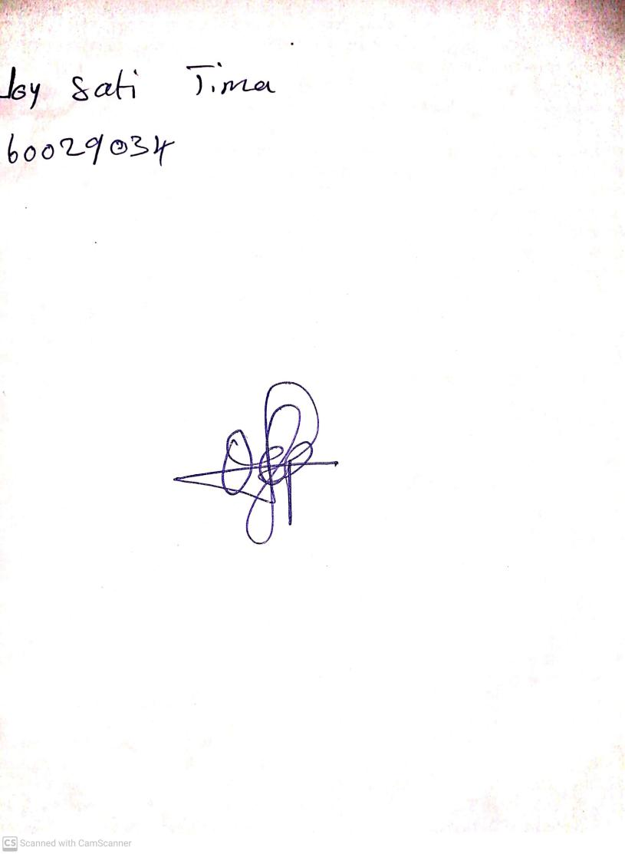

10th May, 2023

Perpetual Ojoma

Stream Head Nursery