EMERALD ROYAL INTERNATIONAL SCHOOL MPAPE, ABUJA

LESSON PLAN AND NOTE FOR WEEK 7 PERIOD 1 ENDING 27/10/2023

TERM: FIRST

WEEK: 7TH

DATE: 23/10/2023

CLASS: NURSERY 2

SUBJECT: NUMBER WORK

TOPIC: SHAPES

SUB-TOPIC: MEANING OF SHAPES AND EXAMPLES.

PERIOD: 2ND

TIME: 08: 50-09: 30 am

DURATION: 40 MINUTES

NUMBER IN CLASS: 16

AVERAGE AGE: 4

SEX: MIXED

SPECIFIC OBJECTIVES: BY THE END OF THE LESSON, THE PUPILS SHOULD BE ABLE

TO:

1. IDENTIFY OBJECTS AROUND US.
2. SAY THE SHAPES OF THE OBJECTS.

RATIONALE: FOR PUPILS TO BE ABLE TO KNOW SHAPES AROUND THEM.

PREVIOUS KNOWLEDGE: PUPILS ARE USED TO OBJECTS AROUND THEM.

INSTRUCTIONAL MATERIALS: CLOCK, MATCHES BOX, WHITE BOARD, CUBE OF SUGAR AND

DICE.

REFERENCE MATERIALS: MY CHOICE OF MATHEMATICS STAGE 3 BY TOP STAR.

LESSON DEVELOPMENT

|  |  |  |  |
| --- | --- | --- | --- |
| STAGES/STEPS | TEACHER’S ACTIVITIES | PUPILS’ ACTIVITIES | LEARNING POINT |
| INTODUCTION | Teacher introduces the lesson by reviewing the previous lesson. | Pupils listen attentively to the teacher. | To arouse pupils interest for the lesson ahead. |
| PRESENTATION STEP 1 | Teacher use cube of sugar, dice, matches box, tin, ball, and whiteboard to explain the shape identify to pupils and then asks them to repeat after her. | Pupils pay attention to the teacher and repeat after her. | For proper understanding. |
| STEP 2 | Teacher says the shape of the objects mentioned above to pupils and also asks them to repeat after her. | Pupils pay attention to the board and tell the time. | To create plat form for slow learners. |
| BOARD SUMMARY | Teacher summarizes the lesson by writing the whole note of lesson on the board for pupils to copy into their books. That is;  SHAPES  Every object around us has shape.  The different shapes are :   1. Rectangle 2. Triangle 3. Square 4. Circle 5. Oval 6. Cylinder etc. | Pupils copy the note on the board into their exercise books. | For onward study. |
| EVALUATION | Teacher evaluates the lesson by asking the following questions:  What is the shape of the following ?   1. Cube of sugar 2. Dice 3. Matches box 4. Tin 5. Ball 6. Whiteboard | Pupils answer the questions asked by the teacher. | To asses pupils level of understanding of the lesson. |
| CONCLUSION | Teacher concludes the lesson by marking pupils books. | Pupils submit their books for marking. | For endorsement. |
| ASSIGNMENT | ACTIVITY 1 page 110 , AND ACTIVITY 2 page 111. | Pupils do their assignment at home. | To encourage learning at home. |

EMERALD ROYAL INTERNATIONAL SCHOOL MPAPE, ABUJA

LESSON PLAN AND NOTE FOR WEEK 7 PERIOD 2 ENDING 27/10/2023

TERM: FIRST

WEEK: 7TH

DATE: 24/10/2023

CLASS: NURSERY 2

SUBJECT: NUMBER WORK

TOPIC: SHAPE

SUB-TOPIC: CIRCLE AND TRIANGLE

PERIOD: 2ND

TIME: 08: 50-09: 30 am

DURATION: 40 MINUTES

NUMBER IN CLASS: 16

AVERAGE AGE: 4

SEX: MIXED

SPECIFIC OBJECTIVES: BY THE END OF THE LESSON, THE PUPILS SHOULD BE ABLE

TO:

1.IDENTIFY SHAPE OF CIRCLE AND TRIANGLE

2. EXPLAIN THE SIDES AND CORNERS OF CIRCLE AND THAT

OF A TRIANGLE.

RATIONALE: FOR PUPILS TO KNOW MORE ABOUT CIRCLE AND TRIANGLE.

PREVIOUS KNOWLEDGE: PUPILS HAVE LEARNT ABOUT MEANING OF SHAPES AN EXAMPLES OF SHAPES IN PREVIOUS LESSON.

INSTRUCTIONAL MATERIALS: A CLOCK AND A FUNNEL.

REFERENCE MATERIALS: MY CHOICE OF MATHEMATICS STAGE 3 BY TOP STAR.

LESSON DEVELOPMENT

|  |  |  |  |
| --- | --- | --- | --- |
| STAGES/STEPS | TEACHER’S ACTIVITIES | PUPILS’ ACTIVITIES | LEARNING POINT |
| INTODUCTION | Teacher introduces the lesson by reviewing the previous lesson. | Pupils listen attentively to the teacher. | To arouse pupils interest for the lesson ahead. |
| PRESENTATION STEP 1 | Teacher draws a circle and a triangle shape on the board for pupils to identify. | Pupils pay attention to the teacher and identify the shapes on the board. | For proper understanding. |
| STEP 2 | Teacher explains the sides and corners of a circle and triangle to the pupils and then asks them to repeat after her. | Pupils listen very attentively to the teacher and repeat after her. | For better understanding of the lesson. |
| BOARD SUMMARY | Teacher summarizes the lesson by writing the whole note of lesson on the board for pupils to copy into their books. That is;  Sides and corners of a circle and triangle   1. A circle is round in shape it has no sides. 2. A triangle has three (3) equal sides and three (3 ) corners. | Pupils copy the note on the board into their exercise books. | For onward study. |
| EVALUATION | Teacher evaluates the lesson by asking the following questions;   1. What is a circle? 2. How may sides and corners does a triangle has? | Pupils answer the questions asked by the teacher. | To asses pupils level of understanding of the lesson. |
| CONCLUSION | Teacher concludes the lesson by marking pupils books. | Pupils submit their books for marking. | For endorsement. |
| ASSIGNMENT | Assignment on page 112, activity 3. | Pupils do their assignment at home. | To encourage learning at home. |

EMERALD ROYAL INTERNATIONAL SCHOOL MPAPE, ABUJA

LESSON PLAN AND NOTE FOR WEEK 7 PERIOD 3 ENDING 27/10/2023

TERM: FIRST

WEEK: 7TH

DATE: 27/10/2023

CLASS: NURSERY 2

SUBJECT: NUMBER WORK

TOPIC: SHAPES.

SUB-TOPIC: SQUARE AND RECTANGLE .

PERIOD: 1ST

TIME: 08: 10-08:50 am

DURATION: 40 MINUTES

NUMBER IN CLASS: 16

AVERAGE AGE: 4

SEX: MIXED

SPECIFIC OBJECTIVES: BY THE END OF THE LESSON, THE PUPILS SHOULD BE ABLE

TO:

1. IDENTIFY THE SHAPE OF A SQUARE AND RECTANGLE
2. EXPLAIN THE SIDES AND CONNERS OF A SQUARE AND

RECTANGLE.

RATIONALE: FOR PUPILS TO KNOW HOW TO IDENTIFY VARIOUS SHAPES.

PREVIOUS KNOWLEDGE: PUPILS HAVE LEARNT ABOUT THE SHAPE OF A CIRCLE AND TRIANGLE IN PREVIOUS LESSON.

INSTRUCTIONAL MATERIALS: A DICE AND A MATCHES BOX.

REFERENCE MATERIALS: TOP STAR MY CHOICE OF MATHEMATICS STAGE 3 BY TOP STAR PUBLISHING LTD.

LESSON DEVELOPMENT

|  |  |  |  |
| --- | --- | --- | --- |
| STAGES/STEPS | TEACHER’S ACTIVITIES | PUPILS’ ACTIVITIES | LEARNING POINT |
| INTODUCTION | Teacher introduces the lesson by reviewing the previous lesson. | Pupils listen attentively to the teacher. | To arouse pupils interest for the lesson ahead. |
| PRESENTATION STEP 1 | Teacher draws the shape of a rectangle and square on the board for pupils to identify. | Pupils pay attention to the teacher and identify the shapes on the board. | For proper understanding. |
| STEP 2 | Teacher explains the sides and corners of a rectangle and square to pupils and also asks them to repeat after her. | Pupils listen very attentively to the teacher and repeat after her. | For better understanding of the lesson. |
| BOARD SUMMARY | Teacher summarizes the lesson by writing the whole note of lesson on the board for pupils to copy into their books. That is;  Rectangle and square   1. A rectangle has four (4) sides. Not all the sides are equal,   Opposite sides are equal and parallel.  A rectangle also has four (4) corners.   1. A square has four (4) sides. All sides are equal and four (4) corners. | Pupils copy the note on the board into their exercise books. | For onward study. |
| EVALUATION | Teacher evaluates the lesson by asking pupils to explain the following shapes;   1. Rectangle 2. square | Pupils answer the questions asked by the teacher. | To asses pupils level of understanding of the lesson. |
| CONCLUSION | Teacher concludes the lesson by marking pupils books. | Pupils submit their books for marking. | For endorsement. |
| ASSIGNMENT | Assignment page 113 activity 4. | Pupils do their assignment at home. | To encourage learning at home. |

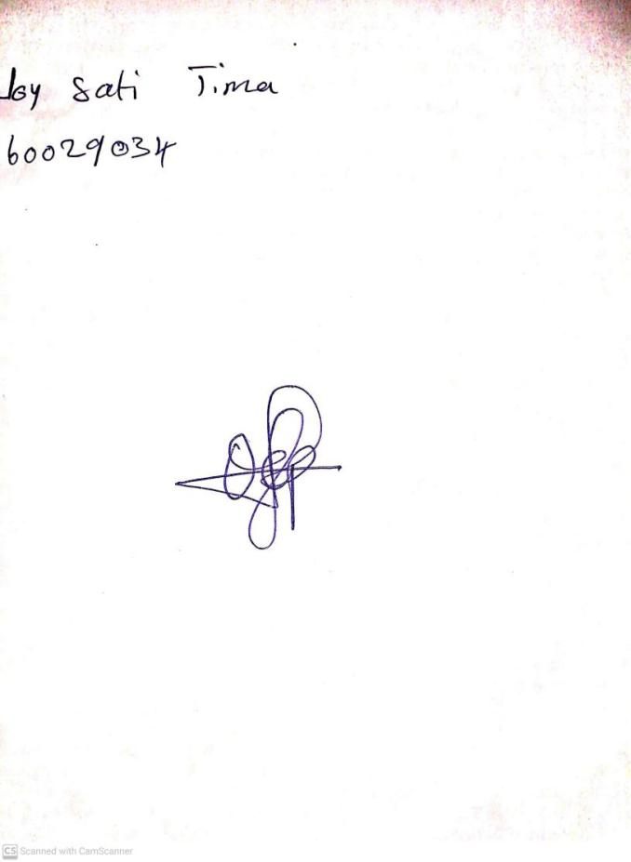

27th August, 2023

Perpetual Ojoma Ocheja

Stream Head Nursery