**EMERALD ROYAL INTERNATIONAL SCHOOL**

**MPAPE, ABUJA.**

**LESSON PLAN AND NOTE FOR WEEK 2 PERIOD 1 ENDING 20/09/2024**

**TERM: FIRST**

**WEEK: 2ND**

**DATE: 16/09/2024**

**CLASS: NURSERY 2**

**SUBJECT: LITERACY**

**TOPIC: THREE LETTER WORDS"AT” "AD", "AN"**

**"AG", "AM" AND "AP" .**

**SUB-TOPIC: THREE LETTER WORDS ENDING IN " AT" , AND "**

**" AD".**

**PERIOD: 1ST**

**TIME: O8:50-09:30.**

**DURATION: 40 MINUTES.**

**NUMBER IN CLASS: 17**

**AVERAGE AGE: 5 YEARS.**

**SEX: MIXED.**

**SPECIFIC OBJECTIVES: BY THE END OF THE LESSON,THE PUPILS SHOULD BE**

**ABLE TO:**

**1. IDENTIFY THREE LETTER WORDS ENDING IN "AT"**

**AND " AD".**

**2. SPELL AND PRONOUNCE THREE LETTER WORDS**

**ENDING IN "AT" AND "AD".**

**RATIONALE: FOR PUPILS TO BE ABLE TO SPELL AND PRONOUNCE**

**THERE LETTER WORDS ENDING IN "AT" AND "AD".**

**PREVIOU KNOWLEDGE: PUPILS HAVE LEARNT TWO LETTER WORDS IN PREVIOUS LESSON.**

**INSTRUCTIONAL MATERIALS: MAT, HAT, AND PICTURE OF A SAD FACE.**

**REFERENCE MATERIALS: MASTERING ENGLISH BOOK 2 BY J. M OMOGBAI**

**LESSON DEVELOPMENT**

|  |  |  |  |
| --- | --- | --- | --- |
| **STAGES/STEPS** | **TEACHER’S ACTIVITIES** | **PUPILS’ ACTIVITIES** | **LEARNING POINTS** |
| **INTRODUCTION** | **Teacher introduces the lesson by asking pupils to recite two Letter words..** | **Pupil listen to the teacher and recite two letter words.** | **To arouse pupils interest for the lesson ahead.** |
| **PRESENTATION**  **STEP 1** | **Teacher presents the lesson by writes three letter words ending in " at" and "ad" on the board, identify and then asks pupils to repeat after her.** | **Pupils pay attention and repeat after the teacher.** | **For proper understanding of the lesson .** |
| **STEP 2** | **Teacher spells and pronounce the three letter words ending in "at" and "ad" on the board and also asks pupils to repeat after her.** | **Pupils spelled the three letter words on the board after the teacher.** | **For better understanding of the lesson.** |
| **BOARD SUMMARY** | **Teacher summarizes the lesson by writing the whole note of lesson on the board for pupils to copy into their books.that is,**  **THREE LETTER WORDS ENDING IN "AT" AND "AD" ARE:**  **"at" as in;**   1. **Cat** 2. **Fat** 3. **Pat** 4. **Sat** 5. **Hat** 6. **Rat** 7. **Bat** 8. **Mat etc.**   **"ad" as in;**   1. **Lad** 2. **Bad** 3. **Sad** 4. **Dad** 5. **Mad** 6. **Had** 7. **Pad etc.** | **Pupils copy the note into their exercise books.** | **For onward study.** |
| **EVALUATION** | **Teacher asks pupils to go to the board one after the other and read.** | **Pupils read the note on the board one after another.** | **To assess pupils level of understanding of the lesson so far.** |
| **CONCLUSION** | **Teacher marks pupils books.** | **Pupils submit their books for marking.** | **For endorsement.** |
| **ASSIGNMENT** | **Assignment on page 23 in Mastering English text book.** | **Pupils do their assignment at home.** | **To encourage learning at home.** |

**LESSON PLAN AND NOTE FOR WEEK 2 PERIOD 2 ENDING 20/09/2024**

**TERM: FIRST**

**WEEK: 2ND**

**DATE: 17/09/2024**

**CLASS: NURSERY 2**

**SUBJECT: LITERACY**

**TOPIC: THREE LETTER WORDS ENDING IN "AT " ,"AD","AN",**

**"AG", " AM" AND "AP".**

**SUB-TOPIC: THREE LETTER WORDS ENDING IN" AN" AND "AG".**

**PERIOD: 2ND**

**TIME: O8:50-09:30.**

**DURATION: 40 MINUTES.**

**NUMBER IN CLASS: 17**

**AVERAGE AGE: 5 YEARS.**

**SEX: MIXED.**

**SPECIFIC OBJECTIVES: BY THE END OF THE LESSON,THE PUPILS SHOULD BE**

**ABLE TO:**

**1. IDENTIFY THREE LETTER WORDS ENDING IN" AN"**

**AND "AG".**

**2. SPELL AND PRONOUNCE THREE LETTER WORDS**

**ENDING IN " AN" AND "AG".**

**RATIONALE: FOR PUPILS TO BE ABLE TO READ WORDS THAT ENDS**

**WITH " AN" AND "AG".**

**PREVIOU KNOWLEDGE: PUPILS HAVE LEARNT THREE LETTER WORDS ENDING IN " AT" AND "AD" IN PREVIOUS LESS0N.**

**INSTRUCTIONAL MATERIALS: TAG, FAN, BAG AND RAG.**

**REFERENCE MATERIALS: MASTERING ENGLISH 2 BY J. M OMOGBAI.**

**LESSON DEVELOPMENT**

|  |  |  |  |
| --- | --- | --- | --- |
| **STAGES/STEPS** | **TEACHER’S ACTIVITIES** | **PUPILS’ ACTIVITIES** | **LEARNING POINTS** |
| **INTRODUCTION** | **Teacher introduces the lesson by reviewing the previous lesson.** | **Pupil listen attentively to the teacher.** | **To arouse pupils interest for the lesson ahead.** |
| **PRESENTATION**  **STEP 1** | **Teacher presents the lesson by writing three Letter words ending in "an" and "ag" on the board, identify and then asks pupils to repeat after.** | **Pupils listen and repeat after the teacher.** | **For proper understanding of the lesson .** |
| **STEP 2** | **Teacher spells and pronounce the three letter words ending in "an" and "ag" on the board and also asks pupils to repeat after her.** | **Pupils pay attention and repeat after the teacher.** | **For better understanding of the lesson.** |
| **BOARD SUMMARY** | **Teacher summarizes the lesson by writing the whole note of lesson on the board for pupils to copy into their books.that is;**  **THREE LETTER WORDS ENDING IN "AN" AND "AG" ARE:**  **"an" as in;**   1. **Can** 2. **Fan** 3. **Ran** 4. **Pan** 5. **Man** 6. **Ban etc.**   **"ag" as in;**   1. **Rag** 2. **Bag** 3. **Tag** 4. **Wag** 5. **Sag** 6. **Nag etc.** | **Pupils copy the note into their exercise books.** | **For onward study.** |
| **EVALUATION** | **Teacher asks Pupils to read the three Letter words ending in "an" and "ag" on the board one after the other.** | **Pupils read the note on the board one after another.** | **To assess pupils understanding of the lesson.** |
| **CONCLUSION** | **Teacher marks pupils books.** | **Pupils submit their books for marking.** | **For endorsement.** |
| **ASSIGNMENT** | **Assignment on page 25 in Mastering English.** | **Pupils do their assignment at home.** | **To encourage learning at home.** |

**LESSON PLAN AND NOTE FOR WEEK 2 PERIOD 3 ENDING 18/09/2024**

**TERM: FIRST**

**WEEK: 2ND**

**DATE: 18/09/2024**

**CLASS: NURSERY 2**

**SUBJECT: LITERACY**

**TOPIC: THREE LETTER WORDS ENDING IN "AT", " AD",**

**"AN", " AG", "AM", AND " AP".**

**SUB-TOPIC: THREE LETTER WORDS ENDING IN "AM" AND "AP".**

**PERIOD: 3RD**

**TIME: 08:10- 08:50am**

**DURATION: 40 MINUTES.**

**NUMBER IN CLASS: 17**

**AVERAGE AGE: 5 YEARS.**

**SEX: MIXED.**

**SPECIFIC OBJECTIVES: BY THE END OF THE LESSON,THE PUPILS SHOULD**

**BE ABLE TO:**

**1. IDENTIFY THREE LETTER WORDS ENDING IN "AM"**

**AND "AP".**

**2. SPELL AND PRONOUNCE THREE LETTER WORDS**

**ENDING IN "AM" AND "AP".**

**RATIONALE: FOR PUPILS TO KNOW HOW TO PRONOUNCE WORDS**

**THAT ENDS WITH " AM" AND "AP".**

**PREVIOU KNOWLEDGE: PUPILS HAVE LEARNT ABOUT THREE LETTER WORDS ENDING IN "AN" AND "AG" IN PREVIOUS LESS0N.**

**INSTRUCTIONAL MATERIALS: CAP AND YAM.**

**REFERENCE MATERIALS: MASTERING ENGLISH BOOK 2 BY J.M OMOGBAI.**

**LESSON DEVELOPMENT**

|  |  |  |  |
| --- | --- | --- | --- |
| **STAGES/STEPS** | **TEACHER’S ACTIVITIES** | **PUPILS’ ACTIVITIES** | **LEARNING POINTS** |
| **INTRODUCTION** | **Teacher introduces the lesson by reviewing the previous lesson.** | **Pupils pay attention to the teacher.** | **To arouse pupils interest for the lesson ahead.** |
| **PRESENTATION**  **STEP 1** | **Teacher presents the lesson by writing three letter words ending in "am" and "ap" on the board, identify and then asks pupils to repeat after her.** | **Pupils listen to the teacher and repeat after her.** | **For proper understanding of the lesson .** |
| **STEP 2** | **Teacher guides pupils to spell and pronounce the words ending in "am" and "ap" on the board.** | **Pupils spell and pronounced the words on the board.** | **For better understanding of the lesson.** |
| **BOARD SUMMARY** | **Teacher summarizes the lesson by preparing pupils books for them to copy the note on the board.ie,**  **Three Letter words ending in " am" and "ap" are:**  **"am" as in;**   1. **Ram** 2. **Yam** 3. **Dam** 4. **Sam** 5. **Pam** 6. **Fam** 7. **Lam** 8. **Cam etc.**   **"ap" as in;**   1. **Map** 2. **Pap** 3. **Tap** 4. **Cap** 5. **Lap** 6. **Gap** 7. **Nap etc.** | **Pupils copy the note into their exercise books.** | **For onward study.** |
| **EVALUATION** | **Teacher evaluates the lesson by asking pupils to all stand and spell and pronounce three Letter words ending in "am" and "ap" on the board all together.** | **Pupils all stand and spelled and pronounced the words on the board.** | **To create platform for slow learners.** |
| **CONCLUSION** | **Teacher concludes the lesson by marking pupils books.** | **Pupils submit their books for marking.** | **For endorsement.** |
| **ASSIGNMENT** | **Fill in the missing letters and pronounce.**   1. **M ___ t** 2. **B ___g** 3. **B ___ t** 4. **R ___ g** 5. **M ___ d** 6. **M ___ p** 7. **D ___ d** 8. **L ___ p** 9. **R ___ M** 10. **R ___ t** | **Pupils do their assignment at home.** | **To encourage learning at home.** |

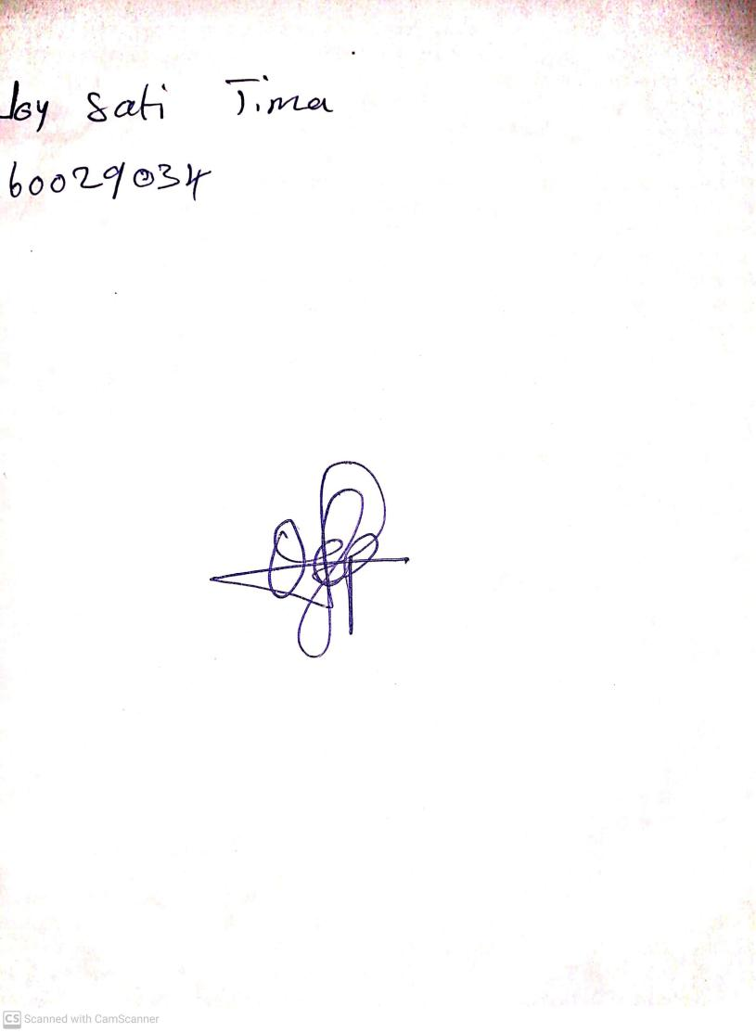

**13th September, 2024**

**Perpetual Ojoma Ocheja**

**Stream Head Nursery**