**LESSON PLAN AND NOTE FOR WEEK 3 ENDING 26/01/2024**

**Term 2nd term**

**Week 3rd week.**

**Date 23rd January ,2024**

**Class Nursery one**

**Subject Social Norms**

**Topic Social studies**

**Sub-topic Meaning & types of social studies**

**Period 3rd period**

**Time 9:30am**

**Duration 35 minutes**

**No in class 15**

**Average Age 3 years**

**Sex Mixed**

**Specific Objectives: By the end of the lesson the pupils should be able to:**

1. **Define social studies**
2. **Mention the types of social studies**

**Rationale: To ensure the pupils know the meaning of social studies Previous Knowledge: The pupils can identify places and activities in their school Instructional Resources: Board,marker ,online research.**

**Reference Materials: Smart smart Civic Education by A.M Solu, T.Y Alabi, Nursery 2**

**LESSON PRESENTATION**

|  |  |  |  |
| --- | --- | --- | --- |
| **Steps** | **Teacher’s Activities** | **Pupils’ Activities** | **Learning Points** |
| **Introduction** | **The teacher introduces the topic (Social studies) by teaching the pupils the meaning of social studies as “the study of man and it’s environment”.** | **The pupils listen attentively to the teacher and repeats the meaning of social studies continuously** | **To arouse the pupils’ interest towards the lesson.** |
| **Step 1** | **The teacher assists the pupils to continuously say the meaning of social studies.** | **The pupils repeats continuously the meaning of social studies.** | **For proper understanding.** |
| **Step 2** | **The teacher teaches the pupils the types of social studies that includes physical and social environment** | **The pupils pays attentively to the teacher’s teaching and they mention the types of social studies.** | **For better understanding.** |
| **Summary** | **The teacher summarizes the lesson by listing examples of physical environment such as “land”, “river”.** | **The pupil understands the lesson [social studies]** | **For onward study.** |
| **Evaluation** | **Question:**   1. **What is social studies?** 2. **Mention the types of social studies?** | **The pupils answer the questions accordingly.** | **To ascertain the pupils’ understanding.** |
| **Conclusion** | **The teacher summarizes,reacts,and corrects the pupils.** | **The teacher gives answers to the teacher’s question.** | **To consolidate the lesson.** |
| **Assignment** | **Question:**   1. **What is social studies?** 2. **Mention the types of social studies?** | **The pupils copy and do their homework at home.** | **To encourage learning while at home.** |

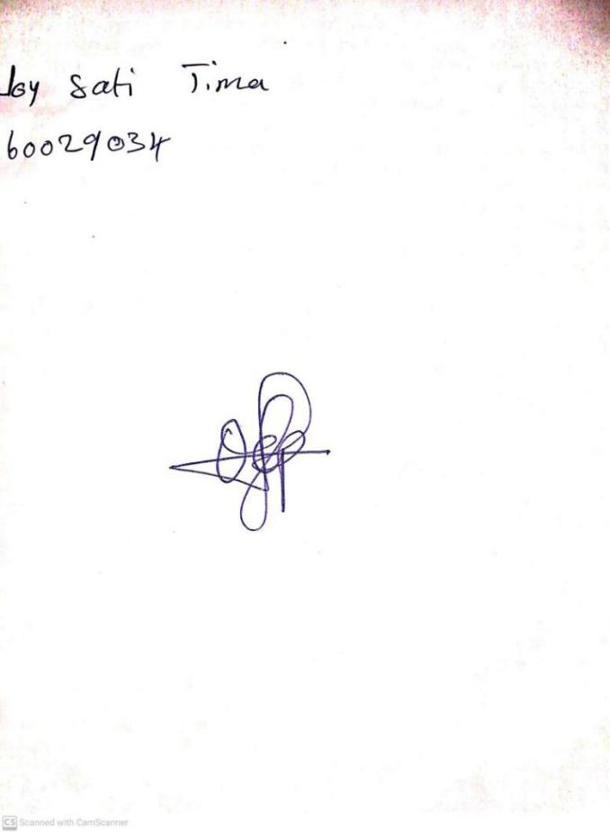

19TH January, 2024

Perpetual Ojoma Ocheja

Stream Head Nursery