**EMERALD ROYAL INTERNATIONAL SCHOOL MPAPE, ABUJA**

**LESSON PLAN AND NOTE FOR WEEK 5 ENDING 09/02/2024**

**TERM: 2nd**

**WEEK: 5**

**DATE: 05/02/2024**

**CLASS: Nursery 2**

**SUBJECT: Letter work**

**TOPIC: Initial and final consonant blend**

**SUB—TOPIC: Meaning of final consonant blends and Examples**

**PERIOD: 3rd**

**TIME: 09:30—10:10am**

**DURATION: 40**

**NUMBER IN CLASS: 13**

**AVERAGE AGE: 5 years**

**SEX: Mixed**

**LEARNING OBJECTIVES: By the end of the lesson, the Pupils should be able to:**

**1. Explain the meaning of final consonant blend**

**2. Mention the examples of final consonant blend**

**RATIONALE: For Pupils to know what final consonant means.**

**PREVIOUS KNOWLEDGE: Pupils have learnt the meaning and examples of initial consonant blend in previous lesson.**

**INSTRUCTIONAL MATERIALS: A chart of final consonant blends**

**REFERENCE MATERIALS: My choice of English Language stage 3 by J.F. OMOTAYO**

**LESSON DEVELOPMENT**

|  |  |  |  |
| --- | --- | --- | --- |
| **STEPS** | **TEACHER'S ACTIVITIES** | **PUPILS' ACTIVITIES** | **LEARNING POINT** |
| **Introduction** | **Teacher introduces the lesson by asking pupils the meaning of initial consonant blend.** | **Pupils answer the question ask by the teacher** | **To prepare pupils minds for the lesson ahead.** |
| **Presentation step 1** | **Teacher explains the meaning of final consonant blend and then asks Pupils to repeat after her.** | **Pupils listen to the teacher and repeat after her.** | **For proper understanding.** |
| **Step 2** | **Teacher mentions the examples of final consonant blends and also asks Pupils to repeat after her.** | **Pupils pay attention to the teacher and repeat after her.** | **For better understanding.** |
| **Board summary** | **Teacher summarizes the lesson by writing the whole note on the board for pupils to copy. That is;**  **Initial final consonant blends: This is a group of letters, usually two or three that make their own sound at the end of the word.**  **Examples are.**  **1. Mask**  **2. Lamp**  **3. Sand**  **4. Cold**  **5. Golf**  **6. Tent**  **7. Bird**  **8. Park**  **9. Bank**  **10.Skunk** | **Pupils copy the note into their exercise books.** | **For onward study.** |
| **Evaluation** | **Teacher evaluates the lesson by asking pupils to spell and pronounce the examples of final consonant blends on the board one after the other.** | **Pupils go to the board one after the other to spell and pronounce the words on the board.** | **To enhance Pupils participation in class.** |
| **Conclusion** | **Teacher evaluates the lesson by marking pupils books.** | **Pupils submit their books for marking.** | **For endorsement.** |
| **Assignment** | **Generate words with the following final consonant blends**  **1. St**  **2. SK**  **3. Ld** | **Pupils do their assignment at home.** | **To encourage learning at home.** |

**LESSON PLAN AND NOTE FOR WEEK 5 ENDING 09/02/2024**

**TERM: 2nd**

**WEEK: 5**

**DATE: 08/02/2024**

**CLASS: Nursery 2**

**SUBJECT: Letter work**

**TOPIC: Initial and final consonant blends 1**

**SUB—TOPIC: Generating words with“ st”and “sk”**

**PERIOD: 2nd period**

**TIME: 08:50—09:30am**

**DURATION: 40 minutes**

**NUMBER IN CLASS: 13**

**AVERAGE AGE: 5 years**

**SEX: Mixed**

**LEARNING OBJECTIVES: By the end of the lesson, the Pupils should be able to:**

**1.Generate words with initial and final consonant “st”**

**2. Form words with initial and final consonant “sk”**

**RATIONALE: For Pupils to know the difference between initial and final consonant blends.**

**PREVIOUS KNOWLEDGE: Pupils have learnt the meaning and examples of final consonant blends.**

**INSTRUCTIONAL MATERIALS: A chart of initial and final consonant blends words.**

**REFERENCE MATERIALS: My choice of English Language stage 3 by J.F OMOTAYO**

**LESSON DEVELOPMENT**

|  |  |  |  |
| --- | --- | --- | --- |
| **STEPS** | **TEACHER'S ACTIVITIES** | **PUPILS' ACTIVITIES** | **LEARNING POINT** |
| **INTRODUCTION** | **Teacher introduces the lesson by singing nursery rhymes.** | **Pupils sing the rhymes along with the teacher.** | **To arouse pupils interest for the lesson.** |
| **PRESENTATION STEP 1** | **Teacher presents the lesson by generating words with initial and final consonant “st” on the board and then asks Pupils to spell and pronounce after her.** | **Pupils listen to the teacher and then spell and pronounce the words on the board after her.** | **For proper understanding.** |
| **STEP 2** | **Teacher forms words with initial and final consonant 'sk' on the board and also asks Pupils to repeat after her.** | **Pupils pay attention to the teacher and repeat after her.** | **For better understanding.** |
| **BOARD SUMMARY** | **Teacher writes the whole note of lesson on the board for pupils to copy. That is;**  **INITIAL AND FINAL CONSONANT ‘ST’**   |  |  | | --- | --- | | **Initial consonant ‘st’** | **Final consonant ‘st’** | | **Stop** | **List** | | **Stamp** | **Twist** | | **Star** | **Wrist** | | **Stick** | **Host** | | **Stoop** | **Cast** | | **Starch** | **Dust** | | **State** | **Fast** | | **Stork etc.** | **Nest etc.** |   **INITIAL AND FINAL CONSONANT ‘SK’**   |  |  | | --- | --- | | **Initial consonant ‘sk’** | **Final consonant ‘sk’** | | **Skirt** | **Dusk** | | **Sky** | **Desk** | | **Skip** | **Task** | | **Skull** | **Mask** | | **Skeleton** | **Risk** | | **Skunk** | **Disk** | | **Skim** | **Brisk** | | **Skillet etc.** | **Tusk etc.** | | **Pupils copy the note into their books.** | **For onward study.** |
| **EVALUATION** | **Teacher evaluates the lesson by asking pupils to all stand and then, spell and pronounce the initial and final consonant blends ‘st’ and ‘sk’ on the board.** | **Pupils all stand and then spell and pronounce the words on the board all together.** | **To assess Pupils reading ability.** |
| **CONCLUSION** | **Teacher concludes the lesson by marking pupils books.** | **Pupils submit their books for marking.** | **For endorsement.** |
| **ASSIGNMENT** | **Generate words with the following initials and final consonant blends**  **1). ‘ld’**  **2). ‘nd’**  **3). ‘nk’** | **Pupils do their assignment at home.** | **To encourage learning at home.** |

**LESSON PLAN AND NOTE FOR WEEK 5 ENDING 09/02/2024**

**TERM: 2nd**

**WEEK: 5**

**DATE: 09/02/2024**

**CLASS: Nursery 2**

**SUBJECT: Letter work**

**TOPIC: Initial and final consonant 1**

**SUB—TOPIC: Generating words with initial ‘ld’ ‘nd ’and ‘nk’**

**PERIOD: 3rd**

**TIME: 09:30—10:10am**

**DURATION: 40 minutes**

**NUMBER IN CLASS: 13**

**AVERAGE AGE: 5 years**

**SEX: Mixed**

**LEARNING OBJECTIVES: By the end of the lesson, the Pupils should be able to:**

**1. Make words with final consonant ‘ld’**

**2. Generate words with final consonant ‘nd’**

**3. Form words with final consonant ‘nk’**

**RATIONALE: For Pupils to know more of final consonant blends.**

**PREVIOUS KNOWLEDGE: Pupils have learnt words with initial and final consonant ‘st’ and ‘sk’ in previous lesson.**

**INSTRUCTIONAL MATERIALS: A chart of final initial**

**REFERENCE MATERIALS: My choice of English Language stage 3 by J.M. OMOTAYO**

**LESSON DEVELOPMENT**

|  |  |  |  |
| --- | --- | --- | --- |
| **STAGES/ STEPS** | **TEACHER'S ACTIVITIES** | **PUPILS' ACTIVITIES** | **LEARNING POINT** |
| **Introduction** | **Teacher introduces the lesson by singing nursery rhymes.** | **Pupils sing the rhymes along with the teacher.** | **To arouse pupils interest for the lesson.** |
| **Presentation step 1** | **Teacher makes words with final consonant 'ld' on the board and ask Pupils to repeat after her.** | **Pupils pay attention to the teacher and repeat after her.** | **For proper understanding.** |
| **Step 2** | **Teacher generates words with final consonant 'nd' and also asks Pupils to repeat after her.** | **Pupils listen to the teacher and also repeat after the teacher.** | **For better than.** |
| **Step 3** | **Teacher guides pupils to form words with final consonant ‘nk’.** | **Pupils form words with final consonant ‘nk’** | **To enhance Pupils participation in class.** |
| **Board summary** | **Teacher summarizes the lesson by writing the whole note of lesson on the board for pupils to copy. That is;**  **FINAL CONSONANT ‘LD’ ARE:**  **1. Cold**  **2. Told**  **3. Fold**  **4. Mold**  **5. Gold**  **6. Sold etc**  **FINAL CONSONANT ‘ND’ ARE:**  **1. Sand**  **2. Wand**  **3. Pond**  **4. Send**  **5. Tend**  **6. Find etc**  **FINAL CONSONANT ‘NK‘ARE:**  **1.Skunk**  **2. Sink**  **3. Think**  **4. Thank**  **5. Tank**  **6. Drunk**  **7. Blink**  **8. Frank**  **9. Blank**  **10. Bank etc.** | **Pupils copy the note on the board into their exercise books.** | **For onward study.** |
| **Evaluation** | **Teacher evaluates the lesson by asking pupils to spell and pronounce the words on the board one after the other.** | **Pupils spell and pronounce the words on the board one after the other** | **To assess Pupils pronunciation ability.** |
| **Conclusion** | **Teacher concludes the lesson by marking pupils books.** | **Pupils submit their books for marking.** | **For endorsement.** |
| **Assignment** | **Identify and write 10 things you can see in your house.** | **Pupils do their assignment at home.** | **To encourage learning at home.** |

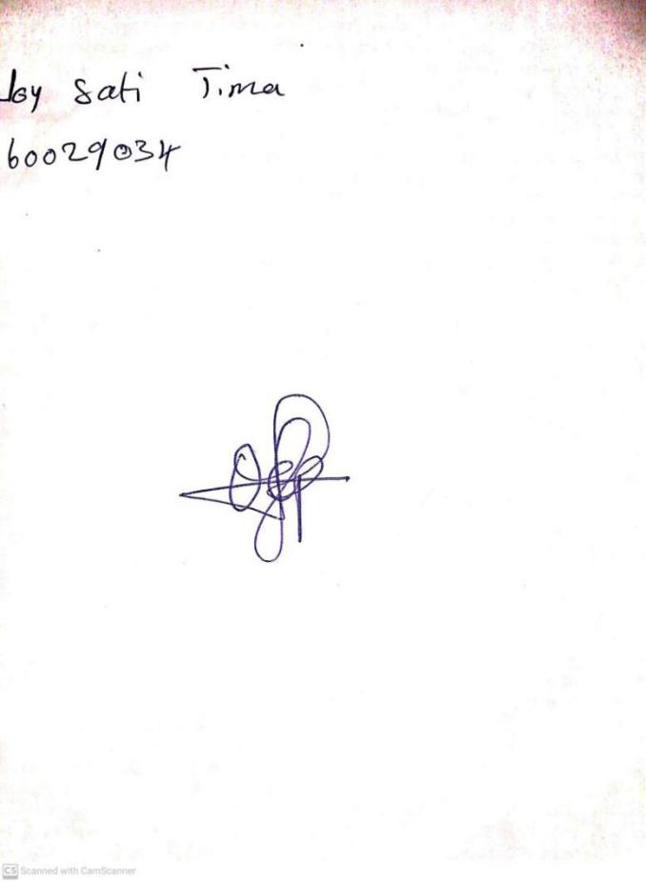

**2ND FEBRUARY, 2024**

**Perpetual Ojoma Ocheja**

**Stream Head Nursery**