**EMERALD ROYAL INTERNATIONAL SCHOOL**

**MPAPE, ABUJA.**

**LESSON PLAN AND NOTE FOR WEEK 8 PERIOD 1 ENDING 23/06/2023**

TERM: 3RD

WEEK: 8TH

DATE: 19/06/2023

CLASS: NURSERY 2

SUBJECT: NUMBERWORK

TOPIC: NUMBERS IN WORDS 11-20 .

SUB-TOPIC: RECITING AND WRITING OF NUMBERS 11-15

PERIOD: 1ST

TIME: O8:50-09:30.

DURATION: 40 MINUTES.

NUMBER IN CLASS: 17

AVERAGE AGE: 5 YEARS.

SEX: MIXED.

SPECIFIC OBJECTIVES: BY THE END OF THE LESSON,THE PUPILS SHOULD BE

ABLE TO:

1. RECITE NUMBERS IN WORDS 11-15
2. IDENTIFY AND READ NUMBERS IN WORDS 11-15

RATIONALE: FOR PUPILS TO KNOW NUMBERS IN WORDS 11-15

PREVIOU KNOWLEDGE: PUPILS HAVE LEARNT NUMBERS IN WORDS 1-10 PREVIOUS LESS0N.

INSTRUCTIONAL MATERIALS: A CHART OF NUMBERS IN WORDS 11-15 .

REFERENCE MATERIALS: THE NEW MASTERING MATHEMATICS FOR NURSERY SCHOOLSBOOK 3 BY HENRY.Z.IDOGUN.

**LESSON DEVELOPMENT**

|  |  |  |  |
| --- | --- | --- | --- |
| STAGES/STEPS | TEACHER’S ACTIVITIES | PUPILS’ ACTIVITIES | LEARNING POINTS |
| INTRODUCTION | Teacher introduces the lesson by reviewing the previous lesson. | Pupil listen to the teacher. | To arouse pupils interest for the lesson ahead. |
| PRESENTATION  STEP 1 | Teacher recites numbers 11-15 and then asks pupils to repeat after her. | Pupils listen attentively to the teacher and repeat after her. | For proper understanding of the lesson . |
| STEP 2 | Teacher writes numbers 11-15 in words on the board and then recite and also asks pupils to identify and repeat after her. | Pupils pay attention to the board and repeat after the teacher. | For better understanding of the lesson. |
| BOARD SUMMARY | Teacher summarizes the lesson by writing the whole note of lesson on the board for pupils to copy into their books. That is,  NUMBERS IN WORDS 11-15  Eleven 11  Twelve 12  Thirteen 13  Fourteen 14  Fifteen 15 | Pupils copy the note into their exercise books. | For onward study. |
| EVALUATION | Teacher asks Pupils to identify and recite the number in words 11-15 on the board one after the other. | Pupils identify and recite the number in words 11-15 on the board one after another. | To assess pupils understanding of the lesson. |
| CONCLUSION | Teacher marks pupils books. | Pupils submit their books for marking. | For endorsement. |
| ASSIGNMENT | Identify, recite and write numbers 16-20 in words | Pupils do their assignment at home. | To encourage learning at home. |

**LESSON PLAN AND NOTE FOR WEEK 8 PERIOD 2 ENDING 23/06/2023**

TERM: 3RD

WEEK: 8TH

DATE: 20/06/2023

CLASS: NURSERY 2

SUBJECT: NUMBER WORK

TOPIC: NUMBERS IN WORDS 11-20 .

SUB-TOPIC: IDENTIFY, RECITE AND WRITE NUMBERS IN WORDS 16- 20

PERIOD: 2nd

TIME: O8:50-09:30.

DURATION: 40 MINUTES.

NUMBER IN CLASS: 17

AVERAGE AGE: 5 YEARS.

SEX: MIXED.

SPECIFIC OBJECTIVES: BY THE END OF THE LESSON,THE PUPILS SHOULD BE

ABLE TO:

1. RECITE NUMBERS IN WORDS 16-20
2. IDENTIFY AND READ NUMBERS IN WORDS 16-20

RATIONALE: FOR PUPILS TO KNOW NUMBERS IN WORDS 16-20 .

PREVIOU KNOWLEDGE: PUPILS HAVE LEARNT NUMBERS IN WORDS 11-15 IN PREVIOUS LESS0N.

INSTRUCTIONAL MATERIALS: A CHART OF NUMBERS IN WORDS 16- 20 .

REFERENCE MATERIALS: THE NEW MASTERING MATHEMATICS FOR NURSERY SCHOOLSBOOK 3 BY HENRY.Z.IDOGUN.

**LESSON DEVELOPMENT**

|  |  |  |  |
| --- | --- | --- | --- |
| STAGES/STEPS | TEACHER’S ACTIVITIES | PUPILS’ ACTIVITIES | LEARNING POINTS |
| INTRODUCTION | Teacher introduces the lesson by asking pupils to all stand and recite numbers in words 11- 15. | Pupil all stand and recite numbers in words 11-15 | To prepare pupils minds for the lesson ahead. |
| PRESENTATION  STEP 1 | Teacher presents the lesson by reciting numbers in words 16-20 and then asks pupils to repeat after. | Pupils pay attention to the teacher and the repeat after her. | For proper understanding of the lesson . |
| STEP 2 | Teacher writes numbers in words 16-20 on the board and then read and also asks pupils to repeat after her. | Pupils pay attention to the teacher and repeat after her. | For better understanding of the lesson. |
| BOARD SUMMARY | Teacher summarizes the lesson by writing the whole note of lesson on the board for pupils to copy into their books .That is,  NUMERS IN WORDS 16-20  SIXTEEN 16  SEVENTEEN 17  EIGHTEEN 18  NINTEEN 19  TWENTY 20 | Pupils copy the note into their exercise books. | For onwardstudy. |
| EVALUATION | Teacher asks Pupils to all stand and recite number in words 16-20 on the board all together. | Pupils all stand and recite the numbers 16-20 in words on the board all together. | To create platform for slow learners. |
| CONCLUSION | Teacher marks pupils books. | Pupils submit their books for marking. | For endorsement. |
| ASSIGNMENT | Identify, recite and write numbers in words 11-20. | Pupils do their assignment at home. | To encourage learning at home. |

**LESSON PLAN AND NOTE FOR WEEK 8 PERIOD 3 ENDING 23/06/2023**

TERM: 3RD

WEEK: 8TH

DATE: 23/06/2023

CLASS: NURSERY 2

SUBJECT: NUMBER WORK

TOPIC: NUMBERS IN WORDS 11-20 .

SUB-TOPIC: IDENTIFY,READ AND WRITE NUMBER IN WORDS 11-20

PERIOD: 3RD

TIME: 08:10- 08:50am

DURATION: 40 MINUTES.

NUMBER IN CLASS: 17

AVERAGE AGE: 5 YEARS.

SEX: MIXED.

SPECIFIC OBJECTIVES: BY THE END OF THE LESSON,THE PUPILS SHOULD BE

ABLE TO:

1. READ NUMBERS IN WORDS 11-20 ORALLY

2. WRITE NUMBERS IN WORDS 11-20

RATIONALE: FOR PUPILS TO BE COVERSANT WITH NUMBERS IN

WORDS 1-10.

PREVIOU KNOWLEDGE: PUPILS HAVE LEARNT NUMBERS IN WORDS 11- 20

INSTRUCTIONAL MATERIALS: NUMBER CHART IN WORDS 11-20 .

REFERENCE MATERIALS: THE NEW MASTERING MATHEMATICS FOR NURSERY

SCHOOLS BOOK 3 BY J.M OMOGBAI.

**LESSON DEVELOPMENT**

|  |  |  |  |
| --- | --- | --- | --- |
| STAGES/STEPS | TEACHER’S ACTIVITIES | PUPILS’ ACTIVITIES | LEARNING POINTS |
| INTRODUCTION | Teacher introduces the lesson by singing nursery numbers rhymes .That  1little, 2little, 3little fingers  4little, 5little,6little figers……… | Pupils sing the rhymes along with the teacher. | To arouse pupils interest for the lesson ahead. |
| PRESENTATION  STEP 1 | Teacher presents the lesson by writing numbers in words 11-20 on the board and then recites and then asks pupils to repeat after her. | Pupils listen to the teacher and repeat after her. | For proper understanding of the lesson . |
| STEP 2 | Teacher guides pupils to recite numbers in words 11-20 often and often. | Pupils recite numbers 11-20 in words often and often. | For better understanding of the lesson. |
| BOARD SUMMARY | Teacher summarizes the lesson by preparing pupils books for them to copy the note on the board.ie,  NUMBERS IN WORDS 11-20..  Eleven 11  Twelve 12  Thirteen 13  Fourteen 14  Fifteen 15  Sixteen 16  Seventeen 17  Eighteen 18  Ninteen 19  Twenty 20 | Pupils copy the note into their exercise books. | For onwardstudy. |
| EVALUATION | Teacher evaluates the lesson by asking pupils to all stand and recite numbers in words 11-20 on the board all together. | Pupils all stand and recite numbers 11-20 in words on the board all together. | To create platform for slow learners. |
| CONCLUSION | Teacher concludes the lesson by marking pupils notes . | Pupils submit their books for marking. | For endorsement. |
| ASSIGNMENT | Practice and write numbers in words 1-20 | Pupils do their assignment at home. | To encourage learning at home. |

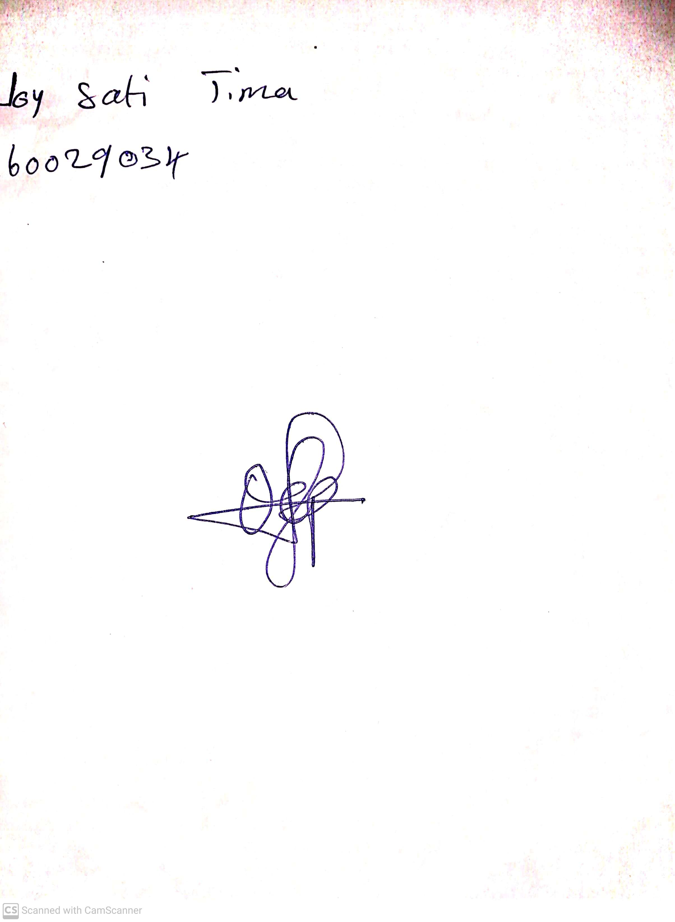

14th May, 2023

Perpetual Ojoma

Stream Head Nursery