LESSON PLAN AND NOTE FOR WEEK 6 ENDING 20/10/2023

TERM: 1st

WEEK: 6th

DATE: 16/10/2023

CLASS: Nursery 2

SUBJECT: Nature studies

TOPIC: Living things

SUB—TOPIC: Meaning, examples and characteristics of living things.

PERIOD: 4th

TIME: 10:40—11:20am

DURATION: 40 minutes

NUMBER IN CLASS: 14

AVERAGE AGE: 5 years

SEX: Mixed

LEARNING OBJECTIVES: By the end of the lesson, the pupils should be able to:

1. Define living things.

2. Mention the examples of living things

3. State the characteristics of living things.

RATIONALE: For pupils to know what living things means.

PREVIOUS KNOWLEDGE: Pupils have been seeing plants, animals and human beings without knowing there are living things.

INSTRUCTIONAL MATERIALS: A plant, pictures f animals, trees and humans in pupils text books.

REFERENCE MATERIALS: Basic science and technology for Nursery schools book 3 by OPEMIPO DADA.

LESSON DEVELOPMENT

|  |  |  |  |
| --- | --- | --- | --- |
| Steps | Teacher's activities | Pupils' activities | Learning point |
| Introduction | Teacher introduces the lesson by reviewing the previous lesson. | Pupils pay attention to the teacher. | To prepare pupils minds for the lesson ahead. |
| Presentation step 1 | Teacher defines living things to pupils and then asks them to repeat after her. | Pupils listen to the teacher and repeat after her. | To improve pupils listening and speaking ability. |
| Step 2 | Teacher mentions the examples of living things to pupils and also asks them to repeat after her. | Pupils pay attention to the teacher and repeat her. | To enhance pupils participation in the class. |
| Step 3 | Teacher states the characteristics of living things to pupils and also asks pupils to repeat after her. | Pupils listen attentively to the teacher and repeat after her. | To improve pupils speaking ability. |
| Board summary | Teacher writes the whole note of lesson on the board for pupils to copy into their books. That is;  Living things:  Living things are those things that have life in them.  Examples of living things:   1. Human beings 2. Animals 3. Plants 4. Insects   Characteristics of living things:  Characteristics of living things are MR NIGER D which means;  M — Movement  R — Reproduction  N — Nutrition  I — Irritability  G — Growth  E — Excretion  R — Respiration  D — Death | Pupils copy the note into their exercise books. | For onward study. |
| Evaluation | Teacher evaluates the lesson by asking pupils the following questions;   1. Define living things. 2. Mention the examples of living things. 3. States the characteristics of living things. | Pupils answer the questions asked by the teacher. | To assess pupils level of understanding. |
| Conclusion | Teacher concludes the lesson by marking pupils books. | Pupils submit their books for marking. | For endorsement. |
| Assignment | 1. What are non living things? 2. Mention 5 examples of non living things in the classroom. 3. State 5 examples of non living things at home. | Pupils do their assignment at home. | To encourage learning at home. |

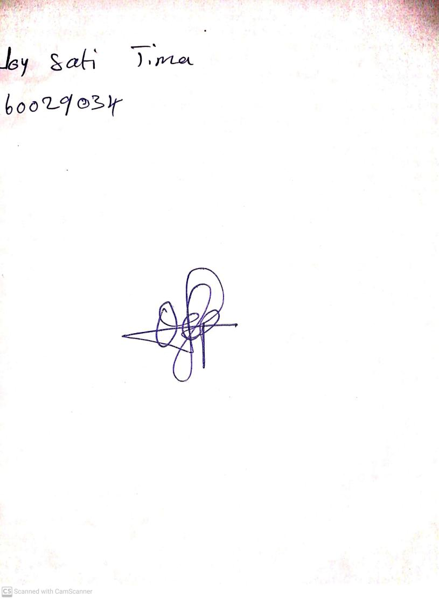

27th August, 2023

Perpetual Ojoma Ocheja

Stream Head Nursery