**LESSON PLAN AND NOTE FOR WEEK 3 ENDING 19/5/2023**

**Term 3rd term**

**Week 3rd week**

**Date 19/5/2023**

**Class Nursery one**

**Subject Nature studies**

**Topic Balanced Diet**

**Sub-topic Meaning of balanced diet.**

**Period 2nd period**

**Time 9:05 am**

**Duration 35 minutes**

**No in class 18**

**Average Age 3 years**

**Sex Mixed.**

**Specific Objectives: By the end of the lesson, the pupils should know how to:**

1. **Define balanced diet**
2. **Name examples of balanced diet.**

**Rationale: To help the pupils have vital knowledge of balanced diet.**

**Previous Knowledge: The pupils have knowledge of food.**

**Instructional Resources: Online Research,Balanced diet chart.**

**Reference Materials: Online Research, Elementary Science by Showers Kiddies.**

**LESSON PRESENTATION**

|  |  |  |  |
| --- | --- | --- | --- |
| **Steps** | **Teacher’s Activities** | **Pupils’ Activities** | **Learning Points** |
| **Introduction** | **The teacher introduces the topic (Balanced Diet) by showing the pupils pictures of examples of balanced diet.** | **The pupils could identify the examples of balanced diet meal.** | **To arouse the interest of the pupils.** |
| **Step 1** | **The teacher starts the lesson by teaching the pupils the meaning of balanced diet as “the act of eating a meal that is right and complete”.** | **The pupils listen attentively to the teacher and repeats after the teacher the meaning of balanced diet.** | **For proper understanding.** |
| **Step 2** | **The teacher mention the examples of balanced diet that includes**  **Friuts e.g Apple,etc**  **Vegetables e.g Tomatoes**  **Protein e.g Meat etc**  **Rice etc** | **The pupils listens to the teacher and repeats the examples of balanced diet.** | **For better understanding.** |
| **Step 3** | **The teacher lists the examples of balanced diet**  **Rice**  **Meat**  **Milk**  **Juice**  **Tomatoes**  **Mango etc** | **The pupils listens to the teacher attentively hearing their favourite food.** | **For further understanding.** |
| **Summary** | **The teacher summarizes the lesson by defining balanced diet.** | **The pupils knows the definition of balanced diet.** | **For onward study.** |
| **Evaluation** | **Question:**  **Define Balanced Diet?**  **Mention the three examples of balanced diet?.** | **The pupils answer the question correctly.** | **To ascertain the pupils’ understanding.** |
| **Conclusion** | **The teacher summarizes, reacts, and corrects the pupils.** | **The pupils gives answers to the teacher’s question.** | **To consolidate the lesson.** |
| **Assignment** | **Question:**  **Mention your own balanced diet meal you like?** | **The pupils copy and do their homework at home.** | **To encourage learning while at home.** |

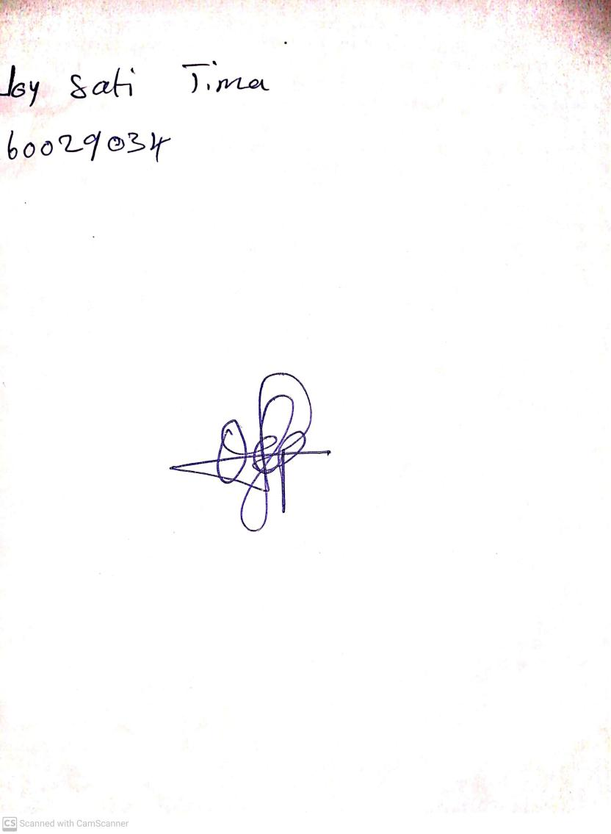

30th April, 2023

Perpetual Ojoma

Stream Head Nursery