**LESSON PLAN/NOTE FOR WEEK 6 ENDING 09/06/2023**

**Term**: 3rd

**Week**: 6

**Date**: 07/06/2023

**Class**: SS 1

**Subject**: Civic Education

**Topic**: Orderliness

**Sub-Topic:** Examples of orderliness in the society.

**Period**: 5th

**Time**: 11:10-11:50

**Duration**: 40 Minutes

**Number in class**: 8 students

**Average Age**: 14 Years

**Sex**: Mixed

**Specific objectives:** By the end of the lesson, the students should be able to:

(1) State the Examples of orderliness

(11) Explain the examples of orderliness

**Rationale**: For the students to be able to be able to follow due process in handling issues and obeying rules and regulations.

**Previous knowledge**: The students have been following issues accordingly in the school.

**Instructional material**: A chart showing people queue in the bank to withdraw and to deposit money.

**Reference material:** Gbenga Babalola (2017) Essential civic Education for senior secondary schools.

**LESSON DEVELOPMENT**

|  |  |  |  |
| --- | --- | --- | --- |
| **Stages/Steps** | **Teacher's Activities** | **Students' Activities** | **Learning points** |
| **Introduction** | Review the previous lesson | Participate actively in the class discussion | To arouse the students interest to learn. |
| **Step 1** | States the examples of orderliness as:  (1) Queuing culture (2) Decorum etc. | Listen carefully to the teacher | For better understanding of the lesson. |
| **Step 11** | Guides the students to explain the examples of orderliness in the society | Respond to the class activity | To encourage critical thinking. |
| **Board summary** | Summarizes the lesson as:  **Examples of orderliness in the society**  (1) Queuing culture: Queuing is an important way to maintain orderliness in the society. There may be need for us to queue up at some places where many people want to enjoy same services with us. This will help in letting things go in a well orderly manner. Examples of places where we may need to queue up are: Hospitals, banks, airports, petrol stations, supermarkets, ATM points etc.  (2) Decorum: This is referring to as a requirement of correct behavior in polite society. It is a right behaviour expected at a particular situation. This behaviour should be exhibited always. For example, perfect silence is expected from students while the principal is giving them instructions on the assembly ground.  (3) Obeying traffic rules and regulation: It is important for us to obey traffic rules and regulations while driving. There is need for proper understanding of traffic signs. | Copy and submit the note book for marking. | For future reference. |
| **Evaluation** | Evaluates the students as:  (1) state 3 examples of orderliness in the society  (2) Explain 2 examples of orderliness in the society. | Respond to the questions | Ascertaining the attainment of the stated objectives. |
| **Conclusion** | Rounds up the lesson by marking and correcting students work. | Check do their correction | Consolidation of the lesson. |
| **Assignment** | Gives home work as:  (1) Explain the following examples of orderliness: (a) Decorum (b) Queue (c) traffic. | Respond by doing the home work at home | To ensure continuity of learning. |

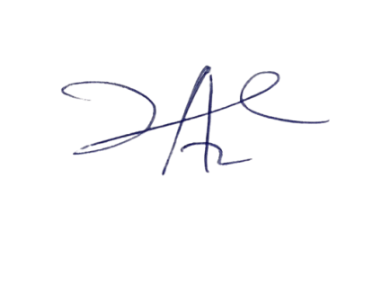

2/6/2023

Principal Head Instuctor