**EMERALD ROYAL INTERNATIONAL SCHOOL, MPAPE ABUJA**

**LESSON PLAN AND NOTE FOR WEEK 8 ENDING FRIDAY, 3RD NOVEMBER, 2023**

**TERM:** FIRST TERM

**WEEK:** WEEK 8

**SUBJECT:** BASIC SCIENCE

**TOPIC:** AIR

**SUB-TOPIC:** MEANING OF AIR

**DATE:** TUESDAY, 31ST OCTOBER, AND WEDNESDAY, 1ST NOVEMBER, 2023

**TIME:** 08:45 – 09:25AM AND 09:25 – 09:55AM

**DURATION:** 40 MINUTES

**PERIOD:** 2ND AND 3RD

**CLASS:** NURSERY 3

**NUMBER IN CLASS:** ELEVEN

**AVERAGE AGE:** FIVE

**SEX:** MIXED

**LEARNING OBJECTIVES:** By the end of the lesson, the pupils should be able to:

1. Define the meaning of air.
2. State the uses of air.

**RATIONALE:** for pupils to learn the meaning of air.

**PREVIOUS KNOWLEGDE:** pupils have learnt the meaning and types of soil.

**INSTRUCTIONAL MATERIALS:**

1. Flash cards.
2. Road chart.

**REFERENCE MATERIALS:**

Smart Basic Science and Technology book 1 by D. I. Bika, Cambridge University Press

**LESSON DEVELOPMENT**

|  |  |  |  |
| --- | --- | --- | --- |
| **STAGES/STEPS** | **TEACHER’S ACTIVITIES** | **PUPILS’ ACTIVITIES** | **LEARNING POINTS** |
| **INTRODUCTION** | Review previous knowledge | Respond to the teacher | To arouse the pupils’ interest. |
| **PRESENTATION**  **STEP 1** | Teaches and explain the meaning of air.  **Meaning of air**  Air is an invisible gas that we cannot see, smell or taste but we can feel it presence. | Define the meaning of air. | Meaning of air. |
| **STEP 2** | Teaches the uses of air  **Uses of air**   1. We breathe in and out air all the time. This is because we need air to live. 2. Air is used to make kite fly. 3. Air helps plant to grow through the process of photosynthesis. 4. Its helps in combustion. 5. It helps in temperature control 6. It helps bird to fly from one place to another. | State the uses of air. | Uses of air. |
| **SUMMARY** | Summarises the lesson by emphasising on the main concept and writes note on the board | Listen and copy their notes | For onward study |
| **EVALUATION** | Asks pupils to:   1. Define air. 2. state the uses of air. | Respond to the teacher’s question. | To test the pupils understanding on the lesson. |
| **CONCLUSION** | Summarizes, corrects and mark pupils’ notebooks | Submit their notebooks for marking. | Clarifying the concept. |
| **HOME WORK** | 1. Define air. 2. Write down the uses of air. | Cope and return with task. | Extending lesson home. |

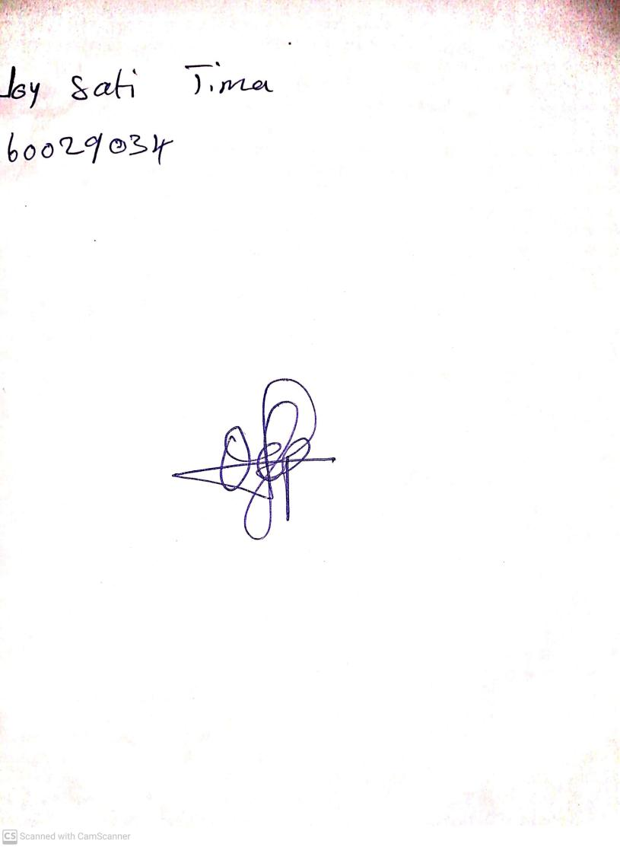

27TH October, 2023

Perpetual Ojoma Ocheja

Stream Head Nursery



29TH September, 2023

Perpetual Ojoma Ocheja

Stream Head Nursery