**LESSON PLAN AND NOTE 1 FOR WEEK 7 ENDING 7/06/2024**

**Term 3rd term**

**Week 7th week**

**Date 3rd June,2024**

**Class Nursery One**

**Subject Number Work**

**Topic Introduction of Addition.**

**Sub-topic Meaning of Addition**

**Period 2ND period**

**Time 9:05 am**

**Duration 35 minutes**

**No in class 14**

**Average Age 3 years**

**Sex Mixed**

**Specific Objectives: By the end of the lesson ,the pupils should**

**be able to:**

1. **Define Addition.**
2. **Identify the mathematics simple signs.**

**Rationale: To make sure the pupils define & identify Addition**

**signs.**

**Previous Knowledge: The pupils knows even numbers of objects & numbers.**

**Instructional Resources: Chart, board, marker, etc.**

**Reference Material: Online Research.**

**LESSON PRESENTATION**

|  |  |  |  |
| --- | --- | --- | --- |
| **Steps** | **Teacher’s Activities** | **Pupils’ Activities** | **Learning Points** |
| **Introduction** | **The teacher introduces the topic (Addition) to the pupils.** | **The pupils pays attention to the teacher.** | **To arouse the pupils’ interest.** |
| **Step 1** | **The teacher teaches the pupils the meaning of Addition as “the adding of numbers to get a total value”.** | **The pupils listen and repeats after the teacher the meaning of Addition.** | **For proper understanding.** |
| **Step 2** | **The teacher start by introducing the simple mathematics signs and their names to the pupils**  **Plus [ + ]**  **Minus [ - ]**  **Equals to [ = ].** | **The pupils participate with the teacher in naming and identifying the simple mathematics signs and names.** | **For better understanding.** |
| **Summary** | **The teacher summarizes the lesson by asking the pupils to identify the following mathematics signs**  **Plus [ + ]**  **Minus [ - ]**  **Equals to [ = ].** | **The pupils identify the simple mathematics signs.** | **For onward study.** |
| **Evaluation** | **Question:**  **Define Addition?.**  **What is the mathematical sign of addition?**   1. **Plus [ + ]** 2. **Minus [ - ]** 3. **Equals to [ = ].** | **The pupils answer the question correctly.** | **To ascertain the pupils’ understanding.** |
| **Conclusion** | **The teacher summarizes, reacts and corrects the pupils.** | **The pupils gives answers to the teacher's question.** | **To consolidate the lesson.** |
| **Assignment** | **Question:**  **Define Addition?.**  **What is the mathematical sign of addition?**   1. **Plus [ + ]** 2. **Minus [ - ]** 3. **Equals to [ = ].** | **The pupils copy and do their homework at home.** | **To encourage while at home.** |

**LESSON PLAN AND NOTE 2 FOR WEEK 7 ENDING 7/06/2024**

**Term 3rd term**

**Week 7th week**

**Date 5th June,2024**

**Class Nursery One**

**Subject Number Work**

**Topic Introduction of Addition**

**Sub-topic Addition of objects.**

**Period 2ND period**

**Time 9:05 am**

**Duration 35 minutes**

**No in class 14**

**Average Age 3 years**

**Sex Mixed**

**Specific Objectives: By the end of the lesson ,the pupils should be able to:**

1. **Add different objects.**
2. **Identify Addition of objects.**

**Rationale: To make sure the pupils identify & add objects**

**Previous Knowledge: The pupils can define addition of numbers.**

**Instructional Resources: Chart, board, marker, etc.**

**Reference Material: Online Research.**

**LESSON PRESENTATION**

|  |  |  |  |
| --- | --- | --- | --- |
| **Steps** | **Teacher’s Activities** | **Pupils’ Activities** | **Learning Points** |
| **Introduction** | **The teacher introduces the topic (Addition) to the pupils.** | **The pupils pays attention to the teacher.** | **To arouse the pupils’ interest.** |
| **Step 1** | **The teacher starts the lesson by adding objects below for the pupils** | **The pupils actively pays attention to the teacher.** | **For proper understanding.** |
| **Step 2** | **The teacher leads the pupils to identify Addition of objects** | **The pupils identify the Addition of objects.** | **For better understanding.** |
| **Summary** | **The teacher summarizes the lesson by explaining Addition of objects below**    **One Triangle + One triangle = Two Triangles.** | **The pupils have knowledge of Addition of objects.** | **For onward study.** |
| **Evaluation** | **Question:**  **Do the simple Addition of objects?** | **The pupils answer the question correctly.** | **To ascertain the pupils’ understanding** |
| **Conclusion** | **The teacher summarizes, reacts and corrects the pupils.** | **The pupils gives answers to the teacher's question.** | **To consolidate the lesson.** |
| **Assignment** | **Question:**  **Do the simple Addition of object below?** | **The pupils copy and do their home-work at home.** | **To encourage learning while at home.** |

**LESSON PLAN AND NOTE 3 FOR WEEK 7 ENDING 7/06/2024**

**Term 3rd term**

**Week 7th week**

**Date 7th June,2024**

**Class Nursery One**

**Subject Number Work**

**Topic Introduction of Addition**

**Sub-topic Addition of Numbers.**

**Period 2nd period**

**Time 9:50 am**

**Duration 35 minutes**

**No in class 14**

**Average Age 3 years**

**Sex Mixed**

**Specific Objectives: By the end of the lesson ,the pupils should be able to:**

1. **Add different numbers.**
2. **Identify the Addition of numbers.**

**Rationale: To make sure the pupils add & identify numbers.**

**Previous Knowledge: The pupils have add & identify Addition of objects.**

**Instructional Resources: Board, Chart.**

**Reference Material: Online research, Chart, Board.**

**LESSON PRESENTATION**

|  |  |  |  |
| --- | --- | --- | --- |
| **Steps** | **Teacher’s Activities** | **Pupils’ Activities** | **Learning Points** |
| **Introduction** | **The teacher introduces the topic (Addition) to the pupils.** | **The pupils pays attention to the teacher.** | **To arouse the pupils’ interest.** |
| **Step 1** | **The teacher starts the lesson by adding numbers below**  **6 + 4 = 10**  **How?**  **////// + //// = //////////**  **( 6 lines plus 4 lines all together gives total of 10 lines).** | **The pupils actively listens to the teacher.** | **For proper understanding.** |
| **Step 2** | **The teacher leads the pupils to identify the s Addition of numbers below**  **7 + 4 = 11**  **/////// + //// = ///////////** | **The pupils identify the Addition of the numbers below**  **7 + 4 = 11**  **/////// + //// = ///////////** | **For better understanding.** |
| **Summary** | **The teacher summarizes the lesson by doing few Addition of numbers**  **6 + 3 = 9**  **7 + 3 = 10**  **7 + 5 = 12**  **4 + 3 = 7** | **The pupils have knowledge of Addition of numbers and understands the lesson.** | **For onward study.** |
| **Evaluation** | **Question:**  **Do the Addition of numbers below?**  **8 + 5 =**  **5 + 4 =**  **8 + 6 =** | **The pupils answer the question correctly.** | **To ascertain the pupils’ understanding.** |
| **Conclusion** | **The teacher summarizes, reacts and corrects the pupils.** | **The pupils gives answers to the teacher's question.** | **To consolidate the lesson.** |
| **Assignment** | **Question:**  **Do the following Addition of numbers below?**  **10 + 6 =**  **6 + 4 =**  **7 + 6 =**  **8 + 4 =**  **7 + 3 =** | **The pupils copy and do their home-work at home.** | **To encourage learning while at home.** |

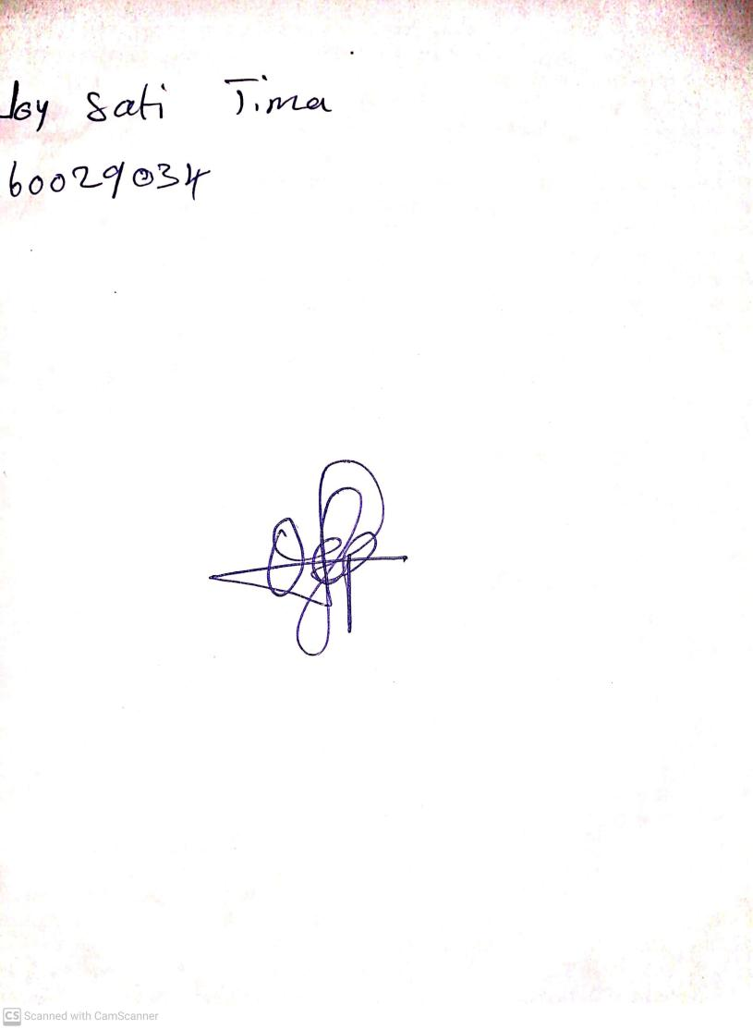

31st May, 2024

Perpetual Ojoma Ocheja

Stream Head Nursery