**LESSON PLAN AND NOTE FOR WEEK 8 ENDING 14/6/2024**

**Term 3rd term**

**Week 8TH week**

**Date 13th June, 2024**

**Class Nursery One**

**Subject Social Norms**

**Topic States in my country.**

**Sub-topic Mention the states in your country.**

**Period 4th period**

**Time 10:40 am**

**Duration 35 minutes**

**No in class 14**

**Average Age 3 years**

**Sex Mixed**

**Specific Objectives: By the end of the lesson, the pupils should be able to:**

1. **Identify the number of state in their country.**
2. **Mention the states in your country.**

**Rationale: To teach & ensure the pupils to know the states in their country.**

**Previous Knowledge: The pupils can define & identify their country.**

**Instructional Resources: Online research.**

**Reference Material: Smart Smart Civic Education by A.M Solu & T.Y Alabi, nursery 2**

**LESSON PRESENTATION**

|  |  |  |  |
| --- | --- | --- | --- |
| **Steps** | **Teacher’s Activities** | **Pupils’ Activities** | **Learning Points** |
| **Introduction** | **The teacher introduces the lesson[My Country] by showing the pupils the states and capital chart .** | **The pupils rhyme with the teacher the states and capital.** | **To arouse the pupils’ interest.** |
| **Step 1** | **The teacher tells and**  **leads the pupils to identify the numbers of states NIGERIA has, which is 36 states and capital.** | **The pupils pay attention and repeats after the teacher.** | **For proper understanding.** |
| **Step 2** | **The teacher guides and mention the 36 states and capital from the states and capital chart.** | **The pupils mention the states and capital of NIGERIA along with the teacher.** | **For better understanding.** |
| **Summary** | **The teacher summarizes the lesson by naming the 36 states and capital to the pupils.** | **The pupils listen and understands the lesson.** | **For onward study.** |
| **Evaluation** | **Question:**  **How many states and capital does NIGERIA has?.**  **Rhyme the 36 states and capital?** | **The pupils answer the question correctly.** | **To ascertain the pupils’ understanding.** |
| **Conclusion** | **The teacher summarizes the lesson to the pupils.** | **The pupils gives answers to the teacher.** | **To consolidate the lesson.** |
| **Assignment** | **Question:**  **How many states and capital does NIGERIA has?.**  **Rhyme the 36 states and capital?** | **The pupils copy and do their homework .** | **To encourage learning while at home.** |

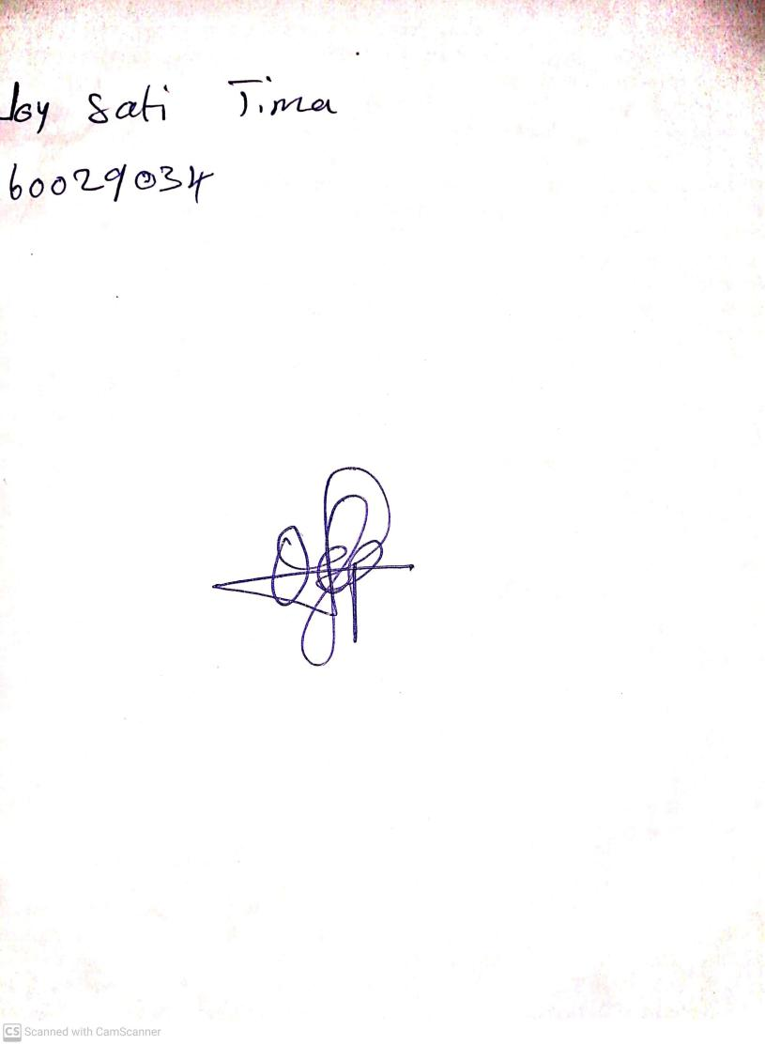

7th June, 2024

Perpetual Ojoma Ocheja

Stream Head Nursery