**EMERALD ROYAL INTERNATIONAL SCHOOL**

**MPAPE, ABUJA.**

**LESSON PLAN AND NOTE FOR WEEK 1 PERIOD 1 ENDING 13/09/2024**

**TERM: First**

**WEEK: 1**

**DATE: 09/09/2024**

**CLASS: NURSERY 2**

**SUBJECT: NUMBER WORK**

**TOPIC: NUMBERS 1- 20 .**

**SUB-TOPIC: IDENTIFY,COUNT AND WRITE NUMBER 1- 10**

**PERIOD: 1ST**

**TIME: O8:50-09:30.**

**DURATION: 40 MINUTES.**

**NUMBER IN CLASS: 17**

**AVERAGE AGE: 5 YEARS.**

**SEX: MIXED.**

**SPECIFIC OBJECTIVES: BY THE END OF THE LESSON,THE PUPILS SHOULD BE**

**ABLE TO:**

**1. COUNT NUMBER 1 - 10**

**2. WRITE NUMBER 1 - 10**

**RATIONALE: FOR PUPILS TO BE ABLE TO COUNT NUMBERS 1–10.**

**PREVIOU KNOWLEDGE: PUPILS HAVE LEARNT COUNTING OF NUMBERS 1- 9 IN PREVIOUS CLASS.**

**INSTRUCTIONAL MATERIALS: NUMBER CHART 1–10 .**

**REFERENCE MATERIALS: THE NEW MASTERING MATHEMATICS FOR NURSERY SCHOOLS BOOK 3 BY HENRY.Z.IDOGUN.**

**LESSON DEVELOPMENT**

|  |  |  |  |
| --- | --- | --- | --- |
| **STAGES/STEPS** | **TEACHER’S ACTIVITIES** | **PUPILS’ ACTIVITIES** | **LEARNING POINTS** |
| **INTRODUCTION** | **Teacher introduces the lesson by singing nursery number rhymes like, 1 little 2 little 3 little fingers,4 little 5 little 6 little fingers, 7 little 8 little 9 little fingers, 10 little fingers on my hands.** | **Pupil listen to the teacher and sing the rhymes along with the teacher.** | **To arouse pupils interest for the lesson ahead.** |
| **PRESENTATION**  **STEP 1** | **Teacher presents the lesson by counting numbers from 1- 10 and then asks pupils to repeat after her.** | **Pupils count the numbers after the teacher.** | **For proper understanding of the lesson .** |
| **STEP 2** | **Teacher writes numbers on the board for pupils to identify numbers. Ie, 1 2 3 4 5**  **6 7 8 9 10 .** | **Pupils identify the numbers 1- 10 on the board.** | **For better understanding of the lesson.** |
| **BOARD SUMMARY** | **Teacher summarizes the lesson by writing the whole note of lesson on the board for pupils to copy into their books.that is,**  **COUNTING OF NUMBERS 1- 10**  **1 2 3 4 5**  **6 7 8 9 10** | **Pupils copy the note into their exercise books.** | **For onward study.** |
| **EVALUATION** | **Teacher asks pupils to count numbers 1- 10 on the board one after the other.** | **Pupils count numbers 1- 10 on the board one after another.** | **To assess pupils understanding of the lesson.** |
| **CONCLUSION** | **Teacher marks pupils books.** | **Pupils submit their books for marking.** | **For endorsement.** |
| **ASSIGNMENT** | **1.Identify, count and write numbers 1–10.**  **2.Rewrite the following numbers**  **11 12 13 14 15**  **___ ___ ___ ___ ___**  **16 17 18 19 20**  **___ ___ ___ ___ ___** | **Pupils do their assignment at home.** | **To encourage learning at home.** |

**LESSON PLAN AND NOTE FOR WEEK 1 PERIOD 2 ENDING 13/09/2024**

**TERM: First**

**WEEK: 1**

**DATE: 10/09/2024**

**CLASS: NURSERY 2**

**SUBJECT: NUMBER WORK**

**TOPIC: NUMBERS 1–20 .**

**SUB-TOPIC: IDENTIFY,COUNT AND WRITE NUMBER 11- 20**

**PERIOD: 2nd**

**TIME: O8:50-09:30.**

**DURATION: 40 MINUTES.**

**NUMBER IN CLASS: 17**

**AVERAGE AGE: 5 YEARS.**

**SEX: MIXED.**

**SPECIFIC OBJECTIVES: BY THE END OF THE LESSON,THE PUPILS SHOULD BE**

**ABLE TO:**

**1.COUNT NUMBERS 11 - 20**

**2.IDENTIFY AND WRITE NUMBERS 11 - 20**

**RATIONALE: FOR PUPILS TO BE ABLE TO COUNT AND WRITE**

**NUMBER 11–20**

**PREVIOU KNOWLEDGE: PUPILS HAVE LEARNT COUNTING OF NUMBERS 1- 10 IN PREVIOUS LESS0N.**

**INSTRUCTIONAL MATERIALS: NUMBER CHART 11–20**

**REFERENCE MATERIALS: THE NEW MASTERING MATHEMATICS FOR NURSERY SCHOOLS BOOK 3 BY HENRY.Z.IDOGUN.**

**LESSON DEVELOPMENT**

|  |  |  |  |
| --- | --- | --- | --- |
| **STAGES/STEPS** | **TEACHER’S ACTIVITIES** | **PUPILS’ ACTIVITIES** | **LEARNING POINTS** |
| **INTRODUCTION** | **Teacher introduces the lesson by asking pupils to count number 1-10.** | **Pupil count number 1–10** | **To arouse pupils interest for the lesson ahead.** |
| **PRESENTATION**  **STEP 1** | **Teacher presents the lesson by counting numbers from 11- 20 and then asks pupils to repeat after.** | **Pupils count the numbers after the teacher.** | **For proper understanding of the lesson .** |
| **STEP 2** | **Teacher writes numbers 11- 20 on the board, identify and count and then asks pupils to identify and count after her.** | **Pupils identify the numbers 11- 20 on the board and count after the teacher.** | **For better understanding of the lesson.** |
| **BOARD SUMMARY** | **Teacher summarizes the lesson by writing the whole note of lesson on the board for pupils to copy into their books.that is,**  **COUNTING OF NUMBERS 11–20.**  **11 12 13 14 15 16 17 18 19 20** | **Pupils copy the note into their exercise books.** | **For onward study.** |
| **EVALUATION** | **Teacher asks Pupils to count numbers 11- 20 on the board one after the other.** | **Pupils count numbers 11- 20 on the board one after another.** | **To assess pupils understanding of the lesson.** |
| **CONCLUSION** | **Teacher marks pupils books.** | **Pupils submit their books for marking.** | **For endorsement.** |
| **ASSIGNMENT** | **Identify, count and write numbers 11- 20.** | **Pupils do their assignment at home.** | **To encourage learning at home.** |

**LESSON PLAN AND NOTE FOR WEEK 1 PERIOD 3 ENDING 13/09/2024**

**TERM: First**

**WEEK: 1**

**DATE: 13/09/2024**

**CLASS: NURSERY 2**

**SUBJECT: NUMBER WORK**

**TOPIC: NUMBERS 1–20 .**

**SUB-TOPIC: IDENTIFY,COUNT AND WRITE NUMBER 1- 20**

**PERIOD: 3RD**

**TIME: 08:10- 08:50am**

**DURATION: 40 MINUTES.**

**NUMBER IN CLASS: 17**

**AVERAGE AGE: 5 YEARS.**

**SEX: MIXED.**

**SPECIFIC OBJECTIVES: BY THE END OF THE LESSON,THE PUPILS SHOULD**

**BE ABLE TO:**

**1.COUNT NUMBERS 1- 20**

**2. WRITE NUMBER 1- 20**

**RATIONALE: FOR PUPILS TO KNOW COUNTING OF NUMBERS 1-20**

**PREVIOU KNOWLEDGE: PUPILS HAVE LEARNT COUNTING OF NUMBERS 11–20 IN PREVIOUS LESS0N.**

**INSTRUCTIONAL MATERIALS: NUMBER CHART 1–20**

**REFERENCE MATERIALS: THE NEW MASTERING MATHEMATICS FOR NURSERY**

**SCHOOLS BOOK 3 BY J.M OMOGBAI.**

**LESSON DEVELOPMENT**

|  |  |  |  |
| --- | --- | --- | --- |
| **STAGES/STEPS** | **TEACHER’S ACTIVITIES** | **PUPILS’ ACTIVITIES** | **LEARNING POINTS** |
| **INTRODUCTION** | **Teacher introduces the lesson by jumping and counting numbers 1- 20.** | **Pupils jump and count the numbers along with the teacher.** | **To arouse pupils interest for the lesson ahead.** |
| **PRESENTATION**  **STEP 1** | **Teacher presents the lesson by writing number 1- 20 on the board,count and then asks pupils to repeat after her.** | **Pupils listen to the teacher and repeat after her.** | **For proper understanding of the lesson .** |
| **STEP 2** | **Teacher guides pupils to count and identify the numbers on the board often and often.** | **Pupils count and identify the numbers on the board.** | **For better understanding of the lesson.** |
| **BOARD SUMMARY** | **Teacher summarizes the lesson by preparing pupils books for them to copy the note on the board.ie,**  **COUNTING AND WRITING OF NUMBERS 1- 20.**  **1 2 3 4 5**  **6 7 8 9 10**  **11 12 13 14 15**  **16 17 18 19 20** | **Pupils copy the note into their exercise books.** | **For onward study.** |
| **EVALUATION** | **Teacher evaluates the lesson by asking pupils to all stand and count the numbers on the board all together.** | **Pupils all stand and count the numbers on the board.** | **To create platform for slow learners.** |
| **CONCLUSION** | **Teacher concludes the lesson by marking pupils notes .** | **Pupils submit their books for marking.** | **For endorsement.** |
| **ASSIGNMENT** | **Fill in the missing numbers.**  **1 2 __ 4 __ 6 __ 8 __ 10 __ 12 __ 14 __ 16 __ 18 __ 20 .** | **Pupils do their assignment at home.** | **To encourage learning at home.** |

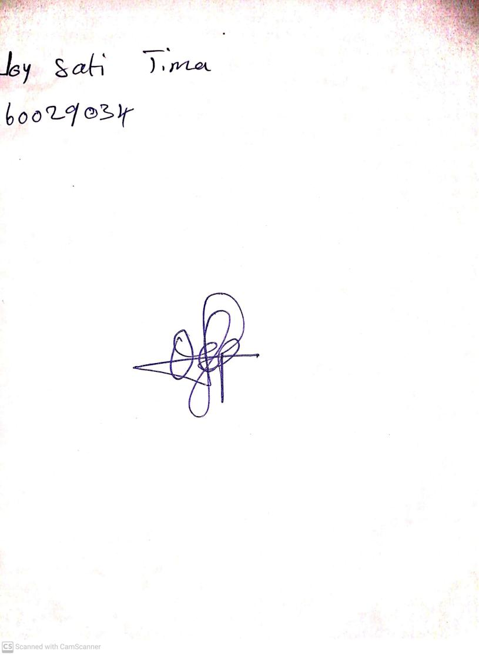

**30TH August, 2024**

**Perpetual Ojoma Ocheja**

**Stream Head Nursery**