LESSON PLAN FOR WEEK 7 ENDING 24TH FEB. 2023

|  |  |
| --- | --- |
| TERM | 2ND |
| WEEK | 8 |
| DATE | 23RD FEB 2023 |
| CLASS | SS1 |
| SUBJECT | History |
| TOPIC | The Benin Empire |
| SUB-TOPIC | The Administrative System |
| PERIOD | 4th |
| TIME | 10:30-11:10 |
| DURATION | 40 Minutes |
| NO IN CLASS | 11 |
| AVERAGE AGE | 15 years |
| SEX | Mixed |
| SPECIFIC OBJECTIVES | By the end of the lesson, scholars should be able to:  i.Explain the administrative system of Benin system.  ii.Mention some important events that took place in the Benin empire. |
| RATIONALE | To acquaint the scholars with the administrative of the Benin empire. |
| PREVIOUS KNOWLEDGE | The scholars can explain the administrative system Kingdom. |
| INSTRUCTIONAL RESOURCES | Charts from textbook explaining the topic. |
| REFERENCE MATERIAL | A History of Nigeria.  GIC Eluwa (2017) |

LESSON DEVELOPMENT

|  |  |  |  |
| --- | --- | --- | --- |
| STEPS | TEACHER’S ACTIVITIES | SCHOLARS’ ACTIVITIES | LEARNING POINTS |
| Introduction | The teacher introduces the topic by asking the scholars to mention two Obas in the Benin empire. | The scholars mention them as:  i.Oba Ewuare  ii.Oba Esigie | To arouse scholars’ interest towards the topic. |
| Step 1 | The teacher explains the administrative system of the Benin Empire. | The scholars pay attention. | To enhance proper understanding of the topic. |
| Step 2 | The teacher mentions some important events in the Benin empire. | The scholars listen and ask questions. | To encourage logical reasoning on the topic. |
| Board summary | The teacher summarizes the lesson thus:  The Administrative System of the Benin Empire  The effective of the empire during these two centuries of ascendancy has not been properly determined by historians. Already we have information that it stretched at one time between Lagos and Idah to the North-West and between Akure,Ekiti and Owo on the northern direction as far as Ishan, southern frontiers of Idah, on the Eastern side, it included at different times different areas of Western Igbo.  The administrative system on which law and order in this extensive empire depended was a complex and interesting achievement. In spite of it’s fluctuating boundaries, the administrative system continued until until the British occupation of Benin in 1897. At the centre of the imperial was the Oba or was a divine monarch or a priest king. He was prevented by innumerable taboos from leaving the palace except on occasions when ceremonies fundamental to the well-being of the state were being performed. Super-human qualities were ascribed to him and it was popularly believed that he did not eat or die, and that he had the most powerful charms. He had legislative, executive and judicial powers and had monopoly right to impose and commute capital sentences. He controlled the grant of politically important titles. He controlled the minor chiefs and could proclaim peace or war and was said to own all the land in Benin. To maintain his household, he imposed regular tributes on foodstuffs in the kingdom and empire. He controlled tolls on all trade coming into the city. He had the right to impose special levies on the chiefs. He had a monopoly of certain trades with outsiders especially Europeans. He collected dues from those whom he granted titles. he made money from court fines and fees from all slaves captured in war.  Next to the Oba in the imperial political system was the Benin state council which was made up of senior titled chiefs under the leadership of the Iyase, the Prime Minister , the second most important man in Benin after the Oba. The council was usually summoned by the Oba on the enactment of a new and the proclamation of war and peace. But for day to day administration, the Oba consulted the prominent titled chiefs. Although the Oba was prevented by many taboos from moving outside as he liked, he was able to retain an effective control of the kingdom through a complex bureaucratic arrangement. | The scholars copy notes into their notebooks. | For reference purposes. |
| Evaluation | The teacher evaluates the scholars thus:  i.Explain the administrative system of the Benin kingdom.  ii.Who was the Prime Minister of the Benin empire. | The scholars attempt the questions. | To ascertain scholars understanding of the lesson. |
| Conclusion | The teacher checks scholars notes and make corrections. | The scholars take corrections made by the teacher. | For consolidation of the lesson. |
| Assignment | The teacher gives the scholars assignment:  Explain the administrative system of the Benin empire. | The scholars copy their assignment to do it at home. | To encourage the scholars to learn and study at home. |

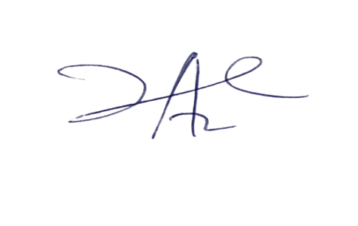

**20/3/2023**

**Principal Head Insrtuctor**