**LESSON PLAN AND NOTE 1 FOR WEEK 11 ENDING 22/3/2024**

**Term 2nd term**

**Week 11th week**

**Date 18th March,2024**

**Class Nursery one**

**Subject Letter work**

**Topic Coping words with letter Kk-Ll.**

**Sub-topic Naming three letter words with letter Kk-Ll.**

**Period 2nd period**

**Time 9:05 am**

**Duration 35 minutes**

**No in class 14**

**Average Age 3 years**

**Sex Mixed.**

**Specific Objectives: By the end of the lesson, the pupils should be able to:**

1. **Name three letters words that start with Kk-Ll.**
2. **Trace three letters words that start with Kk-Ll.**

**Rationale: To make the pupils mention & trace three letter words with Kk-Ll.**

**Previous Knowledge:The pupils match & write three letter words starting with letter Jj.**

**Instructional Resources: Chart, board, marker.**

**Reference Material: Online research, chart.**

**LESSON PRESENTATION**

|  |  |  |  |
| --- | --- | --- | --- |
| **Steps** | **Teacher’s Activities** | **Pupils’ Activities** | **Learning Points** |
| **Introduction** | **The teacher introduces the topic (coping words with letter Kk-Ll.) to the pupils.** | **The pupils listen to the teacher attentively.** | **To arouse the interest of the pupils.** |
| **Step 1** | **The teacher starts by naming three letter words with Kk-Ll for the pupils to repeat after**    **Kk**  **‘’key’’, ‘’keg’’.**  **Ll**  **“leg” , “log”** | **The pupils repeat after the teacher three letter words with Kk-Ll**  **Kk**  **‘’key’’, ‘’keg’’.**  **Ll**  **“leg” , “log”** | **For proper understanding.** |
| **Step 2** | **The teacher guides the pupils in writing three letter words with sound Kk-Ll inside their notebook.**     |  | | --- | | **k e y** | |  | | **k e g** | |  | | **The pupils write the three letter words with Kk-Ll as the teacher guides them inside their notebook.** | **For better understanding.** |
| **Summary** | **The teacher summarizes the lesson by sounding three letter words with Kk-Ll**  **‘’key’’, ‘’keg’’**  **“leg” , “log”** | **The pupils mention three letter words with Kk-Ll.**  **‘’key’’, ‘’keg’’**  **“leg” , “log”** | **For onward study.** |
| **Evaluation** | **Question:**  **Mention three letter words with Kk-Ll.**  **Write the following three letter words with letter Kk-Ll below**   |  |  | | --- | --- | | **k e y** | **k e g** | |  |  | | **l e g** | **l o g** | |  |  | | **The pupils answer the question correctly.** | **To ascertain the pupils’ understanding of the lesson.** |
| **Conclusion** | **The teacher summarizes, reacts and corrects the pupils.** | **The pupils gives answers to the teacher's question.** | **To consolidate the lesson.** |
| **Assignment** | **Question:**  **Mention three letter words with Kk-Ll.**  **Write the following three letter words with letter Kk-Ll below**   |  |  | | --- | --- | | **k e y** | **k e g** | |  |  | | **l e g** | **l o g** | |  |  | | **The pupils copy and their homework at home** | **To encourage learning while at home.** |

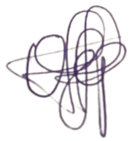

**8TH March, 2024**

**Perpetual Ojoma Ocheja**

**Stream Head Nursery**

**LESSON PLAN AND NOTE 2 FOR WEEK 11 ENDING 22/3/2024**

**Term** **2nd term**

**Week** 11**th week**

**Date** **20th March,2024**

**Class** **Nursery one**

**Subject** **Letter work**

**Topic** **Coping words with letter Kk-Ll.**

**Sub-topic** **Colouring objects & animals with letter Kk-Ll.**

**Period** **2nd period**

**Time** **9:32 am**

**Duration** **35 minutes**

**No in class** **14**

**Average Age** **3 years**

**Sex** **Mixed.**

**Specific Objectives:**  **By the end of the lesson, the pupils should be able to:**

**1.** **Identify three letters words & objects that start with Kk-Ll.**

**2.**  **Colour three letters words & objects that start with Kk-Ll.**

**Rationale:To make the pupils identify & colour three letter words & objects With Kk-Ll.**

**Previous Knowledge:The pupils name & trace three letter words starting with letter Kk-Ll.**

**Instructional Resources:**  **Crayons, pencils, exercise books, board, marker.**

**Reference Material:**  **Online research.**

**LESSON PRESENTATION**

|  |  |  |  |
| --- | --- | --- | --- |
| **Steps** | **Teacher’s Activities** | **Pupils’ Activities** | **Learning Points** |
| **Introduction** | **The teacher introduces the topic (coping words with letter Kk-Ll.) to the pupils.** | **The pupils listen to the teacher attentively.** | **To arouse the interest of the pupils.** |
| **Step 1** | **The teacher draws objects that start with three letter word Kk-Ll for the pupils to identify inside their notebook.** | **The pupils participate to identify objects that starts with Kk-Ll.** | **For proper understanding.** |
| **Step 2** | **The teacher draws & guides the pupils to colour objects starting with letter Kk-Ll inside their notebook.** | **The pupils colour the objects that start with letter Kk-Ll inside their notebook.** | **For better understanding.** |
| **Summary** | **The teacher summarizes the lesson by identifying other objects with letter Kk-Ll.** | **The pupils have knowledge of identifying & colouring objects with letter Kk-Ll.** | **For onward study.** |
| **Evaluation** | **Question:**  **Identify the object below with letter Kk-Ll.**  **Colour the object below with letter Kk-Ll.** | **The pupils answer the question correctly.** | **To ascertain the pupils’ understanding of the lesson.** |
| **Conclusion** | **The teacher summarizes, reacts and corrects the pupils.** | **The pupils gives answers to the teacher's question.** | **To consolidate the lesson.** |
| **Assignment** | **Question:**  **Identify the object below with letter Kk-Ll.**  **Colour the object below with letter Kk-Ll.** | **The pupils copy and do their homework at home.** | **To encourage learning while a home.** |



**8TH March, 2024**

**Perpetual Ojoma Ocheja**

**Stream Head Nursery**

**LESSON PLAN AND NOTE 3 FOR WEEK 11 ENDING 22/3/2024**

**Term** **2nd term**

**Week** 11**TH week**

**Date** **22nd March,2024**

**Class** **Nursery one**

**Subject** **Letter work**

**Topic** **Coping words with letter Kk-Ll.**

**Sub-topic** **Matching objects & animals with letter Kk-Ll on**

**Cardboard (practical)**

**Period** **2nd period**

**Time** **9:55 am**

**Duration** **35 minutes**

**No in class** **14**

**Average Age** **3 years**

**Sex** **Mixed.**

**Specific Objectives:**  **By the end of the lesson, the pupils should be able to:**

**1. Pick from a box a picture words with letter Kk-Ll & paste it on the cardboard 2.**  **Write three letters words with Kk-Ll.**

**Rationale:** **To make the pupils match & write three letter words with Kk-Ll.**

**Previous Knowledge:The pupils have identify & colour three letter words with letter Kk-Ll.**

**Instructional Resources:**  **Cardboard, pencils, exercise books.**

**Reference Material:**  **Online research ,cardboard.**

**LESSON PRESENTATION**

|  |  |  |  |
| --- | --- | --- | --- |
| **Steps** | **Teacher’s Activities** | **Pupils’ Activities** | **Learning Points** |
| **Introduction** | **The teacher introduces the topic (coping words with letter Kk-Ll) to the pupils.** | **The pupils listen to the teacher attentively.** | **To arouse the interest of the pupils.** |
| **Step 1** | **The teacher present a box with picture words and assists the pupils using gum to paste on the cardboard the pictures starting with Kk-Ll.** | **The pupils participate actively in picking and pasting on the cardboard the word picture with letter Kk-Ll.** | **For proper understanding.** |
| **Step 2** | **The teacher guides the pupils to write three letter words with Kk-Ll inside their notebooks.**  **k e g**  **____________**  **K e y**  **_____________**  **l e g**  **_____________**  **l o g**  **_____________** | **The pupils write three letter words with Kk-Ll as the teacher guides them.** | **For better understanding.** |
| **Summary** | **The teacher summarizes the lesson by sounding random three letter words with Kk-Ll.** | **The pupils have knowledge of three letter words with Kk-Ll.** | **For onward study.** |
| **Evaluation** | **Question:**  **Write the three letter words with Kk-Ll.**   |  | | --- | | **k e g** | |  | | **l e g** | |  | | **The pupils answer the question correctly.** | **To ascertain the pupils’ understanding of the lesson.** |
| **Conclusion** | **The teacher summarizes, reacts and corrects the pupils.** | **The pupil gives answers to the teacher's question.** | **To consolidate the lesson.** |
| **Assignment** | **Write the following three letter words below with letter Kk-Ll**  **k e g**  **____________**  **K e y**  **_____________**  **l e g**  **_____________**  **l o g**  **_____________** | **The pupils copy and do their homework at home.** | **To ensure learning while at home.** |

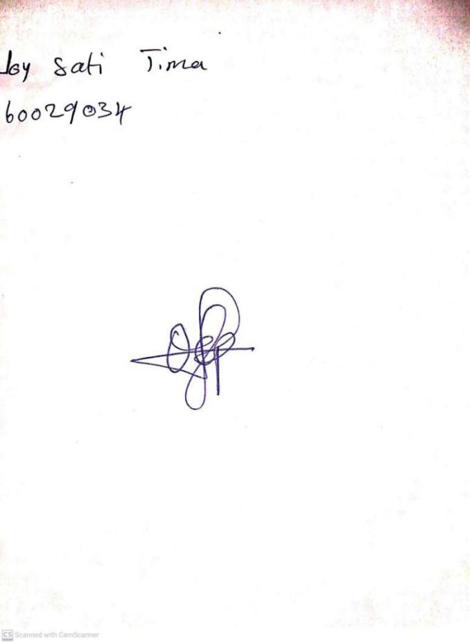

**15TH MARCH, 2024**

**Perpetual Ojoma Ocheja**

**Stream Head Nursery**