EMERALD ROYAL INTERNATIONAL SCHOOL

MPAPE, ABUJA.

LESSON NOTE/PLAN 1 FOR WEEK 4 ENDING 2ND FEBRUARY,2024.

SUBJECT: Letter work

TOPIC: Identification of letter "h" and it's sound.

SUB-TOPIC: Recognition of letter h

DATE: 30TH January,2023.

DURATION: 40 minutes

TIME: 08:50--09:30

PERIOD: 2nd

CLASS: Pre-nursery

NUMBER OF PUPILS: 14

AVERAGE AGE: 2years

SEX: Mixed

SPECIFIC OBJECTIVES: By the end of the lesson, the pupils should be able to:-

1: sing the jolly phonics song for letter h.

2: Identify letter h on the flash cards.

RATIONALE: For pupils to know letters and their sounds.

PREVIOUS KNOWLEDGE: Pupils have been learning to identify and say the sound for letter a-g .

INSTRUCTIONAL MATERIALS: Flash cards and phonics song.

REFERENCE: Mastering English for nursery Schools book 1 by J.M.Omogbai.

LESSON DEVELOPMENT

|  |  |  |  |
| --- | --- | --- | --- |
| Stages/Steps | Teacher's activities | Pupils' activities | Learning points |
| Introduction | Teacher introduces the lesson by singing A,B,C,D's song for the pupils. | Pupils sing the song along with the teacher | To get the pupils attention towards the lesson. |
| Presentation  Step 1 | Teacher sings the jolly phonics song for letter h and does the action for the pupils. | Pupils attempt singing and imitates the teacher to do the action of the song ,  I like to hop,hop hop,up and down.......... | To make Pupils familiar with letter h. |
| Step 2 | Teacher shows the pupils letter " h" on the flash cards and then points at it and say /h/ /h/ /h/. | Pupils point at the flash cards and make the sound for letter h. | To improve learning. |
| Summary | Teacher summarizes the lesson by calling out the pupils one after another to point at letter h on the flash cards again and make it's sound. | Pupils point at letter h on the flash cards and make it's sound. | To enhance Pupils knowledge of the letter h. |
| Evaluation | Teacher asks the pupils to:-  ----- point at letter h on the white board.  ----- say the sound for letter h . | Pupils answer the teacher's questions correctly. | To ascertain pupils understanding of the lesson. |
| Conclusion | Teacher marks the Pupils books and make corrections. | Pupils submit their books for marking and corrections. | For further learning. |
| ASSIGNMENT | The teacher asks the pupils to colour letter h.  Letter h | Pupils do their home work at home. | To ensure learning takes place at home. |

EMERALD ROYAL INTERNATIONAL SCHOOL

MPAPE, ABUJA.

LESSON NOTE/PLAN 2 FOR WEEK 4 ENDING 2ND FEBRUARY,2024.

SUBJECT: Letter work

TOPIC: Identification of letter h and it's sound.

SUB-TOPIC: identification and tracing letter h.

DATE: 31/01/2024.

DURATION: 40 minutes.

TIME: 8:50 - 9:30.

PERIOD: 2nd

CLASS: Pre-nursery.

NUMBER OF PUPILS: 11.

AVERAGE AGE: 2years.

SEX: Mixed.

SPECIFIC OBJECTIVES: By the end of the lesson, the pupils should be able to:-

1. Identify letter h.

2. Trace letter h.

RATIONALE: For pupils to know letters and their sounds.

PREVIOUS KNOWLEDGE: Pupils have been learning about letter h and it's sound in their previous lesson.

INSTRUCTIONAL MATERIALS: Pupils text books and phonics song.

REFERENCE: Mastering English for nursery Schools book 1 by J.M.Omogbai.

LESSON DEVELOPMENT.

|  |  |  |  |
| --- | --- | --- | --- |
| Stages/ steps | Teacher's activities | Pupils' activities activities | Learning points. |
| Introduction | Teacher introduces the lesson by singing the jolly phonics song for letter “h”. | Pupils sing the jolly phonics song along with the teacher. | To arouse the interest of the pupils. |
| Presentation  Step 1 | Teacher writes letter h boldly on the flash cards and asks the pupils to point at it and say ,  Letter h | Pupils point at letter h on the flash cards.  **h** | For better understanding of the lesson. |
| Step 2 | Teacher prepares the pupils books for them to trace letter h. | Pupils trace letter h in their exercise books.  h h h h h | To ensure the Pupils are familiar with letter h. |
| Summary | Teacher summarizes the lesson by asking the pupils to points at letter h again in their books. | Pupils point at letter h in their books. | For proper understanding of the lesson. |
| Evaluation | Teacher evaluates the lesson by asking the pupils to:-   1. point at letter h in their text books. 2. Trace letter h. | Pupils response to the teacher's questions. | To ascertain the pupils understanding of the lesson . |
| Conclusion | Teacher concludes the lesson by marking the Pupils books. | Pupils submit their books for marking. | To consolidate learning. |
| Assignment | Match and identify letter h amongst other letters.  e g  f h  g e  h f | Pupils do the assignment at home. | To encourage the pupils to learn at home. |

EMERALD ROYAL INTERNATIONAL SCHOOL

MPAPE, ABUJA.

LESSON NOTE/PLAN 3 FOR WEEK 4 ENDING 2ND FEBRUARY,2024.

SUBJECT: Letter work

TOPIC: Identification of letter h and it's sound.

SUB-TOPIC: Colouring letter h.

DATE: 2/2/2024.

DURATION: 40 minutes.

TIME: 8:50 - 9:30.

PERIOD: 2nd

CLASS: Pre-nursery.

NUMBER OF PUPILS: 14.

AVERAGE AGE: 2years.

SEX: Mixed.

SPECIFIC OBJECTIVES: By the end of the lesson, the pupils should be able to:-

1. Colour and identify letter h.

2. Sing the jolly phonics song for letter h.

RATIONALE: For pupils to know letters and their sounds.

PREVIOUS KNOWLEDGE: Pupils have been learning about letter h and it's sound in their previous lesson.

INSTRUCTIONAL MATERIALS: Pupils text books and phonics song.

REFERENCE: Mastering English for nursery Schools book 1 by J.M.Omogbai.

LESSON DEVELOPMENT.

|  |  |  |  |
| --- | --- | --- | --- |
| Stages/ steps | Teacher's activities | Pupils' activities activities | Learning points. |
| Introduction | Teacher introduces the lesson by showing the pupils a flash card of letter h and asks them to say the sound of the letter they see on the flash card. | Pupils say the sound of the letter they see on the flash card that was shown to them by the teacher. | To know if the Pupils can remember what was taught to them in the previous lesson. |
| Presentation  Step 1 | Teacher prepares the pupils text books for them to colour letter h. | Pupils colour letter h in their text books . ie  **h** | For better understanding of the lesson. |
| Step 2 | Teacher sings the jolly phonics song for letter h for the pupils and does the action. | Pupils sing along with the teacher ie  I like to hop hop all around.  I like to hop hop hop up and down......... | To ensure the Pupils are familiar with letter h. |
| Summary | Teacher summarizes the lesson by showing the pupils letter h again in the flash card and tell them it's sound. | Pupils point at letter h on the flash card and say it's sound after the teacher. | For proper understanding of the lesson. |
| Evaluation | Teacher evaluates the lesson by asking the pupils to:-  ------- point at letter h in their text books.  --------- say the sound for letter h. | Pupils response to the teacher's questions. | To ascertain the pupils understanding of the lesson . |
| Conclusion | Teacher concludes the lesson by marking the Pupils books. | Pupils submit their books for marking. | To consolidate learning. |
| Assignment | Circle and identify letter h amongst other letter.  h I j h y  J h f v h  D r h t h | Pupils do the assignment at home. | To encourage the pupils to learn at home. |

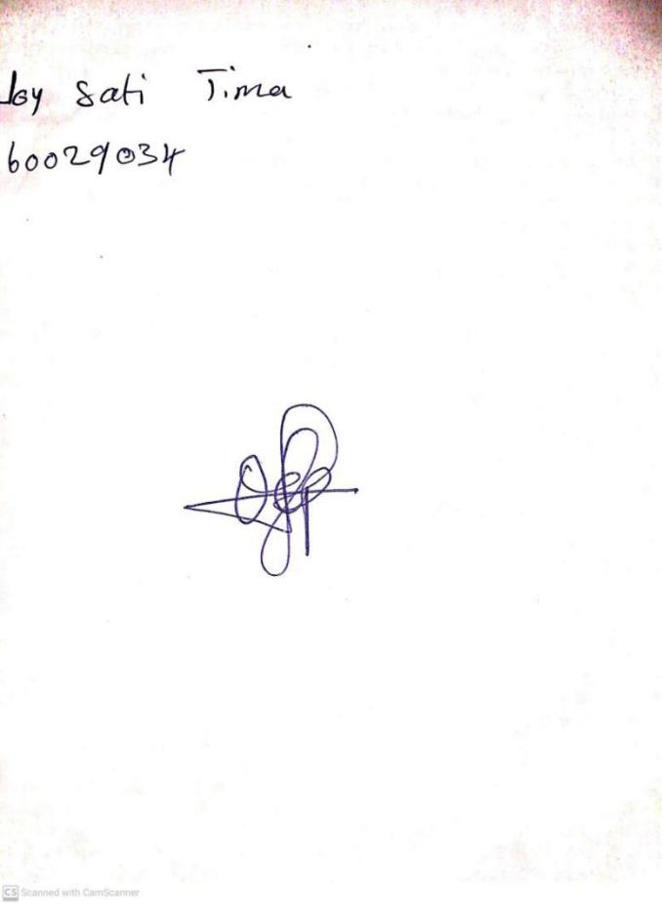

**26TH JANUARY, 2024**

**Perpetual Ojoma Ocheja**

**Stream Head Nursery**