**LESSON PLAN AND NOTE 1 FOR WEEK 10 ENDING 17/11/2023**

**Term 1st term**

**Week 10th week**

**Date 13th November,2023**

**Class Nursery One**

**Subject Number Work**

**Topic Counting numbers 1-90.**

**Sub-topic Count numbers 80-85**

**Period 2nd  period**

**Time 8:50 am**

**Duration 35 minutes**

**No in class 15**

**Average Age 3 years**

**Sex Mixed**

**Specific Objectives: By the end of the lesson ,the pupils should be able to:**

1. **Count numbers 80-85.**
2. **Identify numbers 80-85.**
3. **Write numbers 80-85**

**Rationale: To make sure the pupils count numbers 1-90.**

**Previous Knowledge: The pupils can match & fill in missing numbers 1-80.**

**Instructional Resources: Chart, board, marker, etc.**

**Reference Material: The new mastering mathematics.**

**LESSON PRESENTATION**

|  |  |  |  |  |
| --- | --- | --- | --- | --- |
| **Steps** | **Teacher’s Activities** | **Pupils’ Activities** | **Learning Points** | |
| **Introduction** | **The teacher introduces the topic (counting numbers 1-90) to the pupils by rhyming it.** | **The pupils with the teacher rhyme the numbers 1-90.** | **To arouse the pupils’ interest.** | |
| **Step 1** | **The teacher assists the pupils to count numbers 80-85**  **80 81 82**  **83 84 85** | **The pupils counts numbers 80-85 with their teacher.** | | **For proper understanding.** |
| **Step 2** | **The teacher leads the pupils to identify numbers 80-85**  **80 81 82**  **83** | **The pupils participate with the teacher in identifying numbers 80-85.**  **80 81 82**  **83** | | **For better understanding.** |
| **Step 3** | **The teacher guides the pupils to write numbers 80-85 inside their notebooks.**   |  |  | | --- | --- | | **80** | **81** | |  |  | | **82** | **83** | |  |  | | **84** | **85** | |  |  | | **The pupils write numbers 80-85 as the teacher guides them.**   |  |  | | --- | --- | | **80** | **81** | |  |  | | **82** | **83** | |  |  | | **84** | **85** | |  |  | | | **For further understanding** |
| **Summary** | **The teacher summarizes the lesson by counting numbers 80-85.** | **The pupils have master and count numbers 80-85**  **.** | | **For onward study.** |
| **Evaluation** | **The teacher asks the pupils to:**  **Count numbers 80-85**  **80 81 82**  **83 84 85**  **Identify numbers 80-85.**  **80 81 82**  **83**  **Write numbers 80-85 below**   |  |  | | --- | --- | | **80** | **81** | |  |  | | **82** | **83** | |  |  | | **84** | **85** | |  |  | | **The pupils answers the question correctly.** | | **To ascertain the pupils’ understanding.** |
| **Conclusion** | **The teacher summarizes, reacts and corrects the lesson.** | **The pupils gives answers to the teacher’s questions** | | **To consolidate the lesson** |
| **Assignment** | **Count numbers 80-85**  **80 81 82**  **83 84 85**  **Identify numbers 80-85.**  **80 81 82**  **83**  **Write the following numbers below**   |  |  | | --- | --- | | **80** | **81** | |  |  | | **82** | **83** | |  |  | | **84** | **85** | |  |  | | **The pupils copy and do their homework at home.** | | **To encourage learning while at home.** |

**LESSON PLAN AND NOTE 2 FOR WEEK 10 ENDING 17/11/2023**

**Term 1st term**

**Week 10th week**

**Date 15th November,2023**

**Class Nursery One**

**Subject Number Work**

**Topic Counting numbers 1-90.**

**Sub-topic Count numbers 85-90**

**Period 4th period**

**Time 10:40 am**

**Duration 35 minutes**

**No in class 15**

**Average Age 3 years**

**Sex Mixed**

**Specific Objectives: By the end of the lesson ,the pupils should be able to:**

1. **Count numbers 85-90.**
2. **Identify numbers 85-90.**
3. **Write numbers 85-90.**

**Rationale: To make sure the pupils count numbers 1-90.**

**Previous Knowledge: The pupils knows how to count numbers 80-85.**

**Instructional Resources: Chart, board, marker, etc.**

**Reference Material: The new mastering mathematics.**

**LESSON PRESENTATION**

|  |  |  |  |
| --- | --- | --- | --- |
| **Steps** | **Teacher’s Activities** | **Pupils’ Activities** | **Learning Points** |
| **Introduction** | **The teacher introduces the topic (counting numbers 1-90) to the pupils by rhyming it.** | **The pupils with the teacher rhyme the numbers 1-90.** | **To arouse the pupils’ interest.** |
| **Step 1** | **The teacher assists the pupils to count numbers 85-90**  **85 86 87**  **88 89 90** | **The pupils counts numbers 85-90 with their teacher.** | **For proper understanding.** |
| **Step 2** | **The teacher leads the pupils to identify numbers 85-90**  **85 86 87**  **88** | **The pupils participate with the teacher in identifying numbers 85-90.**  **85 86 87**  **88** | **For better understanding.** |
| **Step 3** | **The teacher guides the pupils to write numbers 85-90 inside their notebooks.**   |  |  | | --- | --- | | **85** | **86** | |  |  | | **87** | **88** | |  |  | | **89** | **90** | |  |  | | **The pupils write numbers 85-90 as the teacher guides them.** | **For further understanding** |
| **Summary** | **The teacher summarizes the lesson by counting numbers 85-90** | **The pupils have master and count numbers 85-90.** | **For onward study.** |
| **Evaluation** | **The teacher asks the pupils to:**  **Count numbers 85-90**  **85 86 87**  **88 89 90**  **Identify numbers 85-90.**  **85 86 87**  **88**  **Write numbers 85-90 below?**   |  |  | | --- | --- | | **85** | **86** | |  |  | | **87** | **88** | |  |  | | **89** | **90** | |  |  | | **The pupils answers the question correctly.** | **To ascertain the pupils’ understanding.** |
| **Conclusion** | **The teacher summarizes, reacts and corrects the lesson.** | **The pupils gives answers to the teacher’s questions** | **To consolidate the lesson** |
| **Assignment** | **Count numbers 85-90**  **85 86 87**  **88 89 90**  **Identify numbers 85-90.**  **85 86 87**  **88**  **Identify the following numbers**  **85 86 87**  **88**  **Write the following numbers below**   |  |  | | --- | --- | | **85** | **86** | |  |  | | **87** | **88** | |  |  | | **87** | **90** | |  |  | | **The pupils copy and do their homework at home.** | **To encourage learning while at home.** |

**LESSON PLAN AND NOTE 3 FOR WEEK 10 ENDING 17/11/2023**

**Term 1st term**

**Week 10th week**

**Date 17th November,2023**

**Class Nursery One**

**Subject Number Work**

**Topic Counting numbers 1-90.**

**Sub-topic Matching numbers 80-90**

**Period 2nd period**

**Time 8:50 am**

**Duration 35 minutes**

**No in class 15**

**Average Age 3 years**

**Sex Mixed**

**Specific Objectives: By the end of the lesson ,the pupils should be able to:**

1. **Match numbers 80-85.**
2. **Fill in the numbers 85-90.**

**Rationale: To make sure the pupils match numbers 1-90.**

**Previous Knowledge: The pupils knows how to count numbers 85-90.**

**Instructional Resources: Chart, board, marker, etc.**

**Reference Material: The new mastering mathematics.**

**LESSON PRESENTATION**

|  |  |  |  |
| --- | --- | --- | --- |
| **Steps** | **Teacher’s Activities** | **Pupils’ Activities** | **Learning Points** |
| **Introduction** | **The teacher introduces the topic (counting numbers 1-90) to the pupils by rhyming it.** | **The pupils with the teacher rhyme the numbers 1-90.** | **To arouse the pupils’ interest.** |
| **Step 1** | **The teacher assists the pupils to match numbers 80-85**  **80 85**  **81 84**    **82 83**  **83 82**  **84 81**  **85 80** | **The pupils match numbers 80-85 with their teacher.**  8**0 85**  8**1 84**    8**2 83**  **83 82**  **84 81**  **85 80** | **For proper understanding.** |
| **Step 2** | **The teacher leads the pupils to fill in the numbers 85-90**  **85____ 87 ______ 89**  **____** | **The pupils participate with the teacher in filling in the missing numbers 85-90.**  **85 86 87**  **88 89 90** | **For better understanding.** |
| **Summary** | **The teacher summarizes the lesson by counting numbers**  **80-90** | **The pupils have master and count numbers 80-90.** | **For onward study.** |
| **Evaluation** | **The teacher asks the pupils to:**  **Match the following numbers below**  **80 85**  **81 84**    **82 83**  **83 82**  **84 81**  **85 80**  **Fill in the missng numbers below?**  **85____ 87 ______ 89**  **____** | **The pupils answers the question correctly.** | **To ascertain the pupils’ understanding.** |
| **Conclusion** | **The teacher summarizes, reacts and corrects the lesson.** | **The pupils gives answers to the teacher’s questions** | **To consolidate the lesson** |
| **Assignment** | **Fill in the missing numbers below**  **80____82____84____86**  **____ 88____ 90**  **Match the following numbers below**  **80 85**  **81 84**    **82 83**  **83 82**  **84 81**  **85 80**  **86 90**  **87 89**  **88 88**  **89 87**  **90 86** | **The pupils copy and do their homework at home.** | **To encourage learning while at home.** |

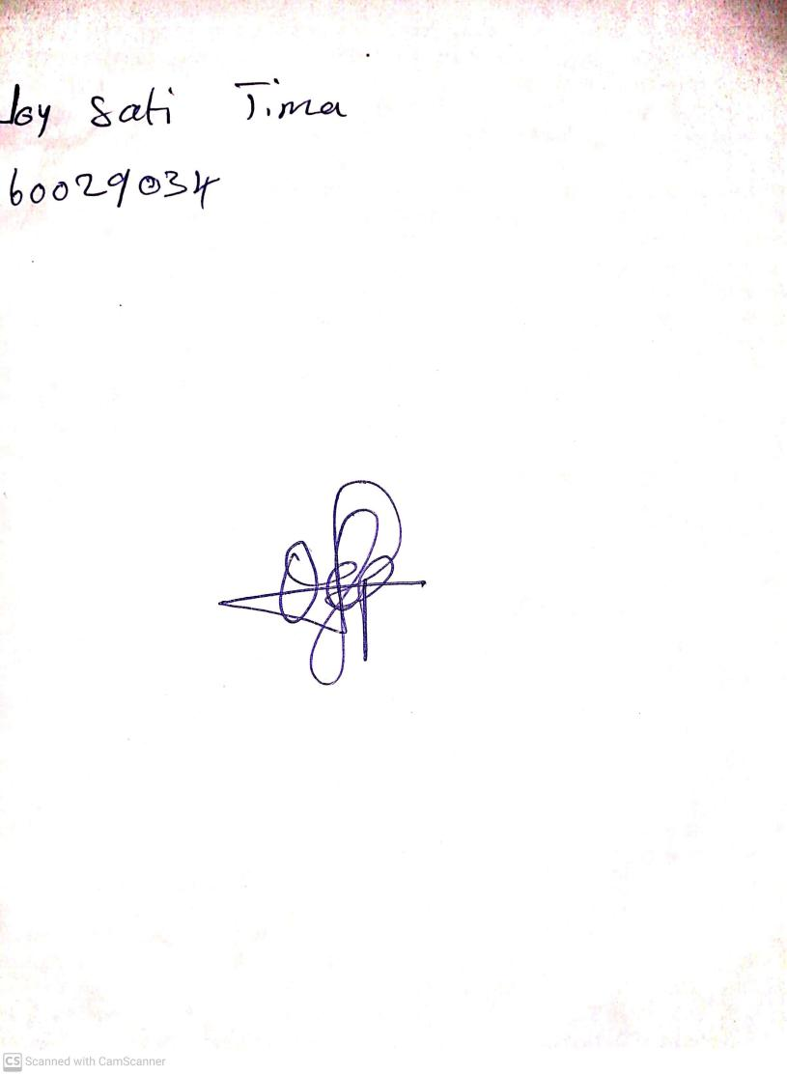

20th August, 2023

Perpetual Ojoma Ocheja

Stream Head Nursery