LESSON PLAN/ NOTE FOR WEEK 7 ENDING 24/02/2023

TERM: 2nd

WEEK: 7th

DATE: 24/02/2023

GLASS: Nursery 2

SUBJECT: Letter work

TOPIC: Initial and final consonant 2

SUB—TOPIC: Words with initial and final consonant 'rm' and 'rp'.

PERIOD: 3rd

TIME: 09: 30—10:10am

DURATION: 40 minutes

NUMBER IN CLASS: 14

AVERAGE AGE: 5 years

SEX: Mixed

LEARNING OBJECTIVES: By the end of the lesson, the Pupils should be able to:

1. Mention words with initial and final consonant 'rm'

2. State words with initial and final consonant 'rp'

RATIONALE: For Pupils to learn how to read.

PREVIOUS KNOWLEDGE: Pupils have learnt initial and final consonant tr, tw, sw and st .

INSTRUCTIONAL MATERIALS: A chart of words with initial and final consonant blends.

REFERENCE MATERIALS: Google. com

LESSON DEVELOPMENT

|  |  |  |  |
| --- | --- | --- | --- |
| Steps | Teacher's activities | Pupils' activities | Learning point |
| Introduction | Teacher introduces the lesson by reviewing the previous lesson. | Pupils pay attention to the teacher. | To arouse pupils interest for the lesson ahead. |
| Presentation step 1 | Teacher mentions the examples of words with initial and final consonant 'rm' to pupils and ask them to repeat after her. | Pupils listen to the teacher and repeat after her. | For proper understanding. |
| Step 2 | Teacher States the examples of words with initial and final consonant 'rp' to pupils and also ask them to repeat after her. | Pupils pay attention to the teacher and repeat after her. | For better understanding. |
| Board summary | Teacher writes the whole note of lesson on the board for pupils to copy. That is;  Initial and final consonant blends 'rm' and 'rp' are:   |  |  | | --- | --- | | Initial 'rm' | Initial 'rp' | | Worm | Harp | | Storm | Sharp | | Farm | Warp | | Alarm | Burp | | Firm | Harp | | Pupils copy the note into their exercise books. | For onward study. |
| Evaluation | Teacher asks pupils to all stand and then spell and pronounce the words on the board. | Pupils all stand and pronounce the words on the board all together. | To enhance Pupils participation in class. |
| Conclusion | Teacher concludes the lesson by marking pupils books. | Pupils submit their books for marking. | For endorsement. |
| Assignment | 1. What are Digraphs?  2. Give 5 examples of digraphs.  3. Generate 5 words with digraphs 'ck' | Pupils do their assignment at home. | To encourage learning at home. |

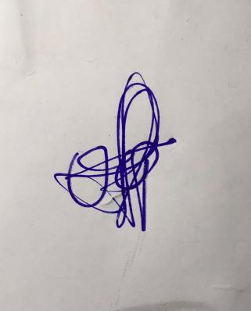

**29th March, 2023**

**Perpetual Ojoma Ocheja**

**Stream Head Nursery**