**LESSON PLAN AND NOTE 1 FOR WEEK 9 ENDING 30/06/2023**

**Term 3rd term**

**Week 9th week**

**Date 30th June,2023**

**Class Nursery One**

**Subject Number Work**

**Topic Introduction of Subtraction.**

**Sub-topic Meaning of subtraction**

**Period 2ND period**

**Time 9:05 am**

**Duration 35 minutes**

**No in class 18**

**Average Age 3 years**

**Sex Mixed**

**Specific Objectives: By the end of the lesson ,the pupils should**

**be able to:**

1. **Define Subtraction.**
2. **Identify the mathematics simple signs.**

**Rationale: To make sure the pupils define & identify subtraction**

**signs.**

**Previous Knowledge: The pupils knows addition of objects & numbers.**

**Instructional Resources: Chart, board, marker, etc.**

**Reference Material: Online Research.**

**LESSON PRESENTATION**

|  |  |  |  |
| --- | --- | --- | --- |
| **Steps** | **Teacher’s Activities** | **Pupils’ Activities** | **Learning Points** |
| **Introduction** | **The teacher introduces the topic (Subtraction) to the pupils.** | **The pupils pays attention to the teacher.** | **To arouse the pupils’ interest.** |
| **Step 1** | **The teacher teaches the pupils the meaning of subtraction as “the taking away of one number from another number”.** | **The pupils listen and repeats after the teacher the meaning of Subtraction.** | **For proper understanding.** |
| **Step 2** | **The teacher start by introducing the simple mathematics signs and their names to the pupils**  **Plus [ + ]**  **Minus [ - ]**  **Equals to [ = ].** | **The pupils participate with the teacher in naming and identifying the simple mathematics signs and names.** | **For better understanding.** |
| **Summary** | **The teacher summarizes the lesson by asking the pupils to identify the following mathematics signs**  **Plus [ + ]**  **Minus [ - ]**  **Equals to [ = ].** | **The pupils identify the simple mathematics signs.** | **For onward study.** |
| **Evaluation** | **Question:**  **Define Subtraction?.** | **The pupils answer the question correctly.** | **To ascertain the pupils’ understanding.** |
| **Conclusion** | **The teacher summarizes, reacts and corrects the pupils.** | **The pupils gives answers to the teacher's question.** | **To consolidate the lesson.** |
| **Assignment** | **Question:**  **Identify the following mathematics signs**  **Minus [ - ]**  **Equals to [ = ].** |  |  |

**LESSON PLAN AND NOTE 2 FOR WEEK 9 ENDING 30/06/2023**

**Term 3rd term**

**Week 9th week**

**Date 30th June,2023**

**Class Nursery One**

**Subject Number Work**

**Topic Introduction of Subtraction**

**Sub-topic Subtraction of objects.**

**Period 2ND period**

**Time 9:05 am**

**Duration 35 minutes**

**No in class 18**

**Average Age 3 years**

**Sex Mixed**

**Specific Objectives: By the end of the lesson ,the pupils should be able to:**

1. **Subtract different objects.**
2. **Identify subtraction of objects.**

**Rationale: To make sure the pupils identify & subtract objects**

**Previous Knowledge: The pupils can add numbers together.**

**Instructional Resources: Chart, board, marker, etc.**

**Reference Material: Online Research.**

**LESSON PRESENTATION**

|  |  |  |  |
| --- | --- | --- | --- |
| **Steps** | **Teacher’s Activities** | **Pupils’ Activities** | **Learning Points** |
| **Introduction** | **The teacher introduces the topic (Subtraction) to the pupils.** | **The pupils pays attention to the teacher.** | **To arouse the pupils’ interest.** |
| **Step 1** | **The teacher starts the lesson by subtracting objects below for the pupils** | **The pupils actively pays attention to the teacher.** | **For proper understanding.** |
| **Step 2** | **The teacher leads the pupils to identify subtraction of objects** | **The pupils identify the subtraction of objects.** | **For better understanding.** |
| **Summary** | **The teacher summarizes the lesson by explaining subtraction of objects below**    **Two Triangles - One triangle = One Triangle.** | **The pupils have knowledge of subtraction of objects.** | **For onward study.** |
| **Evaluation** | **Question:**  **Identify subtraction of object**  **Do the simple subtraction of objects?** | **The pupils answer the question correctly.** | **To ascertain the pupils’ understanding** |
| **Conclusion** | **The teacher summarizes, reacts and corrects the pupils.** | **The pupils gives answers to the teacher's question.** | **To consolidate the lesson.** |
| **Assignment** | **Question:**  **Do the simple subtraction of object below?** | **The pupils copy and do their home-work at home.** | **To encourage learning while at home.** |

**LESSON PLAN AND NOTE 3 FOR WEEK 9 ENDING 30/06/2023**

**Term 3rd term**

**Week 9th week**

**Date 30th June,2023**

**Class Nursery One**

**Subject Number Work**

**Topic Introduction of Subtraction**

**Sub-topic Subtraction of Numbers.**

**Period 2nd period**

**Time 9:50 am**

**Duration 35 minutes**

**No in class 18**

**Average Age 3 years**

**Sex Mixed**

**Specific Objectives: By the end of the lesson ,the pupils should be able to:**

1. **Subtract different numbers.**
2. **Identify the subtraction of numbers.**

**Rationale: To make sure the pupils subtract & identify numbers.**

**Previous Knowledge: The pupils have subtract & identify subtraction of objects.**

**Instructional Resources: Board, Chart.**

**Reference Material: Online research, Chart, Board.**

**LESSON PRESENTATION**

|  |  |  |  |
| --- | --- | --- | --- |
| **Steps** | **Teacher’s Activities** | **Pupils’ Activities** | **Learning Points** |
| **Introduction** | **The teacher introduces the topic (Subtraction) to the pupils.** | **The pupils pays attention to the teacher.** | **To arouse the pupils’ interest.** |
| **Step 1** | **The teacher starts the lesson by subtracting numbers below**  **6 - 4 = 2**  **How?**  **////// - //// = //**  **( 6 lines minus 4 lines all together gives total of 2 lines).** | **The pupils actively listens to the teacher.** | **For proper understanding.** |
| **Step 2** | **The teacher leads the pupils to identify the subtraction of numbers below**  **7 - 4 = 3**  **/////// - //// = ///** | **The pupils identify the subtraction of the numbers below**  **7 - 4 = 3**  **/////// - //// = ///** | **For better understanding.** |
| **Summary** | **The teacher summarizes the lesson by doing few subtraction of numbers**  **6 - 3 = 3**  **7 - 3 = 4**  **7 - 5 = 2**  **4 - 3 = 1.** | **The pupils have knowledge of subtraction of numbers and understands the lesson.** | **For onward study.** |
| **Evaluation** | **Question:**  **Identify the subtraction of numbers below**  **4 - 3 = 1.**  **Do the subtraction of numbers below?**  **8 - 5 =**  **5 - 4 =**  **8 - 6 =** | **The pupils answer the question correctly.** | **To ascertain the pupils’ understanding.** |
| **Conclusion** | **The teacher summarizes, reacts and corrects the pupils.** | **The pupils gives answers to the teacher's question.** | **To consolidate the lesson.** |
| **Assignment** | **Question:**  **Do the following subtraction of numbers below?**  **10 - 6 =**  **6 - 4 =**  **7 - 6 =**  **8 - 4 =**  **7 - 3 =** | **The pupils copy and do their home-work at home.** | **To encourage learning while at home.** |

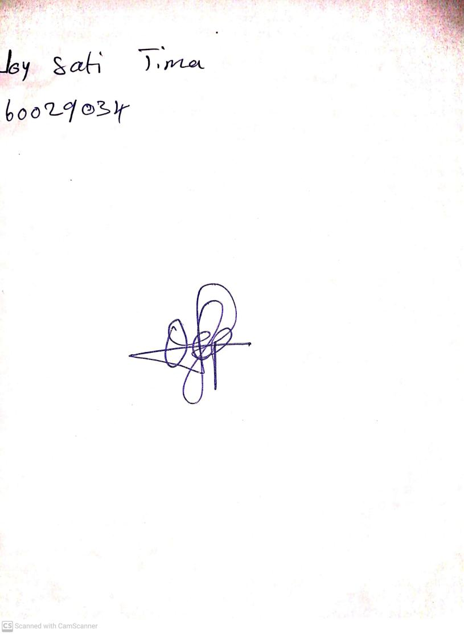

10th May, 2023

Perpetual Ojoma

Stream Head Nursery