**EMERALD ROYAL INTERNATIONAL SCHOOL, MPAPE ABUJA**

**LESSON PLAN AND NOTE FOR WEEK 2 ENDING FRIDAY, 22ND SEPTEMBER, 2023**

**TERM:** FIRST TERM

**WEEK:** WEEK 2

**SUBJECT:** ENGLISH LANGUAGE (SPEECH)

**TOPIC:** ACTING OUT A DRAMA IN THE CLASS

**SUB-TOPIC:** RESPONDING TO ‘WHAT’ QUESTION

**DATE:** WEDNESDAY, 20TH SEPTEMBER, 2023

**TIME:** 02:00 – 02:30PM

**DURATION:** 45 MINUTES

**PERIOD:** 9TH

**CLASS:** NURSERY 3

**NUMBER IN CLASS:** ELEVEN

**AVERAGE AGE:** FIVE

**SEX:** MIXED

**LEARNING OBJECTIVES:** By the end of the lesson, the pupils should be able to:

1. Act out a drama in the class.
2. Respond to ‘what’ question

**RATIONALE:** for pupils to learn how to answer ‘what’ question

**PREVIO US KNOWLEGDE:** pupils have learn about a poem titled where are you from?

**INSTRUCTIONAL MATERIALS:**

1. Individual pupils
2. Textbook

**REFERENCE MATERIALS:**

1. Nigeria Primary English book 1 by B. Someye, D Dallas etal 2000

**LESSON DEVELOPMENT**

|  |  |  |  |
| --- | --- | --- | --- |
| **STAGES/STEPS** | **TEACHER’S ACTIVITIES** | **PUPILS’ ACTIVITIES** | **LEARNING POINTS** |
| **INTRODUCTION** | Previews previous knowledge. | Response to the teacher and listens attentively | Introducing the lesson and arousing interest |
| **PRESENTATION**  **STEP 1** | Teaches and guide pupils to answer ‘what’ question.  **Edet**: my sister celebrated her birthday yesterday. I ate rice and chicken. I also took a bottle of Coke. What did you eat yesterday?  **Osaro:** I took bread and tea in the morning.  **Edet:** what did you eat in the afternoon?  **Osaro:** I ate yam and egg.  **Edet:** what did you do after lunch?  **Osaro:** I slept for 30 minutes and then watch the television till 8 pm.  What is out first lesson today?  **Edet:** it’s English language. Let’s hurry or we’ll be late. | Act up a drama in the classroom | ‘What’ question |
| **SUMMARY** | Summarises the lesson by emphasising on the main concept and writes note on the board. | Listen and copy their notes | For onward study |
| **EVALUATION** | Ask pupils to:   1. Act up a play in the class and answer ‘what’ question | Respond to the teacher’s question | Based on the stated objectives |
| **CONCLUSION** | Summarizes, corrects and mark pupils’ notebooks. | Submit their notebooks for marking. | Clarifying the concept |
| **HOME WORK** | Nigeria Primary English book 1 page 13, exercise 1 | Return with their home work for marking | Extending the lesson home |

**LESSON PLAN AND NOTE FOR WEEK 2 ENDING FRIDAY, 22ND SEPTEMBER, 2023**

**TERM:** FIRST TERM

**WEEK:** WEEK 2

**SUBJECT:** ENGLISH LANGUAGE (GRAMMAR)

**TOPIC:** GRAMMAR

**SUB-TOPIC:** PRONOUN

**DATE:** MONDAY, 18TH SEPTEMBER, 2023

**TIME:** 01:20PM – 02:00PM

**DURATION:** 45 MINUTES

**PERIOD:** 8TH

**CLASS:** NURSERY 3

**NUMBER IN CLASS:** ELEVEN

**AVERAGE AGE:** FIVE

**SEX:** MIXED

**LEARNING OBJECTIVES:** By the end of the lesson, the pupils should be able to

1. Define the meaning of a pronoun and give examples.
2. Make sentences using pronouns.

**RATIONALE:** for pupils to know regular plurals formation with (s) ending.

**PREVIOUS KNOWLEGDE:** pupils have learnt the meaning and examples of a noun.

**INSTRUCTIONAL MATERIALS:**

1. Flash cards
2. pictorial charts

**REFERENCE MATERIALS:**

1. Nigeria Primary English book 1 by B. Someye, D Dallas etal 2000

**LESSON DEVELOPMENT**

|  |  |  |  |
| --- | --- | --- | --- |
| **STAGES/STEPS** | **TEACHER’S ACTIVITIES** | **PUPILS’ ACTIVITIES** | **LEARNING POINTS** |
| **INTRODUCTION** | Review previous knowledge. | Answer the teacher’s question. | Introducing the lesson and arouse the pupils’ interest. |
| **PRESENTATION STEP 1** | Explain the meaning of a pronoun and state the examples.  A pronoun is a word that can be used instead of a noun  Examples of pronoun   1. 1 2. Me 3. He 4. Him 5. Her 6. They 7. Them 8. It | Learns carefully. | Meaning of a pronoun and examples of nouns. |
| **STEP 2** | Teaches pupils how to make sentences using pronouns.   1. He is washing the plate. 2. She is sleeping. 3. It is barking. 4. They are going to school. 5. It is my favourite fruit. | Learns attentively. | Sentence making using pronouns. |
| **SUMMARY** | Summarises the lesson by emphasising on the main concept and writes note on the board. | Listens and copy their notes | For onward study |
| **EVALUATION** | Ask pupils to:  1. Define a noun and give five (5) examples of a noun.  2. Give the meaning of a pronoun and list three examples of a pronoun.  3. Indicate plurals using the structure ‘are’ | Respond to the teacher’s question. | To test the pupils understanding on the lesson. |
| **CONCLUSION** | Summaries, correct and mark pupils note books. | Submit their notebooks for marking. | Clarifying the concept. |
| **HOME WORK** | Nigeria Primary English book 1 page 16. | Return homework for marking. | Extending lesson home. |

**LESSON PLAN AND NOTE FOR WEEK 2 ENDING FRIDAY, 22ND SEPTEMBER, 2023**

**TERM:** FIRST TERM

**WEEK:** WEEK 2

**SUBJECT:** ENGLISH LANGUAGE (COMPREHENSION)

**TOPIC:** READING

**SUB-TOPIC:** OUR PLAY GROUND

**DATE:** WEDNESDAY 20TH SEPTEMBER, 2023

**TIME:** 09:25 – 09:55AM AND 02:15 – 02:40PM

**DURATION:** 45 MINUTES

**PERIOD:** 3RD AND 13TH

**CLASS:** NURSERY 3

**NUMBER IN CLASS:** ELEVEN

**AVERAGE AGE:** FIVE

**SEX:** MIXED

**LEARNING OBJECTIVES:** By the end of the lesson, the pupils should be able to

1. Concentrate fully in reading
2. Pronounce difficult words
3. Answer the questions bellow the passage

**RATIONALE:** for pupils to know and improve in their reading skills and pronunciation.

**PREVIOUS KNOWLEGDE:** pupils read about objects in the classroom.

**INSTRUCTIONAL MATERIALS:**

1. Nigeria Primary English Book 1 by F Ademola – Adeoye, J omiteru etal 2000

**REFERENCE MATERIALS:**

1. Nigeria Primary English book 1 by B. Someye, D Dallas etal 2000

**LESSON DEVELOPMENT**

|  |  |  |  |
| --- | --- | --- | --- |
| **STAGES/STEPS** | **TEACHER’S ACTIVITIES** | **PUPILS ACTIVITIES** | **LEARNING POINT** |
| **INTRODUCTION** | Ask pupils to open their textbooks to page 13. | Open their textbooks. | Arouse the pupils’ interest. |
| **PRSENTATION STEP I** | Guides pupils in reading the passage title ‘our playground’  The playground in our school is big. It is not near the classrooms. The playground is for play and fun. We use it during break time. There is a lot of play and action on our playground.  During break time, my friends and I go to the playground to have fun. Boys run, jump, play football and skip, while the girls play ten-ten and also skip. | Listen attentively and read after the teacher. | To enhance fluency in reading. |
| **STEP 2** | Guides pupils to identify and pronounce difficult words in the passage.   1. Playground 2. Classroom 3. Break 4. Skip 5. Football 6. Swing 7. Seesaw 8. Mates 9. Jump 10. Watch | Pronounce the difficult words after the teacher. | Identifying difficult words. |
| **STEP 3** | Leads pupils on how to answer the questions below the passage orally.  Indicate True if the sentence is true. And False if the sentence is false.   1. Our playground is small.   False   1. We use the playground every time. False 2. There is a swing on the playground. True 3. There is no seesaw. False 4. Girls play ten-ten. True | Answer the questions orally | Answering the questions in the passage |
| **SUMMARY** | Summarises the lesson by emphasising on the main concept and writes note on the board. | Listen and copy their notes | For onward study |
| **EVALUATION** | Ask pupils to:  1.Read the passage carefully.  2. pronounce the difficult words in the passage.  3. Answer the questions in the passage. | Respond to the teacher’s questions. | To test the pupils’ understanding of the lesson. |
| **CONCLUSION** | Summaries, correct and mark pupils work | Answer to the teacher’s question. | Clarifying the concept |
| **HOME WORK** | Nigeria Primary English book 1 page 14. | Return book with task for marking. | Extending lesson home. |

**LESSON PLAN AND NOTE FOR WEEK 2 ENDING FRIDAY, 22ND SEPTEMBER, 2023**

**TERM:** FIRST TERM

**WEEK:** WEEK 2

**SUBJECT:** ENGLISH LANGUAGE (COMPOSITION)

**TOPIC:** COMPOSITION

**SUB-TOPIC:** WRITING CAPITAL AND SMALL LETTER Aa - Dd

**DATE:** THURSDAY, 21ST SEPTEMBER, 2023

**TIME:** 11:10 – 11:50AM

**DURATION:** 45 MINUTES

**PERIOD:** 5TH

**CLASS:** NURSERY 3

**NUMBER IN CLASS:**  ELEVEN

**AVERAGE AGE:** FIVE

**SEX:** MIXED

**LEARNING OBJECTIVES:** By the end of the lesson, the pupils should be able to

1. Identify capital and small letter Aa - Dd
2. Write capital and small letter Aa - Dd

**RATIONALE:** for pupils to learn how to write capital and small letter Aa - ZzS.

**PREVIOUS KNOWLEGDE:** pupils have learnt how to say write about myself. **INSTRUCTIONAL MATERIALS:**

1. A book
2. Pencil
3. Text book – Nigeria Primary English book 1 – Fourth Edition

**REFERENCE MATERIALS:**

1. Nigeria Primary English book 1 by B. Someye, D Dallas etal 2000

|  |  |  |  |
| --- | --- | --- | --- |
| **STAGES /STEPS** | **TEACHER’S ACTIVITIES** | **PUPILS’ ACTIVITIES** | **LEARNING POINT** |
| **INTRODUCTION** | Review previous knowledge. | Open their text books | Arouse their interest |
| **PRESENTATION**  **STEP 1** | Leads pupils to identify capital and small letter Aa - Zz  Aa Bb Cc Dd | Respond to the teacher. | Identify capital and small letter Aa - Dd. |
| **STEP 2** | Leads pupils to write capital and small letter Aa - Dd  Aa Bb Cc Dd | Write capital and small letter Aa - Dd. | Writing capital and small letter Aa - Dd. |
| **SUMMARY** | Summarises the lesson by emphasising on the main concept and writes note on the board. | Listen and copy their notes | For onward study |
| **EVALUATION** | Ask pupils to:  1. Ask pupils to read and write capital and small letters Aa - Dd | Respond to the teacher’s question. | To test the pupils knowledge on the lesson. |
| **CONCLUSION** | Summarizes, correct and mark the pupils note books. | Submits their notes for marking. | Clarifying the concept. |
| **HOME-WORK** | Write the small letter of the following capital letter.  A _____  B _____  C _____  D _____ | Copy and return homework for marking. | Extending lesson home. |

**LESSON PLAN AND NOTE FOR WEEK 2 ENDING FRIDAY, 22ND SEPTEMBER, 2023**

**TERM:** FIRST TERM

**WEEK:** WEEK 2

**SUBJECT:** ENGLISH LANGUAGE (PHONICS)

**TOPIC:** SOUND BANKS

**SUB-TOPIC:** WORDS WITH THE SOUND /æ/ AND /a:/

**DATE:** TUESDAY, 19TH SEPTEMBER, 2023

**TIME:** 10:30AM – 11:10AM

**DURATION:** 30 MINUTES

**PERIOD:** 4TH

**CLASS:** NURSERY 3

**NUMBER IN CLASS:** ELEVEN

**AVERAGE AGE:** FIVE

**SEX:** MIXED

**LEARNING OBJECTIVES:** By the end of the lesson, the pupils should be able to:

1. Identify the sounds /æ/ and /a:/.
2. Pronounce the sounds /æ/ and /a:/.
3. List words with the sounds /æ/ and /a:/.

**RATIONALE:** For pupils to learn how pronounce the sounds /æ/ and /a:/ and identify words associated with the sounds.

**PREVIOUS KNOWLEGDE:** pupils have learnt how to pronounce the sounds /I/ and /I:/ and identify words that is associated with the sounds.

**INSTRUCTIONAL MATERIALS:**

1. Flash cards.
2. Pictorial charts.

**REFERENCE MATERIALS:**

1. Nigeria Primary English book 1 by B. Someye, D Dallas etal 2000

**LESSON DEVELOPMENT**

|  |  |  |  |
| --- | --- | --- | --- |
| **STAGES/STEPS** | **TEACHER’S ACTIVITIES** | **PUPILS’ ACTIVITIES** | **LEARNING POINTS** |
| **INTRODUCTION** | Displays flash cards on a flat surface. | Respond to the teacher’s questions. | Arouse pupils interest. |
| **PRESENTATION**  **STEP 1** | Leads pupils to identify the sounds /æ/ and /a:/ on a flash card.  **/æ/ /a:/** | Identify the sounds. | For proper understanding. |
| **STEP 2** | Teaches pupils how to pronounce the sounds /æ/ and /a:/  /æ/ is a short vowel sound that can be pronounced with the front of the tongue pushed forward and held lower in the mouth.  /a:/ is a long vowel sound. To say /a:/, you open your mouth wide. The back of your tongue is down, and your jaw drops a little. | Pronounce the sounds as taught by the teacher. | For better understanding. |
| **STEP 3** | Teaches pupils words with the sounds /æ/ and /a:/  /æ/ /a:/   1. thanks garden 2. black party 3. tank cart 4. bag arm 5. cat father 6. rat dance | Learn the words with the sounds /æ/ and /a:/ | For further understanding. |
| **SUMMARY** | Summarizes the lesson by emphasizing on the main concept and writes note on the board. | Listen and copy their notes | For onward study |
| **EVALUATION** | Asks pupils to:   1. Identify the sounds /æ/ and /a:/ 2. Pronounce the sounds /æ/ and /a:/ 3. List two words with each of the sounds /æ/ and /a:/ | Respond to the teacher’s questions. | To test the pupils understanding of the lesson. |
| **CONCLUSION** | Summarizes, correct and mark pupils’ notebooks. | Write the note on the board and submit their notebooks for marking | To consolidate the lesson. |
| **HOME-WORK** | Write five words each with the sounds /æ/ and /a:/ | Return home with task. | Extending lesson home. |

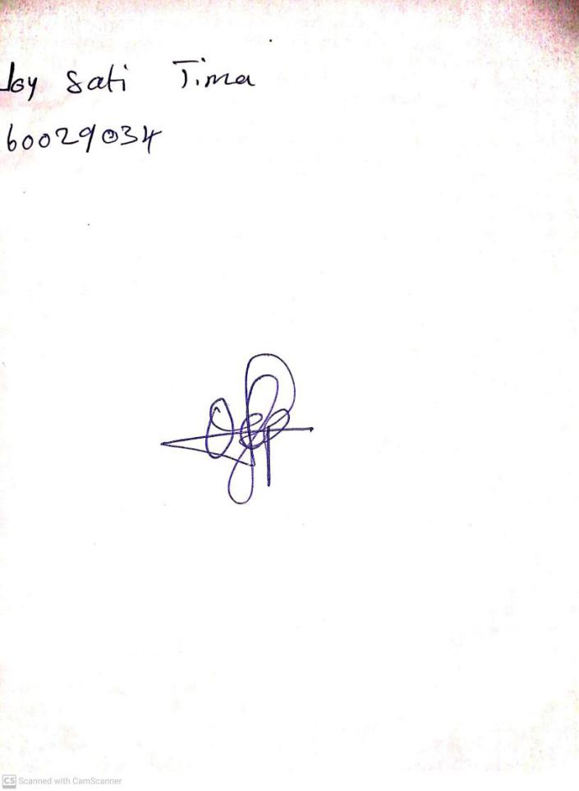

15TH September, 2023

Perpetual Ojoma Ocheja

Stream Head Nursery